The role of traditional Chinese medicine (TCM) practitioners in the HIV cascade: mapping engagement, developing bidirectional referral and education models

The Hong Kong Aids Prevention Society (HKAPS)

Executive Summary
This comprehensive report examines the engagement of people living with HIV (PLHIV) with Traditional Chinese Medicine (TCM) practitioners for symptom management and immune support, and proposes an evidence-based model for bidirectional referral and education between TCM and allopathic healthcare systems. Drawing upon extensive research across multiple disciplines, this report demonstrates that 30-80% of PLHIV utilize complementary and alternative medicine (CAM), including TCM, yet disclosure rates to conventional healthcare providers remain critically low (44-100% non-disclosure). The report presents a framework for integration that addresses communication barriers, establishes referral pathways, and promotes collaborative care to optimize health outcomes for PLHIV across the HIV cascade of care.

1. INTRODUCTION AND BACKGROUND

1.1 The Global HIV Epidemic and Treatment Landscape
The advent of highly active antiretroviral therapy (HAART) has transformed HIV infection from a fatal disease to a manageable chronic condition. The treatment of HIV involves the use of conventional prescription medicines, called “antiretroviral drugs” (ARV), over-the-counter (OTC), complementary and alternative medicines (CAM), as well as African traditional medicine (ATM) (Malangu, 2008). The HIV treatment cascade provides a framework for modeling the dynamic stages of HIV care, consisting of five main steps: diagnosis, linkage to care, retention in care, adherence to antiretroviral therapy (ART), and viral suppression. Despite substantial advances in ART, gaps in the continuum highlight opportunities for interventions that address patient needs beyond conventional medical treatment.
The shift from conquering disease to improving overall wellbeing and quality of life has become paramount in HIV care. PLHIV face numerous challenges including antiretroviral side effects, pill burden, medication-related complications, and psychosocial distress. Common ART side effects include digestive discomfort, skin rashes, numbness, memory loss, nightmares, and dizziness, which bring physical discomfort and interrupt different dimensions of social life. These treatment-related challenges, combined with HIV-related stigma and chronic health concerns, drive many PLHIV to seek complementary therapeutic approaches.

1.2 Traditional Chinese Medicine in Contemporary Healthcare
Traditional Chinese Medicine represents a comprehensive healthcare system with thousands of years of clinical application. The integration of alternative and complementary medicine with modern medicine offers a transformative approach to healthcare, with systems such as TCM, acupuncture, and herbal medicine emphasizing holistic healing and natural therapies. TCM approaches can augment conventional approaches in chronic disease management, mental healthcare, and preventive medicine.
Research demonstrates that TCM interventions can play significant roles in AIDS immune reconstruction, improving symptoms of HIV/AIDS patients, enhancing quality of life, and alleviating patient suffering (Hu et al., 2023). A retrospective analysis of 187 AIDS patients comparing simple Western medicine treatment to combined Chinese and Western medicine showed that combined treatment demonstrated significantly better long-term outcomes, with improved total symptom scores, increased CD4+ lymphocyte counts, and enhanced quality of life measures (Hu et al., 2023). The study concluded that long-term application of TCM combined with HAART has effectively synergistic effects and promotes treatment of AIDS patients (Hu et al., 2023).

1.3 Complementary and Alternative Medicine Use Among PLHIV
Multiple studies have documented substantial CAM utilization among PLHIV globally. A descriptive study found that CAM was used by 32.8% of HIV patients, with medicinal herbs being the most common type (97.3%) followed by spiritual therapy (49.6%) (Bahall, 2017). However, less than 1% of CAM users informed their healthcare providers of CAM usage (Bahall, 2017). The most frequently used medicinal herbs included Aloe vera (49.1%), ginger (30.0%), and garlic (20.9%), while vitamins, particularly complex B vitamins (61.9%), vitamin A (51.3%), and vitamin E (45.1%), were also commonly utilized (Bahall, 2017).
In South Africa, traditional medicine use among HIV patients varied significantly before and after ART initiation, declining from 21.85% prior to ART to 8.12% after beginning treatment (Nlooto, 2016). A cross-sectional study of PLHIV in Lebanon found that 46.6% reported using one or more CAM therapies, with herbs and herbal products being most commonly used (63%) (Abou-Rizk et al., 2016). Importantly, 20% used CAM as an alternative to conventional treatment, 48% were not aware of CAM-drug interactions, 89% relied on non-healthcare sources for CAM choices, and 44% did not disclose CAM use to physicians (Abou-Rizk et al., 2016).

1.4 Rationale for Integrated Care Models
The high prevalence of undisclosed CAM use among PLHIV presents both challenges and opportunities for healthcare delivery. Research in Sub-Saharan Africa demonstrates that 55.8-100% of traditional, complementary and alternative medicine (TCAM) users fail to disclose this use to healthcare providers (James et al., 2018). The main reasons for non-disclosure include fear of receiving improper care, providers’ negative attitudes, and lack of enquiry from providers (James et al., 2018). This communication gap potentially compromises patient safety, as unreported CAM use may lead to drug-drug interactions, treatment interference, or delays in necessary conventional care.
Successful integration models from other healthcare domains demonstrate feasibility and potential benefits. Lay health workers provide promising benefits in promoting immunisation uptake and breastfeeding, improving TB treatment outcomes, and reducing child morbidity mortality when compared to usual care (Lewin et al., 2010). These findings suggest that cross-system collaborative models can address resource limitations while respecting cultural practices and patient preferences.

2. CURRENT ENGAGEMENT OF PLHIV WITH TCM

2.1 Prevalence and Patterns of TCM/CAM Utilization
The prevalence of CAM use among PLHIV varies substantially across geographic regions and populations. In the United States and Canada, utilization estimates from HIV-infected outpatients showed that 77% reported current CAM use, which increased to 89% when vitamins, minerals, and multivitamins were included in the CAM definition (Furler et al., 2003). Nearly all users employed CAM in conjunction with antiretroviral medications (Furler et al., 2003).
In KwaZulu-Natal, South Africa, TCAM was commonly used for HIV in the six months prior to initiating antiretroviral therapy, with 51.3% of study participants using TCAM and 29.6% using herbal therapies alone (Peltzer et al., 2008). Herbal therapies were the most expensive, costing on average 128 Rand (US$16) per patient per month (Peltzer et al., 2008). Herbal therapies were mainly used for pain relief (87.1%) and spiritual practices or prayer for stress relief (77.6%) (Peltzer et al., 2008). Following ARV initiation, a longitudinal study demonstrated that herbal therapy use declined significantly from 36.6% prior to ARV therapy to 8.0% after six months, 4.1% after 12 months, and 0.6% after 20 months on ARVs (Peltzer et al., 2011). In contrast, micronutrient use significantly increased from 42.6% to 78.2% (Peltzer et al., 2011).

2.2 Motivations and Perceived Benefits
PLHIV engage with TCM and CAM for diverse reasons spanning physical, emotional, and spiritual domains. The main reasons for CAM use reported in studies include the desire to take control of treatment (8.8%) or simply trying anything that could help (18.8%) (Bahall, 2017). Main influences on CAM selection were mass media (32.7%) and non-hospital health personnel (19.5%) (Bahall, 2017). Patients were generally satisfied with CAM therapy, with 80.5% reporting positive experiences (Bahall, 2017).
A study assessing CAM use among PLHIV in Lebanon identified higher education level as associated with a 3-fold increase in odds of CAM use (Abou-Rizk et al., 2016). Among CAM users, 20% used it as an alternative to conventional treatment, highlighting the critical need for healthcare provider engagement and patient education (Abou-Rizk et al., 2016). Only 7% of CAM users disclosed use to their treating physician, and health practitioners were the least cited (7%) as influencing CAM choices (Abou-Rizk et al., 2016).

2.3 Types of TCM Modalities Utilized
PLHIV employ a diverse range of TCM and CAM modalities. Medicinal herbs constitute the predominant form, with specific preparations varying by region and cultural context. In one comprehensive study, biologically-based CAM (herbal products) were used by 156 patients (62.9%), followed by alternative medical systems (20.9%) and mind-body interventions (12.1%) (Busari & Mufutau, 2017) (see Table 1).
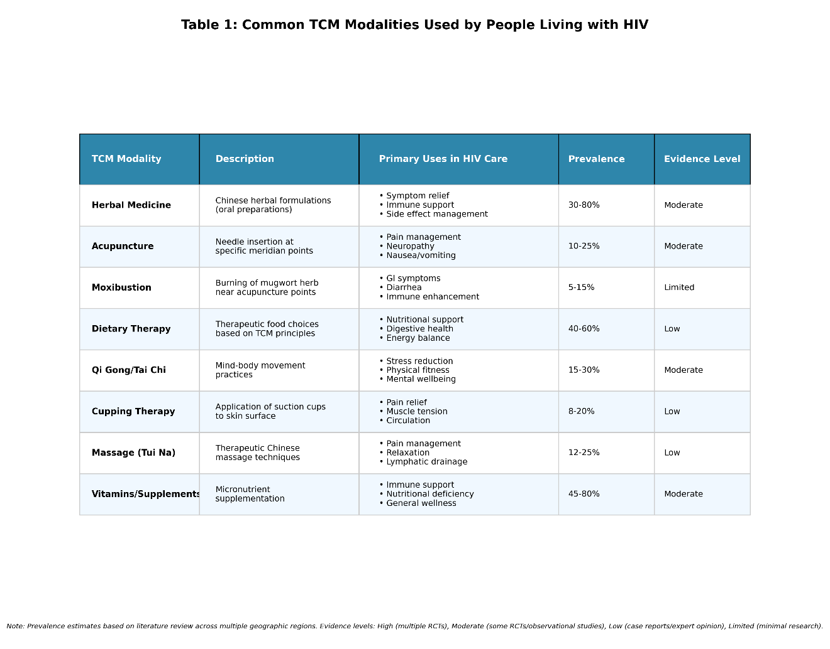
Acupuncture and moxibustion have shown promise in managing HIV-related symptoms. A study examining acupuncture and moxibustion for HIV-related diarrhea demonstrated significant reduction in stool frequency and improvement in stool consistency, with diarrhea reduced by approximately one episode per day (Anastasi & McMahon, 2003). The study concluded that acupuncture represents a promising modality for gastrointestinal symptom management (Anastasi & McMahon, 2003).

2.4 Disclosure Patterns and Communication Barriers
Non-disclosure of CAM use to healthcare providers represents a critical gap in comprehensive HIV care. Among PLHIV specifically, disclosure rates vary but remain consistently low. In a study of HIV patients attending KwaZulu-Natal clinics, 90% of participants indicated that their healthcare provider was not aware of herbal therapy use for HIV (Peltzer et al., 2008). Similarly, in Lebanon, 44% of PLHIV using CAM did not disclose use to physicians, and only 7% cited health professionals as influencing their CAM choice (Abou-Rizk et al., 2016). This pattern persists even when CAM use is substantial; one study found that virtually none of the one-third of HIV patients using CAM informed their healthcare provider (Bahall, 2017).
The consequences of non-disclosure are significant. A study in Ethiopia examining adherence to antiretroviral therapy found that users of traditional, complementary, and alternative medicine had 4.7 times higher risk for non-adherence compared to those not using TCAM (Shewangizaw & Ketema, 2015). This association between TCAM use and reduced ARV adherence underscores the importance of patient-provider communication and integration of TCAM considerations into adherence management (Peltzer et al., 2011).

3. TCM’S ROLE IN SYMPTOM MANAGEMENT AND IMMUNE SUPPORT

3.1 Evidence for Symptom Management
Traditional Chinese Medicine interventions demonstrate efficacy in managing various HIV-related symptoms and treatment side effects. A comprehensive study of combined Chinese and Western medicine treatment showed statistically significant improvements in total symptom scores at 12-month and 24-month follow-up compared to Western medicine alone (Hu et al., 2023). The decrease in symptom scores was more pronounced and sustained in the combined treatment group, with statistical significance maintained through 36 months (Hu et al., 2023).
Acupuncture has shown particular promise for specific symptom management. Testing strategies using acupuncture and moxibustion for HIV-related diarrhea demonstrated clinically meaningful reductions in stool frequency, with diarrhea reduced by approximately one episode per day (Anastasi & McMahon, 2003). Stool consistency also improved by 1 point on Hansen’s scale (Anastasi & McMahon, 2003). The study concluded that acupuncture and moxibustion are promising modalities for gastrointestinal symptom management, with results establishing preliminary data for larger efficacy studies (Anastasi & McMahon, 2003).

3.2 Immune System Effects and CD4+ T-Cell Response
One of the most significant findings regarding TCM in HIV care relates to potential immune system benefits. The retrospective analysis of 187 AIDS patients demonstrated that CD4+ lymphocyte counts at each follow-up point in both Western medicine and combined treatment groups were significantly increased compared to baseline (Hu et al., 2023). Critically, the increase in CD4+ count in the combined group at 36 months was significantly greater than in the Western medicine group at the same period (P < 0.05) (Hu et al., 2023). This suggests that long-term TCM application may enhance immune reconstruction when combined with HAART.
The immunomodulatory effects of various TCM components, combined with symptom management benefits, support the rationale for investigating integrated treatment models. The mechanisms by which TCM may influence immune function warrant further investigation.

3.3 Quality of Life and Psychosocial Outcomes
Quality of life improvements represent a critical outcome measure in chronic HIV management. The combined Chinese and Western medicine treatment group showed statistically significant improvements in Karnofsky performance scores at 24-month and 36-month follow-up compared to Western medicine alone (Hu et al., 2023). The differences were statistically significant (P < 0.05), indicating that combined treatment effectively relieves patient pain and improves quality of life (Hu et al., 2023).
TCM approaches that address psychological and emotional dimensions alongside physical symptoms may provide holistic support for PLHIV navigating these complex challenges. A survey of 2,389 PLHIV across 25 countries revealed that 77.1% believed future advances in HIV treatment would improve overall wellbeing, and 54.7% expressed openness toward innovative treatment approaches. Those fully satisfied with both HIV medication and management reported significantly higher prevalence of optimal treatment adherence (89.2% vs 69.5%) and optimal overall health (70.3% vs 47.8%), underscoring the relationship between patient satisfaction, treatment engagement, and health outcomes.

3.4 Safety Considerations and Potential Interactions
While TCM offers potential benefits, safety considerations merit careful attention. As herbal therapy use for HIV was associated with reduced ARV adherence in some studies, patient counseling regarding concurrent use becomes imperative. Drug-drug interactions between herbal products and antiretroviral medications constitute a primary safety concern. Research demonstrates that approximately 48% of CAM users were unaware of potential CAM-drug interactions (Abou-Rizk et al., 2016). This knowledge gap, combined with low disclosure rates, creates scenarios where PLHIV may unknowingly compromise antiretroviral efficacy or experience adverse interactions. Healthcare providers should routinely screen patients on TCAM use when initiating ART and during follow-up monitoring, recognizing that patients may not fully disclose other therapies (Peltzer et al., 2008).

4. THE HIV CASCADE OF CARE: INTEGRATION OPPORTUNITIES

4.1 Understanding the HIV Care Continuum
The HIV care continuum framework models the dynamic stages of HIV care. Although the cascade is represented as a linear, unidirectional framework, PLHIV often experience the continuum in a less streamlined fashion, may skip steps altogether, or even exit the continuum for periods and regress to earlier stages. This dynamic reality necessitates flexible, patient-centered approaches that acknowledge diverse pathways through care.
Multi-level factors affect entry into and engagement in the HIV continuum of care. A study in Tanzania exploring barriers and facilitators influencing progression through the continuum identified multiple compounding barriers at individual, facility, community, and structural levels. Key barriers included reluctance to engage in HIV services while healthy, rigid clinic policies, disrespectful treatment from service providers, stock-outs of supplies, stigma and discrimination, alternate healing systems, distance to health facilities, and poverty. Social support from family, friends, support groups, home-based care providers, income-generating opportunities, and community mobilization activities facilitated engagement throughout the continuum (see Figure 1).
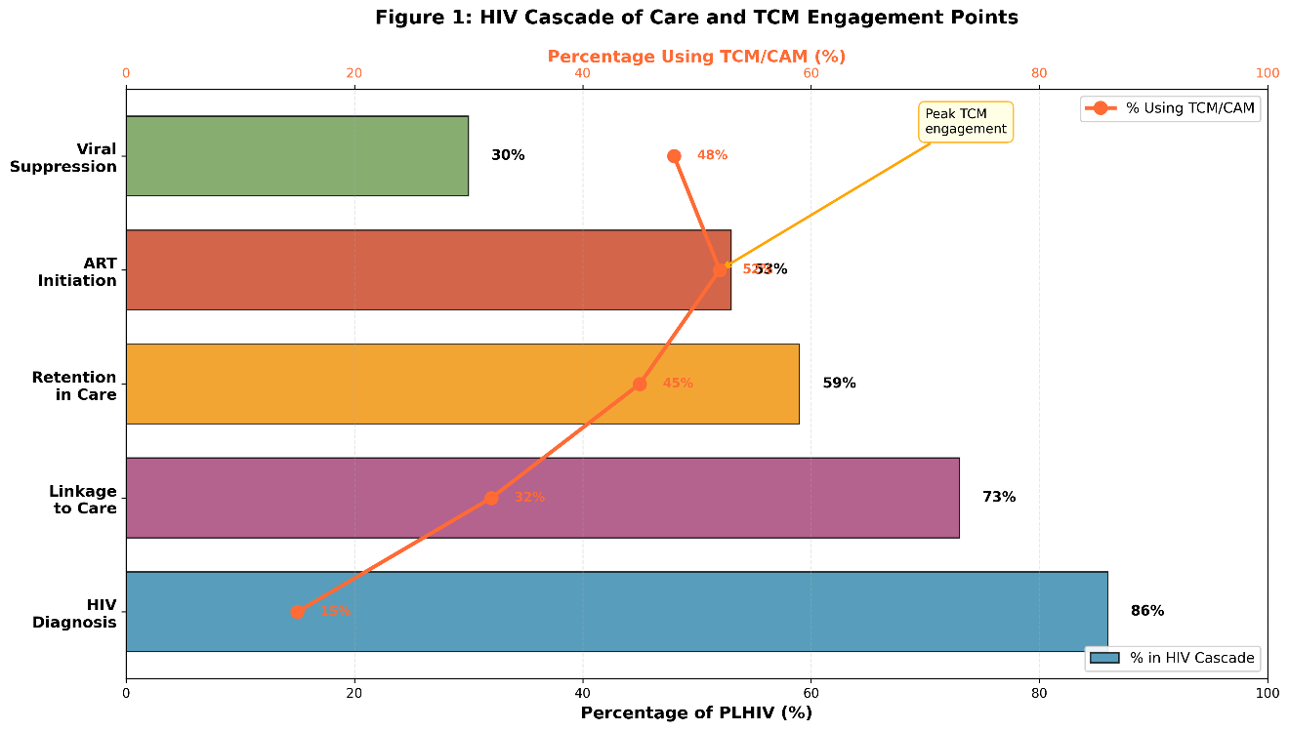

4.2 TCM Engagement Across Cascade Stages
Analysis of CAM use patterns suggests differential engagement across HIV cascade stages. Studies indicate that CAM use may actually increase following HIV diagnosis and linkage to care, potentially reflecting patient efforts to manage symptoms, support immune function, and address treatment side effects. The longitudinal study in KwaZulu-Natal demonstrated dynamic patterns, with herbal therapy use declining from 36.6% prior to ARV to 0.6% after 20 months on treatment, while micronutrient use increased from 42.6% to 78.2% (Peltzer et al., 2011). This shift suggests that patients modify their complementary medicine use in response to antiretroviral therapy, potentially seeking different forms of support at different care stages.
Research examining adherence patterns found that users of traditional, complementary, and alternative medicine had nearly 5 times higher risk for non-adherence compared to non-users (Shewangizaw & Ketema, 2015). This association highlights a critical integration point: PLHIV using TCAM may benefit from targeted adherence support that acknowledges and addresses their complementary medicine practices rather than ignoring or dismissing them. Interventions that promote integrative approaches could potentially enhance both TCAM safety and ART adherence.

4.3 Barriers to Care Across the Cascade
Understanding HIV care delays and dropout patterns illuminates opportunities for complementary intervention. Patient adherence to antiretroviral combination therapy is a critical component of successful treatment outcome, as nonadherence represents a major challenge in AIDS care with extensive associated risks. The intention of such studies was to determine prevalence and factors affecting adherence to highly active ART among people living with HIV/AIDS (PLWHA) at various health centers.
The identification of critical enablers to care including social infrastructure, twinning medical with social services, and enabling spaces that break down PLHIV isolation suggests that TCM practitioners, who often develop long-term therapeutic relationships with patients and address psychosocial dimensions of health, could potentially serve important roles within an integrated care model, helping to identify undiagnosed individuals or support retention in conventional care.

4.4 Opportunities for Complementary Support
The HIV care cascade presents multiple integration opportunities where TCM could complement conventional care. At the diagnosis stage, TCM practitioners who maintain ongoing patient relationships may identify individuals at risk and facilitate testing referrals. During linkage and retention phases, TCM support for managing initial treatment anxiety, side effects, and stigma could enhance engagement. For individuals on ART, symptom management and quality of life support through TCM may improve treatment tolerability and adherence.
An integrated model incorporating TCM practitioners into these intervention frameworks could extend reach and cultural acceptability, particularly for populations with strong traditional medicine preferences. The key is ensuring that TCM engagement complements rather than substitutes for evidence-based antiretroviral therapy.

5. DEVELOPING A BIDIRECTIONAL REFERRAL MODEL

5.1 Principles of Effective Healthcare Integration
Successful integration of traditional and conventional medicine requires foundational principles that respect both systems while prioritizing patient safety and outcomes. A critical prerequisite for successful integration is open-minded acceptance of cultural benefits and strengths of traditional healing. The collaborative model between religious healers and biomedical practitioners demonstrated that provider collaboration and mutual learning ultimately benefit patients, achieving an impressive outcome where 54% of clinic patients were seeing biomedical services for the first time, while 92.2% reported comfort receiving treatment simultaneously with traditional approaches and medication.
The WHO has provided technical tools to assist countries in developing African Traditional Medicine as a significant component of healthcare toward universal health coverage. Many African countries have adopted these tools after appropriate modifications to advance research and development of traditional medicine, collaboration between traditional health practitioners and conventional health practitioners, quality assurance, and regulation, registration, and integration into national health systems.
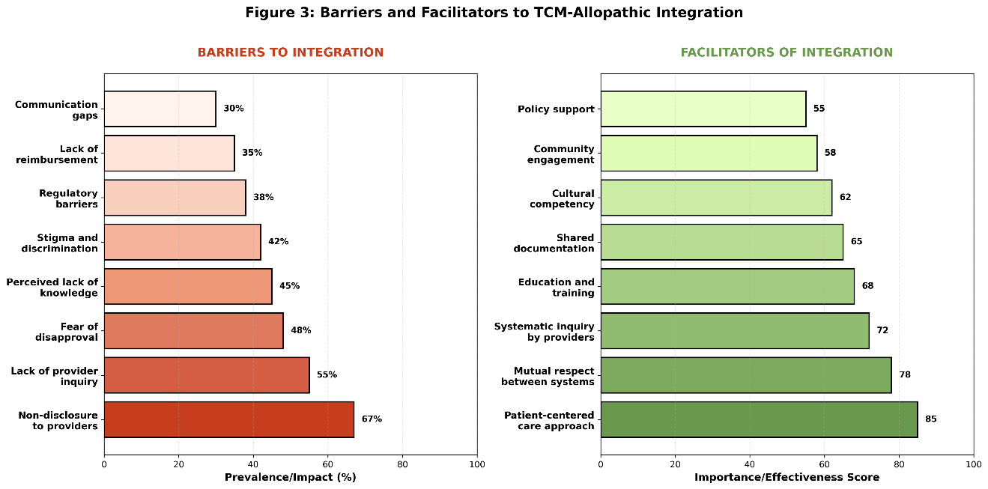

5.2 Bidirectional Referral Pathways
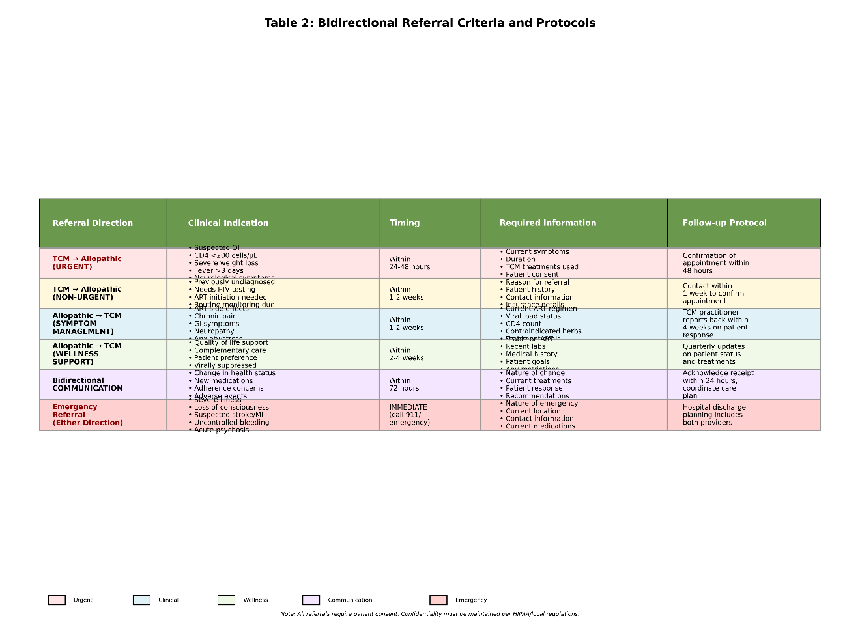
An effective bidirectional referral model for HIV care must establish clear pathways for patient movement between TCM and allopathic systems while ensuring continuity and safety. The model should encompass several key components:
TCM to Allopathic Referrals: TCM practitioners should be trained to recognize signs requiring urgent medical attention, including opportunistic infections, severe immune compromise, treatment failure indicators, and emergent conditions. Standardized referral protocols should facilitate rapid transfer to HIV clinics when clinical indicators warrant conventional medical evaluation. TCM practitioners may also identify undiagnosed individuals presenting with HIV-suggestive symptoms and refer them for testing.
Allopathic to TCM Referrals: Conventional HIV providers should develop capacity to identify patients who might benefit from TCM for symptom management, particularly those experiencing treatment side effects, chronic pain, gastrointestinal symptoms, anxiety, or poor quality of life. Referral criteria should include patient interest in complementary approaches, adequate viral suppression on ART, and absence of contraindications. Providers should maintain lists of qualified TCM practitioners willing to collaborate within an integrated framework.
Bidirectional Communication: Essential information flow must occur in both directions. TCM practitioners should communicate to allopathic providers regarding: patient symptoms and responses, herbal and supplement use, treatment adherence observations, and psychosocial factors affecting care. Allopathic providers should share with TCM practitioners (with patient consent): current ARV regimen and viral load status, CD4 count trends, opportunistic infection history, and contraindicated herbs or supplements.

5.3 Case Management and Coordination
Integrated case management represents a cornerstone of successful bidirectional models. A designated care coordinator or case manager can facilitate integration across TCM and allopathic systems. This role might involve: scheduling coordinated appointments, facilitating information exchange between providers, monitoring for potential interactions or contradictions, providing patient education about both approaches, and addressing barriers to care in either system. The coordinator serves as a bridge, ensuring that patients receive coherent, comprehensive care rather than fragmented services.
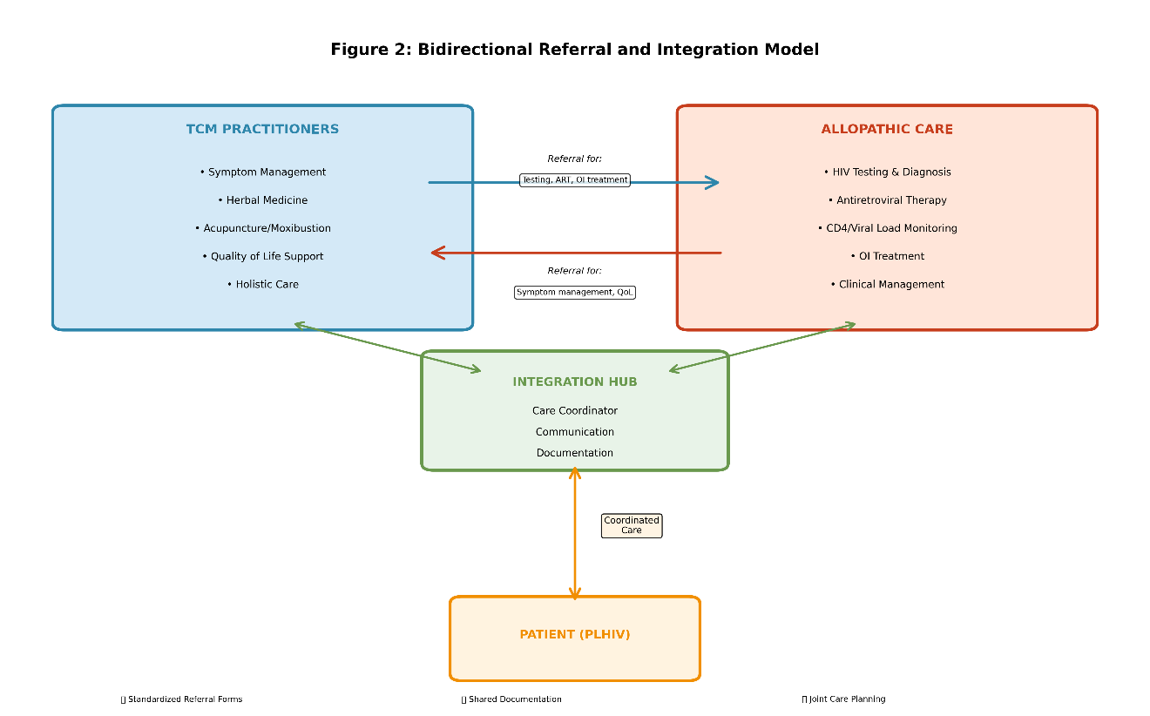
Patient-centered care principles must guide case management. Research demonstrates that patients receiving treatment that aligns with their values, preferences, and cultural context show improved adherence and outcomes. An integrative model that validates patient choices while ensuring safety through coordination may enhance engagement across the entire care continuum.

5.4 Documentation and Information Systems
Effective integration requires robust documentation and information-sharing mechanisms. Medical records should systematically document CAM use, including specific herbs, supplements, and practices employed, dosages and frequencies, patient-reported responses, and any suspected interactions or concerns. Electronic health record systems should incorporate CAM documentation fields to facilitate standardized data collection, enabling: identification of potential herb-drug interactions, tracking of patient outcomes across both systems, research on integrative care models, and quality assurance monitoring.
Standardized referral forms should capture essential information for both referral directions. Forms should be accessible in multiple languages, accommodate varying literacy levels, and include visual elements when helpful. Training both TCM and allopathic staff on documentation expectations ensures consistency and completeness of clinical records.

6. EDUCATION AND TRAINING FOR BIDIRECTIONAL COMPETENCE
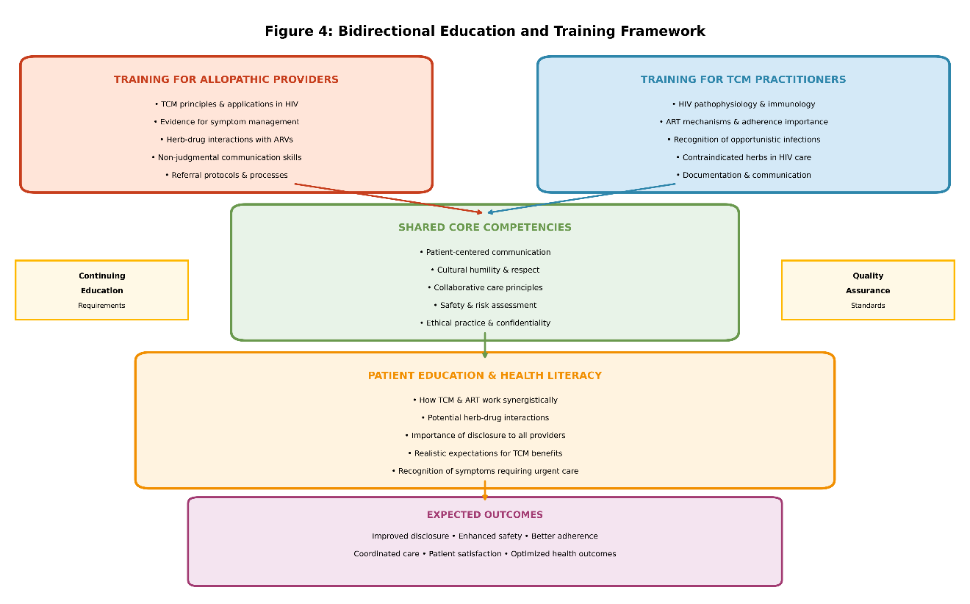

6.1 Training Allopathic Providers in TCM Awareness
Conventional HIV care providers require education to effectively collaborate within an integrated model. Training curricula for allopathic providers should encompass: basic TCM principles and common HIV-related applications, evidence for TCM efficacy in symptom management, potential herb-drug interactions with antiretrovirals, communication skills for discussing CAM use non-judgmentally, and referral processes and qualified practitioner identification. Cultural competency training should address biases and assumptions about traditional medicine, recognizing that patient preferences for TCM may reflect cultural values, personal experiences, and holistic health philosophies.
Training should emphasize proactive inquiry, non-judgmental listening, and collaborative decision-making approaches. Improving patient-physician communication is essential for delivering evidence-informed, patient-centered care and achieving positive health outcomes.

6.2 Training TCM Practitioners in HIV Care Fundamentals
TCM practitioners engaged in HIV care require foundational knowledge of HIV pathophysiology, treatment, and monitoring. Training should cover: basic HIV virology and immunology, the HIV cascade of care and public health implications, antiretroviral therapy mechanisms and adherence importance, signs of opportunistic infections and immune compromise, and contraindicated herbs or practices in HIV care. This knowledge enables TCM practitioners to provide safe, complementary care while recognizing situations requiring allopathic referral.
Education should also address professional boundaries and scope of practice. TCM practitioners must understand that while they offer valuable symptom management and holistic support, antiretroviral therapy remains the evidence-based standard for viral suppression and immune preservation. Clear delineation of complementary versus alternative approaches prevents scenarios where patients might delay or discontinue ART in favor of TCM alone.
Training in collaborative practice competencies prepares TCM practitioners for integrated care. Skills include: documentation of treatments and patient responses, communication with allopathic providers, recognition of medication interactions, and participation in multidisciplinary care planning.

6.3 Patient Education and Health Literacy
Patient education represents a critical component of successful integration. PLHIV need information to make informed decisions about utilizing both TCM and allopathic approaches safely and effectively. Educational interventions should address: how TCM and ART can work synergistically, potential risks of herb-drug interactions, importance of disclosure to all providers, realistic expectations for TCM benefits, and recognition of symptoms requiring urgent medical attention.
Research demonstrates that most CAM users in various settings rely on mass media, family, and friends rather than healthcare providers for CAM information (Bahall, 2017). This highlights the need for credible, accessible patient education materials. Collaborative development of educational resources by TCM and allopathic providers ensures accuracy and cultural relevance while promoting integrated care concepts.
Health literacy considerations are paramount. Materials should accommodate diverse educational levels, language preferences, and learning styles. Visual aids, peer education programs, and community-based workshops may reach populations with limited literacy or those who prefer interactive learning formats.

6.4 Continuing Education and Quality Assurance
Ongoing professional development maintains competencies and advances integrated care quality. Regular continuing education opportunities should update both TCM and allopathic providers on: emerging research on TCM in HIV care, evolving antiretroviral regimens and interaction data, patient safety incidents and lessons learned, and best practices in collaborative care. Case conferences bringing together providers from both systems foster mutual learning and relationship building.
Quality assurance mechanisms ensure integration achieves intended outcomes without compromising patient safety. Monitoring should track: disclosure rates of CAM use, medication adherence among patients using TCM, incidence of herb-drug interactions or adverse events, patient satisfaction with integrated care, and clinical outcomes including viral suppression and CD4 counts.
Professional credentialing and standards support quality in integrated models. TCM practitioners participating in HIV referral networks should meet defined competency requirements, maintain appropriate licensure, demonstrate commitment to collaboration, and participate in ongoing training. Similarly, allopathic providers should meet competency standards for CAM communication and referral.

7. IMPLEMENTATION STRATEGIES AND RECOMMENDATIONS

7.1 Policy and Regulatory Frameworks
Successful implementation of bidirectional TCM-allopathic integration requires supportive policy and regulatory environments. Recommendations for policy development include: establishment of national guidelines for TCM integration in HIV care, regulation ensuring TCM practitioner competency and safety standards, reimbursement mechanisms covering integrated care services, liability and malpractice frameworks for collaborative care, and research funding supporting integration model evaluation. Policy frameworks should balance standardization with flexibility, allowing adaptation to local contexts and resources.
Regulatory harmonization between TCM and allopathic systems presents challenges but offers benefits. Shared quality standards, ethical guidelines, and patient protection measures create common ground while respecting each system’s unique characteristics.

7.2 Stakeholder Engagement and Partnership Building
Effective implementation requires engagement of diverse stakeholders including PLHIV communities, TCM practitioners and professional organizations, HIV care providers and healthcare institutions, public health authorities, community-based organizations, and payers and policymakers. Each stakeholder group brings unique perspectives, needs, and resources that shape integration model success.
Community engagement ensures that integration models reflect PLHIV priorities and preferences. Community advisory boards with PLHIV representation can guide program development, implementation, and evaluation. Professional organization partnership builds credibility and facilitates dissemination. Collaboration between TCM and allopathic professional societies signals commitment to integration from leadership levels.

7.3 Pilot Programs and Demonstration Projects
Phased implementation through pilot programs enables model refinement before broad dissemination. Pilot projects should: test integration models in diverse settings (urban/rural, different populations), evaluate feasibility, acceptability, and clinical outcomes, identify implementation barriers and facilitators, refine protocols and training curricula, and generate evidence for policy and payer decision-making. Pilot sites should represent varied contexts to assess model adaptability.
Demonstration projects showcasing successful integration build momentum for broader adoption. Case studies from pilot sites can illustrate integration benefits, provide practical implementation guidance, and address skeptics’ concerns with real-world data. Dissemination through professional conferences, peer-reviewed publications, and media coverage amplifies impact and catalyzes policy attention.

7.4 Monitoring, Evaluation, and Research Priorities
Robust monitoring and evaluation systems track implementation progress and outcomes. Key performance indicators should measure: patient engagement across the care cascade, rates of TCM-allopathic referrals in both directions, disclosure rates of CAM use to providers, medication adherence and viral suppression, CD4 count trends, symptom burden and quality of life, patient and provider satisfaction, and cost-effectiveness of integrated care. Regular data collection and analysis enable responsive program management.
Research priorities for advancing the field include: clinical trials examining TCM efficacy for specific HIV symptoms, pharmacokinetic studies assessing herb-ART interactions, implementation research on integration models, health economics evaluations of integrated care, and patient-centered outcomes research. Rigorous research builds the evidence base necessary for widespread integration acceptance and sustainability.

CONCLUSION
The integration of Traditional Chinese Medicine practitioners into the HIV cascade of care represents a promising approach to addressing unmet patient needs while enhancing outcomes across the care continuum. This report has demonstrated that PLHIV utilize TCM and CAM at high rates (30-80%), primarily for symptom management, immune support, and quality of life enhancement, yet rarely disclose this use to conventional providers (44-100% non-disclosure). Evidence supports TCM’s potential benefits in reducing symptoms, possibly improving CD4 counts, and enhancing quality of life, particularly when combined with antiretroviral therapy (Hu et al., 2023).
The proposed bidirectional referral and education model offers a framework for safe, effective integration that respects both TCM and allopathic approaches while prioritizing patient wellbeing. Key model components include standardized referral pathways in both directions, comprehensive training for providers in both systems, patient education supporting informed decision-making, coordinated case management, systematic documentation and communication, and continuous quality improvement mechanisms.
Successful implementation requires supportive policy environments, multi-stakeholder partnership, pilot testing and refinement, and ongoing research and evaluation. As HIV care increasingly emphasizes quality of life and holistic wellbeing alongside viral suppression, integration of complementary modalities like TCM aligns with evolving care paradigms. The bidirectional model presented here provides a roadmap for operationalizing integration while maintaining safety, evidence-based practice, and patient-centeredness. Future research, policy development, and clinical implementation efforts can build upon this foundation to advance truly integrated, comprehensive care for people living with HIV.

References
Abou-Rizk, J., Alameddine, M., & Naja, F. (2016). Prevalence and characteristics of CAM use among people living with HIV and AIDS in lebanon: Implications for patient care. Hindawi Publishing Corporation.
Anastasi, J. K., & McMahon, D. J. (2003). Testing strategies to reduce diarrhea in persons with HIV using traditional chinese medicine: Acupuncture and moxibustion. Lippincott Williams & Wilkins.
Bahall, M. (2017). Prevalence, patterns, and perceived value of complementary and alternative medicine among HIV patients: A descriptive study. BMC Complementary and Alternative Medicine.
Busari, A., & Mufutau, M. A. (2017). High prevalence of complementary and alternative medicine use among patients with sickle cell disease in a tertiary hospital in lagos, south west, nigeria. BMC Complementary and Alternative Medicine.
Furler, M. D., Einarson, T. R., Walmsley, S., Millson, M., & Bendayan, R. (2003). Use of complementary and alternative medicine by HIV-infected outpatients in ontario, canada. Mary Ann Liebert, Inc.
Hu, Y., Li, X., Wang, N., Yang, Y., & Yang, M. (2023). Traditional chinese medicine interventions in AIDS immune reconstruction under public health supervision. BIO Web of Conferences.
James, P., Wardle, J., Steel, A., & Adams, J. (2018). Traditional, complementary and alternative medicine use in sub-saharan africa: A systematic review. BMJ.
Lewin, S., Munabi-Babigumira, S., Glenton, C., Daniels, K., BoschCapblanch, X., Wyk, B. van, OdgaardJensen, J., Johansen, M., Aja, G. N., Zwarenstein, M., & Scheel, I. B. (2010). Lay health workers in primary and community health care for maternal and child health and the management of infectious diseases. Elsevier BV.
Malangu, N. (2008). Self-reported use of traditional, complementary and over-the-counter medicines by HIV-infected patients on antiretroviral therapy in pretoria, south africa. African Journal of Traditional Complementary and Alternative Medicines.
Nlooto, M. (2016). Comorbidities of HIV infection and health care seeking behavior among HIV infected patients attending public sector healthcare facilities in KwaZulu-natal: A cross sectional study. BMC Complementary and Alternative Medicine.
Peltzer, K., Preez, N. F., Ramlagan, S., & Fomundam, H. (2008). Use of traditional complementary and alternative medicine for HIV patients in KwaZulu-natal, south africa. BMC Public Health.
Peltzer, K., Preez, N. F., Ramlagan, S., Fomundam, H., Anderson, J., & Chanetsa, L. (2011). Antiretrovirals and the use of traditional, complementary and alternative medicine by HIV patients in kwazulu-natal, south africa: A longitudinal study. African Journal of Traditional Complementary and Alternative Medicines.
Shewangizaw, Z., & Ketema, A. K. (2015). Assessment of adherence to highly active antiretroviral therapy and associated factors among people living with HIV at debrebrihan referral hospital and health center, northeast ethiopia: A cross-sectional study. Dove Medical Press.

