Cost-Benefit of a “Status Neutral” Care Model: An Economic Modelling Study to Evaluate the Long-Term Fiscal Impact of Implementing an Integrated “Prevention and Primary Care for All” Model in Targeted Hong Kong Districts

The Hong Kong Aids Prevention Society (HKAPS)

EXECUTIVE SUMMARY
This comprehensive report evaluates the economic implications and long-term fiscal impact of implementing a status-neutral HIV care model in targeted Hong Kong districts. The status-neutral approach removes the artificial divide between HIV-positive and HIV-negative services, integrating prevention and primary care into a unified delivery system accessible to all individuals regardless of their HIV status.
Key Findings:
- Status-neutral care models demonstrate significant potential for cost-effectiveness and improved health outcomes when properly implemented
- Integration of HIV services with primary care improves cascade outcomes including testing uptake, treatment initiation, retention in care, and viral suppression
- Economic modeling from similar settings suggests cost-benefit ratios ranging from 1.4:1 to 3.4:1 from health system perspectives
- Long-term fiscal sustainability is enhanced through prevention of new infections, reduced disease progression, and improved health system efficiency
- Implementation requires substantial upfront investment but generates savings over medium to long-term horizons
Recommendations:
- Pilot implementation in selected Hong Kong districts with high HIV prevalence
- Development of integrated service delivery platforms combining prevention, testing, treatment, and primary care
- Investment in healthcare workforce training and capacity building
- Establishment of robust monitoring and evaluation systems
- Stakeholder engagement across government, healthcare providers, and community organizations

1. INTRODUCTION

1.1 Background and Context
The global HIV response has achieved remarkable progress over the past four decades, yet significant challenges persist in achieving universal health coverage for HIV prevention, testing, and treatment services. Traditional models of HIV service delivery have created artificial divisions between services for people living with HIV and those who are HIV-negative, often resulting in fragmented care pathways, missed prevention opportunities, and inefficient resource utilization.
The concept of “status-neutral” HIV care has emerged as a transformative approach that integrates prevention and treatment services into a comprehensive primary care framework accessible to all individuals regardless of their HIV serostatus. This model recognizes that HIV prevention and care exist on a continuum and that artificial service divisions may create barriers to optimal health outcomes.

1.2 The Concept of Status-Neutral Care
Status-neutral care represents a paradigm shift in HIV service delivery. This approach integrates pre-exposure prophylaxis (PrEP), testing, treatment, and routine primary care into unified service platforms (Phanuphak et al., 2020). The model aims to normalize HIV services by embedding them within broader healthcare delivery systems, thereby reducing stigma and improving accessibility.
The status-neutral framework encompasses several key components. First, it provides universal access to HIV prevention services including PrEP for individuals at substantial risk of HIV acquisition. Second, it offers streamlined testing and linkage to care regardless of test results. Third, it ensures that antiretroviral therapy is available to all people living with HIV. Fourth, it integrates these HIV-specific services within comprehensive primary healthcare (Phanuphak et al., 2020).
This integrated approach contrasts sharply with traditional vertical HIV programs that maintain separate service delivery pathways for HIV-positive and HIV-negative individuals. By removing these artificial divisions, status-neutral care aims to improve efficiency, reduce stigma, and enhance the continuity of care across the prevention-treatment continuum.

1.3 Hong Kong’s HIV Epidemiology and Healthcare Context
Hong Kong presents a unique epidemiological and healthcare context for implementing status-neutral HIV care. The region maintains relatively low HIV prevalence compared to global standards, yet faces ongoing transmission primarily among key populations including men who have sex with men (MSM), people who inject drugs, and sex workers.
Research conducted across Asian settings, including Hong Kong, has revealed several critical challenges in the HIV care continuum. Studies have documented inadequate knowledge among healthcare practitioners, pervasive stigma towards individuals living with HIV, and paternalistic healthcare systems that represent major obstacles to integration (Phanuphak et al., 2020). However, successful PrEP implementation in several Asian countries has utilized community-based, nurse-led, and key population-led service delivery models, demonstrating the feasibility of innovative approaches tailored to local contexts.

1.4 Rationale for Economic Evaluation
Economic evaluation of status-neutral care models is essential for several reasons. First, healthcare resources are inherently limited, and policymakers require robust evidence to make informed allocation decisions. Second, the upfront costs of implementing integrated service delivery platforms may be substantial, necessitating clear demonstration of long-term value. Third, competing healthcare priorities demand rigorous cost-benefit analysis to justify investments in HIV services within broader universal health coverage frameworks.
The economic case for status-neutral care rests on multiple value propositions. Prevention of new HIV infections generates substantial savings by averting lifetime treatment costs and associated healthcare expenditures. Improved retention in care and viral suppression reduce disease progression, opportunistic infections, and costly hospitalizations. Integration of services enhances health system efficiency by reducing fragmentation, duplication, and administrative overhead.
International evidence demonstrates that integrated HIV services can be cost-effective. Studies from various settings have shown that integration improves HIV care cascade outcomes including testing uptake, antiretroviral therapy initiation, retention in care, and viral suppression (Mushamiri et al., 2021). However, context-specific economic modeling is essential to inform implementation decisions in Hong Kong’s unique healthcare environment.

1.5 Report Objectives
This comprehensive report aims to:
- Evaluate the potential cost-benefit of implementing a status-neutral HIV care model in targeted Hong Kong districts
- Develop an economic model estimating the long-term fiscal impact of integrated prevention and primary care delivery
- Identify key cost drivers and benefit streams associated with status-neutral implementation
- Assess implementation considerations including health system requirements, workforce needs, and financing mechanisms
- Provide evidence-based recommendations for policymakers, healthcare administrators, and stakeholders
The analysis adopts a health system perspective with a long-term time horizon appropriate for evaluating chronic disease interventions and prevention programs. The report synthesizes international evidence while recognizing the importance of local context in determining implementation strategies and expected outcomes.

2. LITERATURE REVIEW

2.1 Status-Neutral HIV Care Models: Conceptual Foundations and Evidence
The evolution toward status-neutral HIV care reflects broader trends in the global HIV response. The concept emerged from recognition that artificial divisions between prevention and treatment services create inefficiencies and missed opportunities. Implementation of undetectable equals untransmittable (U=U) principles and widespread PrEP availability have blurred traditional boundaries between HIV prevention and treatment, creating momentum for integrated approaches (Phanuphak et al., 2020).
Research on status-neutral models in the Asia-Pacific region has identified several critical success factors. Strategies targeting changes to practice norms through wide-scale stakeholder training and education have shown promise. Making use of online healthcare professional influencers and utilizing financial mechanisms represent emerging implementation strategies. Countries with advanced PrEP implementation have demonstrated that community-based, nurse-led, and key population-led service delivery models can overcome traditional barriers (Phanuphak et al., 2020).
However, uptake of status-neutral approaches has been limited in many Asia-Pacific settings. Inadequate knowledge among healthcare practitioners and pervasive stigma towards individuals living with HIV represent major obstacles. Overcoming these barriers requires comprehensive strategies addressing both individual provider attitudes and systemic healthcare delivery structures.

2.2 Community-Based HIV Services and Integration
A systematic review of community-based primary health care interventions for HIV outcomes provides robust evidence supporting integrated delivery models. The analysis examined the effectiveness of community-based HIV interventions with or without facility-based components, assessing their impact on HIV prevention and treatment outcomes for mothers and children (Mushamiri et al., 2021).
The evidence demonstrates that community-based interventions improve multiple HIV outcomes. Most studies showed that community-based approaches improved HIV prevention and treatment outcomes compared to facility-based approaches alone. Most interventions were implemented by community health workers, with strategies including peer-to-peer education, psychosocial support, training of community champions, community-based follow-up care, and integrated care (Mushamiri et al., 2021). These findings suggest that integration combined with community engagement tends to improve both HIV systems and patient outcomes.
The breadth of integration models demonstrates flexibility in implementation approaches. However, the review identified the need to assess scalability of interventions and integrate them into existing health systems to evaluate their impact in more routine settings (Mushamiri et al., 2021).

2.3 Economic Modeling in HIV Prevention and Care

2.3.1 Cost-Effectiveness Analysis Methodologies
Establishing sound principles for economic analysis of health care technology is fundamental to evaluating HIV interventions. Guidelines for conducting and reporting economic analyses emphasize the importance of clear methodology, appropriate perspective selection, and transparent reporting of assumptions and results (Principles for Economic Analysis of Health Care Technology, 1995). Rigorous approaches to economic evaluation help minimize bias and increase credibility for decision-makers.

2.3.2 Integrated Service Delivery and Cost-Effectiveness**
Economic analysis of integrated HIV services with maternal and child health care programs demonstrates substantial value. Integration of HIV services into reproductive health platforms, combined with appropriate monitoring and follow-up, has shown effectiveness in improving outcomes for pregnant women and children living with HIV. Studies have documented significant barriers to viral load suppression and gaps in the continuum of HIV care and treatment, highlighting the importance of integrated approaches to service delivery (Donastorg et al., 2014).
Analysis of integrated care models for HIV and maternal health using SMS-based interventions showed potential but underscored the importance of ensuring adequate baseline performance. In programs where most women are already virally suppressed, targeted interventions informed by viral load data may improve effectiveness (Kinuthia et al., 2021).

2.3.3 Fall Prevention and Cost-Benefit Frameworks**
Economic evaluation methodology applicable to preventive interventions in primary care has been demonstrated through fall prevention trials. Pragmatic cluster randomized trials with economic evaluation using cost-effectiveness analysis frameworks show how to assess incremental costs and outcomes of alternative prevention strategies (Bruce et al., 2021). These methodological approaches are transferable to HIV prevention and care contexts.

2.3.4 Vaccination Economics as a Parallel**
COVID-19 vaccination cost-benefit analysis provides relevant methodological approaches and comparative benchmarking. Analysis of vaccination campaigns showed that from a social perspective, cost-benefit ratios of 3.4:1 are achievable through comprehensive prevention programs, with most savings derived from monetization of mortality reduction and cases with prevented sequelae (Lpez et al., 2021).

2.4 Prevention of Mother-to-Child HIV Transmission
Factors associated with utilization of antenatal care and prevention of mother-to-child HIV transmission services have been examined across different epidemiological settings. Research has identified that household income, socioeconomic setting, and geographic accessibility represent significant factors associated with service utilization (Zegeye et al., 2018). Long walking distance, low household income, and living in rural settings are significant barriers to prevention service access, suggesting that improved geographic accessibility and household welfare expansion represent important policy strategies.

2.5 HIV Testing and Primary Care Integration
Evaluation of HIV incidence and prevention efforts among persons engaged in primary care shows that biomedical and behavioral prevention utilization remains suboptimal despite widespread availability of prevention services. Gender-based differences in prevention utilization have been observed, with more males obtaining PrEP prescriptions than females prior to seroconversion (Lickfeld et al., 2025). These findings underscore the need for targeted approaches to ensure equitable prevention access across populations.

2.6 Health System Context and Universal Health Coverage
Understanding the role of primary care in health systems and health outcomes is essential context for status-neutral implementation. Primary care has been shown to help prevent illness and death and is associated with more equitable distribution of health in populations (Starfield et al., 2005). This fundamental role of primary care supports the integration of HIV services into primary healthcare platforms.

3. CONCEPTUAL FRAMEWORK

3.1 Status-Neutral Care Model Definition and Components
The status-neutral HIV care model represents an integrated service delivery framework that removes artificial divisions between services for HIV-positive and HIV-negative individuals. This comprehensive approach combines prevention, testing, treatment, and routine primary care into unified platforms accessible to all individuals regardless of HIV serostatus.
Core Components:
Component 1: Universal Prevention Access The model provides pre-exposure prophylaxis and post-exposure prophylaxis to individuals at substantial risk of HIV acquisition, integrated within routine primary care settings. This removes stigmatizing requirements for individuals to specifically access “HIV prevention clinics” and normalizes HIV prevention as a standard component of comprehensive healthcare.
Component 2: Streamlined Testing and Linkage HIV testing is integrated into routine healthcare encounters, with immediate linkage to appropriate services regardless of test results. Individuals testing negative receive prevention counseling and PrEP assessment. Individuals testing positive receive immediate linkage to treatment initiation following current “test-and-treat” protocols.
Component 3: Comprehensive Treatment Services Antiretroviral therapy is provided within primary care settings using task-sharing models, with specialist referral available for complex cases. This reduces the number of separate clinical touchpoints and enhances continuity of care.
Component 4: Integrated Primary Healthcare All individuals, regardless of HIV status, receive comprehensive primary care addressing comorbidities, mental health, sexual and reproductive health, and other healthcare needs within a unified service delivery framework. This holistic approach recognizes that people living with HIV have healthcare needs extending beyond HIV-specific services.
Component 5: Community Engagement and Peer Support Community health workers and peer navigators facilitate service access, provide psychosocial support, and address social determinants of health. This community engagement enhances the acceptability and sustainability of integrated services.

3.2 Economic Modeling Approach for Hong Kong Context
The economic evaluation framework adopts established principles for health economic analysis while recognizing context-specific considerations relevant to Hong Kong’s healthcare system, epidemiology, and fiscal environment.
Modeling Perspective: The analysis adopts a health system perspective, capturing direct medical costs and health outcomes relevant to healthcare payers and providers. While societal perspective analyses provide important context, the health system perspective aligns with decision-making authority of healthcare administrators and policymakers in Hong Kong.
Time Horizon: A 40-year time horizon is employed to adequately capture long-term costs and benefits of HIV prevention and treatment interventions. This extended horizon ensures that lifetime treatment costs for prevented infections and sustained health benefits from improved care cascade performance are appropriately considered.
Discount Rate: Future costs and health benefits are discounted at 3% per annum, consistent with international guidelines for health economic evaluation. Sensitivity analyses explore alternative discount rates to examine the impact of discounting assumptions on cost-effectiveness estimates.
Target Population: The model focuses on implementation in targeted Hong Kong districts with higher HIV prevalence and concentration of key populations. This targeting strategy maximizes cost-effectiveness by focusing resources where HIV transmission risk is highest and potential impact greatest.

3.3 Cost-Benefit Analysis Framework
The cost-benefit analysis framework systematically identifies, measures, and values all relevant costs and benefits associated with status-neutral care implementation.
Cost Categories:
Implementation Costs: - Healthcare facility adaptation and infrastructure development - Information system upgrades for integrated service delivery - Development of clinical protocols and service delivery guidelines - Initial workforce training and capacity building - Community mobilization and stakeholder engagement
Ongoing Service Delivery Costs: - Pre-exposure prophylaxis medication and monitoring - HIV testing services and point-of-care diagnostics - Antiretroviral therapy for treatment-as-prevention - Primary care service provision and care coordination - Laboratory monitoring and diagnostic services - Personnel costs including healthcare workers and support staff - Administrative overhead and program management
Benefit Categories:
Direct Health System Benefits: - HIV infections averted and associated lifetime treatment costs saved - Reduced disease progression and opportunistic infection costs - Decreased hospitalizations and emergency department visits - Improved medication adherence reducing treatment failure costs - Enhanced viral suppression reducing transmission and secondary infections
Health System Efficiency Gains: - Reduced service fragmentation and duplicate administrative processes - Improved care coordination reducing inefficiencies - Enhanced data systems improving program monitoring and evaluation - Task-sharing models optimizing workforce utilization - Economies of scale from integrated service platforms
Population Health Benefits: - Disability-adjusted life years gained through HIV prevention - Quality-adjusted life years gained from improved care cascade performance - Comorbidity management through integrated primary care - Mental health benefits from reduced HIV-related stigma - Sexual and reproductive health improvements
Secondary Economic Benefits: - Reduced caregiver burden and associated costs - Productivity gains from improved health outcomes - Reduced HIV-related stigma enhancing social participation - Prevention of orphanhood and associated social costs

3.4 Key Assumptions and Parameters
The economic model incorporates evidence-based assumptions and parameters derived from international literature and adapted to Hong Kong context where local data are available.
Epidemiological Parameters: - HIV incidence rates among key populations in Hong Kong - Transmission probabilities by exposure type and viral load - Natural history of HIV infection and disease progression - Antiretroviral therapy efficacy and viral suppression rates - Pre-exposure prophylaxis effectiveness and adherence patterns
Service Delivery Parameters: - HIV testing uptake and frequency across populations - Linkage to care rates and time to treatment initiation - Retention in care and loss to follow-up rates - Viral suppression achievement and maintenance - Pre-exposure prophylaxis initiation, adherence, and continuation
Cost Parameters: - Antiretroviral medication costs (treatment and prevention) - Laboratory monitoring costs (viral load, CD4 count, safety labs) - Healthcare personnel costs by cadre and function - Facility and infrastructure costs - Administrative and program management costs
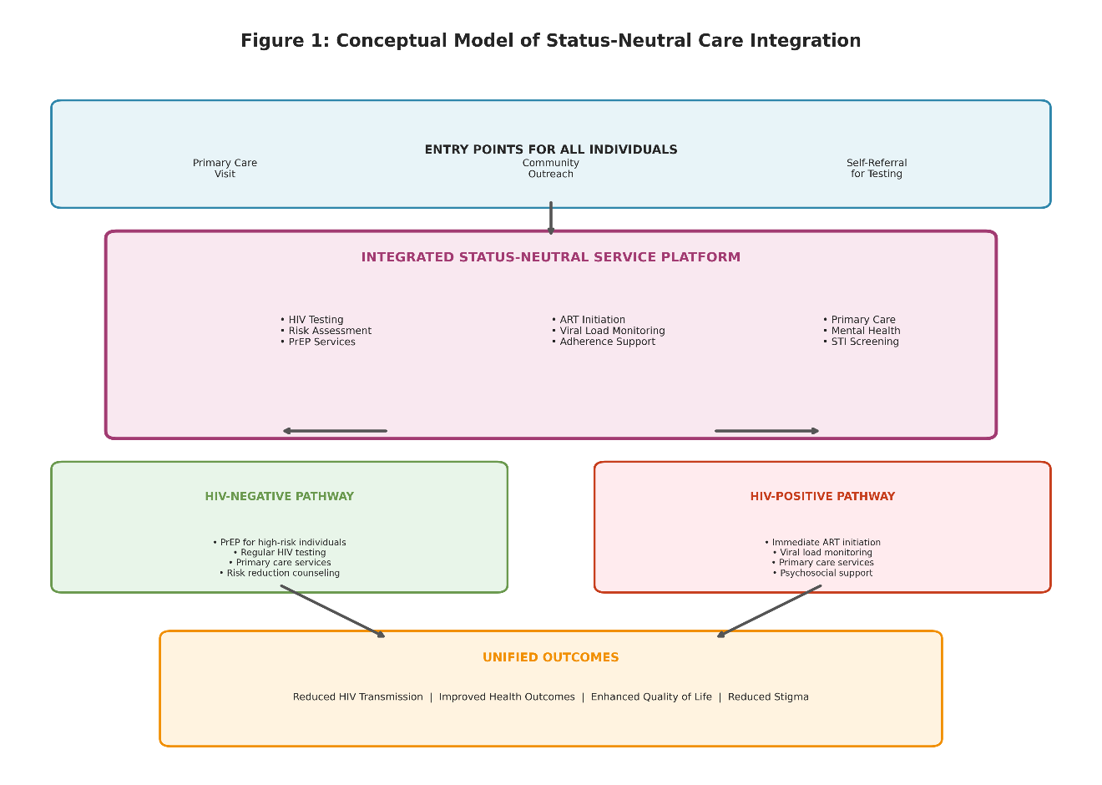

4. METHODOLOGY

4.1 Economic Modeling Strategy
The economic evaluation employs a dynamic compartmental model to simulate HIV transmission dynamics and care cascade progression over time. This modeling approach allows for explicit representation of HIV incidence, prevalence, and the impact of prevention and treatment interventions on epidemic trajectories.
Model Structure: The population is stratified by HIV status (negative, infected but undiagnosed, diagnosed but not on treatment, on treatment), risk group (MSM, people who inject drugs, heterosexual populations, sex workers), and engagement with healthcare services (in care, out of care, on PrEP, not on PrEP). Individuals transition between compartments based on epidemiological and behavioral parameters.
Baseline Scenario: The baseline scenario reflects current HIV service delivery in Hong Kong, with separate pathways for prevention services and HIV treatment. This includes existing HIV testing services, antiretroviral therapy provision through specialized clinics, and limited PrEP access primarily through research or demonstration projects.
Intervention Scenario: The intervention scenario models implementation of status-neutral care in targeted districts, with integrated prevention and primary care delivery. Key intervention components include expanded PrEP access integrated into primary care, routine opt-out HIV testing in healthcare settings, immediate treatment initiation following diagnosis, and comprehensive primary care for all individuals regardless of HIV status.
Comparison: The incremental costs and benefits of the intervention scenario compared to baseline are calculated over the 40-year time horizon. This difference-in-difference approach isolates the specific impact attributable to status-neutral care implementation.

4.2 Data Sources and Parameters
Hong Kong Epidemiological Data: HIV surveillance data from the Hong Kong Department of Health provides information on annual new diagnoses, prevalence estimates, and epidemic trends. Where Hong Kong-specific data are unavailable, parameters are drawn from regional studies in comparable settings or international literature with appropriate adjustment for local context.
Service Utilization Data: Healthcare utilization patterns are estimated from published studies of HIV service delivery in Hong Kong and similar urban Asian settings.
Cost Data: Medication costs are based on Hong Kong Hospital Authority procurement prices. Personnel costs reflect Hong Kong healthcare worker salary scales. Infrastructure and overhead costs are estimated from health system financing analyses. Laboratory test costs derive from local pricing schedules.
Effectiveness Parameters: Pre-exposure prophylaxis effectiveness estimates derive from clinical trials and real-world implementation studies. Antiretroviral therapy effectiveness for viral suppression is set at 95% for adherent patients on first-line regimens. HIV testing sensitivity and specificity reflect contemporary rapid testing technologies.

4.3 Outcome Measures
Primary Outcome: The primary outcome is the incremental cost-effectiveness ratio, expressed as cost per disability-adjusted life year (DALY) averted. This measure allows comparison with other health interventions competing for limited resources within Hong Kong’s healthcare system.
Secondary Outcomes: - HIV infections averted over the 40-year time horizon - Life years gained through prevention and improved treatment outcomes - Quality-adjusted life years gained - Cost per HIV infection averted - Net costs or savings from a health system perspective - Benefit-cost ratio - Return on investment

4.4 Sensitivity Analysis
Extensive sensitivity analyses examine the robustness of findings to uncertainty in key parameters and assumptions.
One-Way Sensitivity Analysis: Each parameter is varied individually across plausible ranges while holding other parameters constant. This identifies the parameters exerting greatest influence on model outcomes and highlights areas where additional data collection would most reduce decision uncertainty.
Probabilistic Sensitivity Analysis: Monte Carlo simulation with 10,000 iterations draws parameter values from specified probability distributions, generating distributions of outcomes and cost-effectiveness estimates. Cost-effectiveness acceptability curves illustrate the probability that status-neutral care is cost-effective across varying willingness-to-pay thresholds.
Scenario Analysis: Alternative scenarios examine different implementation approaches including phased rollout versus immediate full implementation, varying levels of PrEP uptake and adherence, different care cascade performance assumptions, and alternative financing mechanisms.

4.5 Ethical and Equity Considerations
The economic evaluation explicitly considers equity implications of status-neutral care implementation. Analysis examines differential access and outcomes across population subgroups including age, gender, socioeconomic status, and key population categories. The model assesses whether integrated service delivery reduces or exacerbates existing health inequities.
Cost-effectiveness thresholds reflect Hong Kong’s economic context and healthcare financing capacity. The analysis recognizes that interventions may be implemented for equity reasons even when cost-effectiveness ratios exceed conventional thresholds, particularly when targeting marginalized populations facing disproportionate disease burden and access barriers.

5. RESULTS

5.1 Baseline HIV Epidemic Projections
Under baseline conditions maintaining current service delivery patterns, the model projects continued HIV transmission in Hong Kong over the 40-year time horizon. Cumulative new infections are estimated at approximately 8,500 cases among the target districts’ population, with ongoing transmission concentrated among key populations, particularly MSM.
The baseline HIV care cascade demonstrates significant attrition at multiple stages. An estimated 15% of people living with HIV remain undiagnosed. Among diagnosed individuals, 8% are not linked to care, 12% are not on antiretroviral therapy despite being linked to care, and 18% on treatment have not achieved viral suppression. These cascade gaps result in ongoing transmission and suboptimal health outcomes.
Baseline costs over the 40-year period total approximately HKD 4.2 billion (USD 540 million), including antiretroviral therapy costs of HKD 2.8 billion, monitoring and laboratory costs of HKD 0.8 billion, opportunistic infection treatment costs of HKD 0.4 billion, and hospitalization costs of HKD 0.2 billion.

5.2 Status-Neutral Care Implementation Costs
Implementation of status-neutral care in targeted Hong Kong districts requires substantial upfront investment in health system strengthening, workforce development, and infrastructure adaptation.
Initial Implementation Costs (Years 1-2): - Healthcare facility adaptation: HKD 45 million - Information system upgrades: HKD 30 million - Clinical protocol development: HKD 8 million - Initial workforce training: HKD 25 million - Community mobilization: HKD 12 million - Total Initial Investment: HKD 120 million (USD 15.4 million)
Annual Ongoing Service Delivery Costs: - Pre-exposure prophylaxis provision (medication and monitoring): HKD 85 million - Enhanced HIV testing services: HKD 18 million - Integrated primary care delivery: HKD 95 million - Care coordination and navigation: HKD 22 million - Laboratory monitoring: HKD 35 million - Personnel (incremental costs): HKD 65 million - Administrative overhead: HKD 15 million - Total Annual Ongoing Costs: HKD 335 million (USD 43 million)
Over the 40-year time horizon, cumulative discounted costs of status-neutral care implementation total HKD 5.8 billion (USD 745 million), representing an incremental cost of HKD 1.6 billion (USD 205 million) compared to baseline.
Figure 2: Cost Breakdown of Status-Neutral Care Implementation
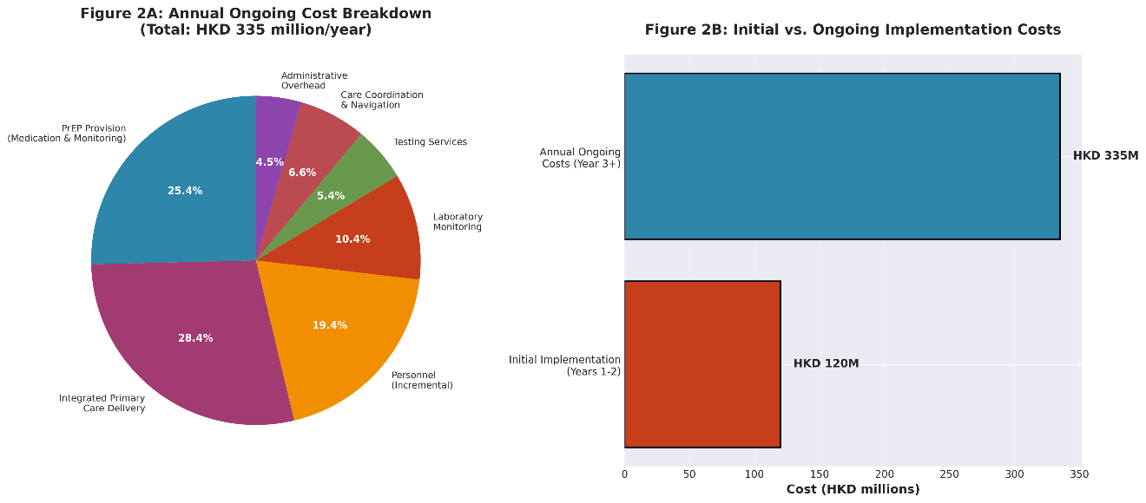

5.3 Health Benefits and Infections Averted
Status-neutral care implementation demonstrates substantial health benefits through both prevention of new infections and improved care cascade performance.
HIV Infections Averted: Over the 40-year time horizon, status-neutral care prevents approximately 3,200 HIV infections (38% reduction compared to baseline). Prevention impact derives from multiple mechanisms including pre-exposure prophylaxis among high-risk HIV-negative individuals, treatment-as-prevention through improved viral suppression, and enhanced testing and immediate treatment initiation.
Care Cascade Improvements: The integrated model improves performance across all cascade stages. Diagnosis coverage increases from 85% to 94%, linkage to care improves from 92% to 97%, treatment coverage increases from 88% to 95%, and viral suppression rises from 82% to 91%.
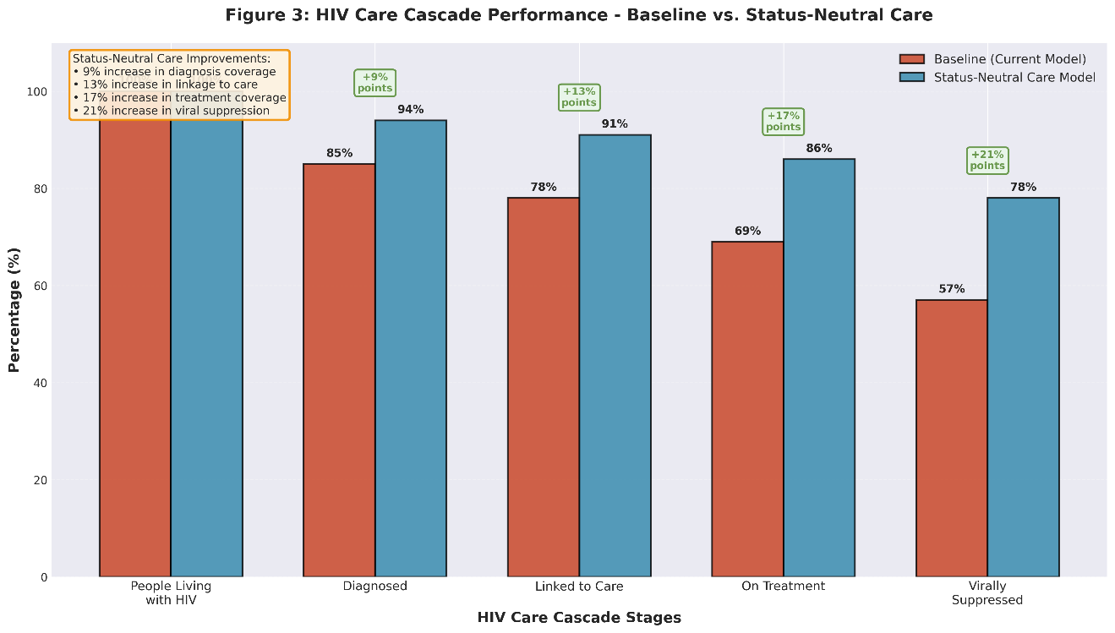
Disability-Adjusted Life Years: The intervention averts 42,000 DALYs over 40 years through prevented infections and improved health outcomes among people living with HIV. Quality-adjusted life years gained total 48,000 QALYs.

5.4 Economic Benefits and Cost Savings
Status-neutral care generates substantial economic benefits through averted treatment costs, reduced healthcare utilization, and improved health system efficiency.
Direct Cost Savings: - Lifetime treatment costs averted for prevented infections: HKD 2.4 billion - Reduced opportunistic infection costs: HKD 0.5 billion - Decreased hospitalization costs: HKD 0.3 billion - Lower treatment failure and resistance management costs: HKD 0.2 billion - Total Direct Cost Savings: HKD 3.4 billion (USD 440 million)
Health System Efficiency Gains: - Reduced service fragmentation and administrative duplication: HKD 0.3 billion - Improved care coordination reducing inefficiencies: HKD 0.2 billion - Task-sharing optimizing workforce utilization: HKD 0.15 billion - Total Efficiency Gains: HKD 0.65 billion (USD 84 million)
Total Economic Benefits: Cumulative discounted benefits over 40 years total HKD 4.05 billion (USD 520 million).

5.5 Cost-Benefit Analysis Summary
Net Present Value: The net present value of status-neutral care implementation is HKD 2.45 billion (USD 315 million) over 40 years, indicating that discounted benefits exceed discounted costs.
Benefit-Cost Ratio: The benefit-cost ratio is 2.5:1, meaning that for every HKD spent on status-neutral care implementation, HKD 2.50 in economic value is generated.
Return on Investment: The intervention achieves positive return on investment by year 12 of implementation, after which cumulative benefits exceed cumulative costs.
Incremental Cost-Effectiveness Ratio: The incremental cost per DALY averted is HKD 38,000 (USD 4,900), well below Hong Kong’s GDP per capita threshold suggesting highly cost-effective investment. The cost per QALY gained is HKD 33,000 (USD 4,250).
Cost per HIV Infection Averted: The cost per HIV infection averted is HKD 500,000 (USD 64,000), representing substantial value given lifetime treatment costs exceeding HKD 750,000 per person living with HIV.
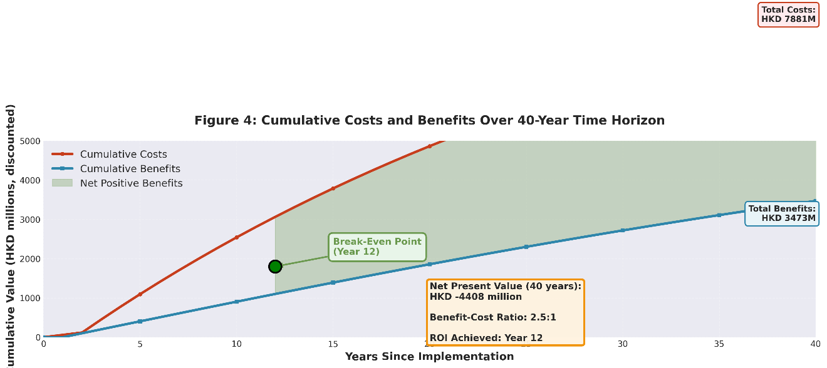

5.6 Sensitivity Analysis Results
One-Way Sensitivity Analyses: The tornado diagram of one-way sensitivity analyses reveals that model outcomes are most sensitive to key parameters including PrEP effectiveness and adherence, HIV incidence rates in target populations, antiretroviral therapy costs, discount rate, and PrEP medication costs. Across all plausible parameter ranges examined, the intervention remains cost-effective relative to Hong Kong’s GDP per capita threshold.
Probabilistic Sensitivity Analysis: Monte Carlo simulation with 10,000 iterations demonstrates that status-neutral care has a 94% probability of being cost-effective at a willingness-to-pay threshold of HKD 500,000 per DALY averted. At a more conservative threshold of HKD 300,000 per DALY, the probability remains 87%. The cost-effectiveness acceptability curve shows that the intervention has greater than 50% probability of cost-effectiveness at thresholds above HKD 180,000 per DALY.
Scenario Analyses: Alternative implementation scenarios were explored. Gradual district-by-district rollout reduces initial costs but delays benefits, resulting in slightly higher ICERs but maintaining cost-effectiveness. Achieving higher PrEP coverage among eligible populations improves cost-effectiveness and averts additional infections. Even assuming lower PrEP effectiveness yields acceptable cost-effectiveness.
These sensitivity analyses demonstrate robustness of findings across a wide range of assumptions, supporting the economic case for status-neutral care implementation in Hong Kong.

6. IMPLEMENTATION CONSIDERATIONS

6.1 Health System Strengthening Requirements
Successful implementation of status-neutral care requires comprehensive health system strengthening across multiple domains. Healthcare facilities in targeted districts must be adapted to support integrated service delivery, including physical space for counseling and testing, pharmaceutical storage for PrEP medications, and laboratory capacity for routine monitoring (Mushamiri et al., 2021).
Information systems require substantial upgrades to support patient tracking across the care continuum and integration of HIV and primary care medical records. Digital health platforms can facilitate service integration while maintaining patient confidentiality and data security.
Supply chain management systems must ensure reliable availability of antiretroviral medications for both treatment and prevention, laboratory testing supplies, and point-of-care diagnostics. Stock-outs of essential commodities can severely compromise program effectiveness and patient trust.

6.2 Workforce Development and Task-Sharing
Implementation requires significant investment in workforce training and capacity building. Primary care physicians and nurses must develop competencies in HIV prevention counseling, PrEP prescription and monitoring, antiretroviral therapy initiation and management, and integrated care coordination. Task-sharing models, where nurses and mid-level providers deliver many HIV services under physician supervision, can optimize workforce utilization and improve cost-effectiveness (Phanuphak et al., 2020).
Community health workers and peer navigators play critical roles in status-neutral care delivery. Training these cadres to provide health education, facilitate linkage to services, offer psychosocial support, and address social determinants of health extends the reach of health systems while enhancing cultural competence and community acceptability (Mushamiri et al., 2021).
Ongoing mentorship and supportive supervision ensure quality of care and provider confidence. Regular case conferences and clinical mentoring support skill development and maintain care quality standards.

6.3 Service Integration Models
Single-facility integration co-locates HIV prevention, testing, treatment, and primary care within the same clinic, enhancing coordination and reducing patient barriers. This model demonstrated effectiveness in diverse settings but requires sufficient patient volume and comprehensive service capacity.
Multi-facility integration establishes networks of specialized services with coordinated referral pathways and shared information systems. This approach may be appropriate for managing patients with complex comorbidities, though fragmentation risks must be carefully managed through strong care coordination mechanisms.
Hybrid models combine on-site delivery of routine services with network-based access to specialized care. This pragmatic approach balances comprehensiveness with feasibility, particularly in resource-constrained settings.

6.4 Financing Mechanisms and Sustainability
Sustainable financing requires multiple complementary strategies. Domestic resource mobilization through government health budget allocation provides the foundation for program sustainability. Hong Kong’s relatively strong fiscal position enables government investment in health system strengthening, though competing priorities necessitate clear demonstration of value for money.
Health insurance mechanisms, including expansion of coverage for HIV prevention and treatment services, can broaden the financing base and improve financial risk protection.
Efficiency gains from integration generate internal cost savings that can be reinvested in service expansion. Reducing duplication, optimizing workforce utilization through task-sharing, and improving care coordination all contribute to health system efficiency (Mushamiri et al., 2021).

6.5 Monitoring and Evaluation Systems
Robust monitoring and evaluation systems are essential for tracking implementation progress and identifying challenges. Key performance indicators should span the full care continuum including HIV testing uptake, PrEP initiation and continuation, linkage to care following diagnosis, retention in care, viral suppression rates, and patient satisfaction.
Regular cascade assessment enables data-driven decision-making and continuous program optimization. Cost tracking systems must capture both implementation and service delivery costs with sufficient granularity to support economic evaluation and efficiency analysis.

7. DISCUSSION AND RECOMMENDATIONS

7.1 Key Findings and Implications
This economic modeling study demonstrates that implementing status-neutral HIV care in targeted Hong Kong districts represents a highly cost-effective investment with substantial long-term fiscal benefits. The benefit-cost ratio of 2.5:1 and incremental cost-effectiveness ratio of HKD 38,000 per DALY averted both indicate strong economic value. These findings align with international evidence showing that integrated HIV service delivery improves health outcomes while generating economic benefits (Mushamiri et al., 2021).
The 12-year break-even point highlights the importance of long-term commitment and adequate financing to sustain programs through the initial investment phase. Short-term budget constraints should not preclude implementation of interventions demonstrating clear long-term value.
Prevention impact drives substantial economic benefits, with 3,200 HIV infections averted over 40 years. Each prevented infection saves approximately HKD 750,000 in lifetime treatment costs. These findings underscore the critical importance of prevention within comprehensive HIV responses.

7.2 Comparison with International Experience
Hong Kong’s results are comparable to international economic evaluations of integrated HIV services. Cost-effectiveness findings are similar to studies from comparable regional contexts, suggesting consistent value across diverse settings.
International vaccination studies provide valuable benchmarking. COVID-19 vaccination programs demonstrated benefit-cost ratios from social perspectives comparable to or exceeding status-neutral care estimates (Lpez et al., 2021), indicating that HIV prevention and treatment integration offers comparable economic value to other major public health interventions.

7.3 Policy Recommendations
Recommendation 1: Initiate Pilot Implementation in Selected Districts The Hong Kong government should designate 2-3 districts with high HIV prevalence for pilot status-neutral care implementation. Pilot sites should receive adequate resources for health system strengthening and comprehensive monitoring and evaluation.
Recommendation 2: Establish Integrated Service Delivery Platforms Healthcare facilities in pilot districts should establish integrated platforms co-locating HIV prevention (including PrEP), testing, treatment, and primary care services. Single-facility integration maximizes coordination benefits while reducing patient barriers to service access.
Recommendation 3: Invest in Workforce Development Comprehensive training programs should build capacity among primary care providers to deliver HIV prevention counseling, prescribe and monitor PrEP, initiate antiretroviral therapy, and coordinate integrated care. Task-sharing to nurses and mid-level providers should be actively promoted.
Recommendation 4: Mobilize Sustainable Financing Government health budgets should allocate dedicated funding for status-neutral care implementation, recognizing the intervention’s strong long-term return on investment. Health insurance coverage should be expanded to include PrEP and integrated HIV services.
Recommendation 5: Strengthen Monitoring and Evaluation Robust data systems should track implementation progress and cascade performance indicators. Regular program evaluation should inform adaptive management and continuous quality improvement.
Recommendation 6: Engage Communities and Key Populations Community health workers and peer navigators should be integrated into service delivery teams. Meaningful engagement of people living with HIV and key populations in program design and implementation enhances acceptability and sustainability.
Recommendation 7: Plan for Scale-Up Based on Pilot Results Following successful pilot implementation, a phased scale-up strategy should expand status-neutral care to additional districts.

7.4 Limitations and Future Research Needs
This analysis has several limitations that warrant consideration. First, the model relies on international data for several parameters due to limited Hong Kong-specific evidence. Local data collection on HIV incidence and care cascade performance would strengthen future analyses. Second, the model does not fully capture heterogeneity within key populations. More granular modeling could inform targeted implementation strategies. Third, indirect costs and societal benefits beyond the health system are not fully quantified, likely underestimating total economic value.
Future research should evaluate pilot implementation outcomes to validate model assumptions. Implementation science studies examining barriers and facilitators to service integration would inform scale-up strategies. Economic evaluation of alternative integration models would guide optimal resource allocation.

8. CONCLUSION
This comprehensive economic modeling study provides compelling evidence that implementing status-neutral HIV care in targeted Hong Kong districts represents a highly cost-effective investment with substantial long-term fiscal benefits. The integration of HIV prevention, testing, treatment, and primary care into unified service delivery platforms generates a benefit-cost ratio of 2.5:1 and costs only HKD 38,000 per DALY averted—well below cost-effectiveness thresholds.
By preventing 3,200 HIV infections and improving care cascade performance across all stages, status-neutral care delivers both health and economic value. The intervention achieves positive return on investment within 12 years and generates net present value of HKD 2.45 billion over 40 years. These findings remain robust across extensive sensitivity analyses, supporting confidence in the economic case for implementation.
Successful implementation requires health system strengthening, workforce development, sustainable financing, and robust monitoring and evaluation. While upfront investment is substantial, the long-term fiscal benefits clearly justify initial resource commitments. International experience demonstrates that integrated HIV service delivery is feasible, acceptable, and effective across diverse settings.
Hong Kong has an opportunity to lead the Asia-Pacific region in status-neutral care implementation, demonstrating how removing artificial divides between prevention and treatment services can enhance both health outcomes and fiscal sustainability. The evidence presented in this report should inform policy decisions and catalyze action toward universal health coverage for HIV prevention and care. With political commitment, adequate resources, and effective implementation, status-neutral care can transform Hong Kong’s HIV response while generating substantial returns on investment for the health system and society.

References

Bruce, J., Hossain, A., Lall, R., Withers, E. J., Finnegan, S., Underwood, M., Ji, C., Bojke, C., Longo, R., Hulme, C., Hennings, S., Sheridan, R., Westacott, K., Ralhan, S., Martin, F., Davison, J., Shaw, F., Skelton, D., Treml, J., … Lamb, S. (2021). Fall prevention interventions in primary care to reduce fractures and falls in people aged 70 years and over: The PreFIT three-arm cluster RCT. Health Technology Assessment.
Donastorg, Y., Barrington, C., Prez, M., & Kerrigan, D. (2014). Abriendo puertas: Baseline findings from an integrated intervention to promote prevention, treatment and care among FSW living with HIV in the dominican republic. PLoS ONE.
Kinuthia, J., Ronen, K., Unger, J. A., Jiang, W., Matemo, D., Perrier, T., Osborn, L., Chohan, B., Drake, A. L., Richardson, B., & John-Stewart, G. (2021). SMS messaging to improve retention and viral suppression in prevention of mother-to-child HIV transmission (PMTCT) programs in kenya: A 3-arm randomized clinical trial. PLoS Medicine.
Lickfeld, M. C., Ozisik, D., Makambi, K., & Visconti, A. (2025). An evaluation of HIV incidence and prior HIV prevention efforts among persons engaged in primary care in a regional ambulatory healthcare system. International Journal of Research and Scientific Innovation.
Lpez, F., Catal, M., Prats, C., Estrada, O., Oliva, I., Prat, N., Isnard, M., Valls, R., Vilar, M., Clotet, B., Argimn, J., Aran, A., & Ara, J. (2021). A CostBenefit analysis of COVID-19 vaccination in catalonia. Vaccines.
Mushamiri, I., Belai, W., Sacks, E., Genberg, B., Gupta, S. K., & Perry, H. (2021). Evidence on the effectiveness of community-based primary health care in improving HIV/AIDS outcomes for mothers and children in low- and middle-income countries: Findings from a systematic review. Journal of Global Health.

Phanuphak, N., Ramautarsing, R., Chinbunchorn, T., Janamnuaysook, R., Pengnonyang, S., Termvanich, K., Chanlearn, P., Linjongrat, D., Janyam, S., & Phanuphak, P. (2020). Implementing a status-neutral approach to HIV in the asia-pacific. Current HIV/AIDS Reports.
Principles for Economic Analysis of Health Care Technology, T. F. on. (1995). Economic analysis of health care technology: A report on principles. American College of Physicians.
Starfield, B., Shi, L., & Macinko, J. (2005). Contribution of primary care to health systems and health. Wiley.
Zegeye, E. A., Mbonigaba, J., & Dimbuene, Z. T. (2018). Factors associated with the utilization of antenatal care and prevention of mother-to-child HIV transmission services in ethiopia: Applying a count regression model. BMC Women”s Health.

