HIV, Cognitive Decline, and Social Support: A Comprehensive Report on HIV-Associated Neurocognitive Disorders (HAND) among Older Adults in Hong Kong

The Hong Kong Aids Prevention Society (HKAPS)

Executive Summary
The global landscape of HIV has transformed dramatically with the advent of combination antiretroviral therapy (cART), converting what was once a fatal illness into a manageable chronic condition. This transformation has resulted in an unprecedented aging population of people living with HIV (PLWH), with nearly half of all HIV-infected individuals in developed regions now aged 50 years or older (Ahmad et al., 2020). However, this demographic success has unveiled a persistent and concerning complication: HIV-associated neurocognitive disorders (HAND), which affect approximately 50% of older adults living with HIV globally despite effective viral suppression (Zenebe et al., 2022).
This comprehensive report examines the multifaceted challenges posed by HAND in older adults, with particular attention to the Hong Kong context. The report synthesizes current evidence on HAND prevalence, explores the critical mediating role of social support in cognitive outcomes, evaluates the bidirectional relationship between cognitive impairment and medication adherence, assesses impacts on independent living, and examines the substantial burden placed on caregivers. The findings reveal that HAND represents a complex interplay of biological, psychological, and social factors that demands integrated, person-centered interventions to optimize outcomes for both patients and their support networks.

1. Epidemiology and Burden of HAND in Older Adults

1.1 Global Prevalence and Regional Variations
HIV-associated neurocognitive disorders remain one of the most prevalent complications of HIV infection in the era of combination antiretroviral therapy. A comprehensive meta-analysis examining global HAND prevalence revealed that approximately 50.41% (95% CI: 45.56-55.26) of people living with HIV experience some form of neurocognitive impairment (Zenebe et al., 2022). This high prevalence persists despite widespread access to effective antiretroviral treatment and viral suppression, suggesting that factors beyond viral replication contribute to cognitive dysfunction in this population.
Regional variations in HAND prevalence demonstrate the influence of demographic, socioeconomic, and healthcare factors on neurocognitive outcomes. In Asia, HAND prevalence reaches 52.03%, slightly higher than the global average, while sub-Saharan Africa reports 49.57%, Europe 50.02%, and the United States 50.41% (Zenebe et al., 2022). These modest regional differences likely reflect variations in study methodologies, screening instruments, and population characteristics rather than true biological differences. Importantly, Sub-Saharan Africa, which bears the greatest burden of HIV globally, shows HAND prevalence comparable to high-income regions, though heterogeneity in measurement approaches complicates direct comparisons (Olajide et al., 2024; Paddick, 2023).
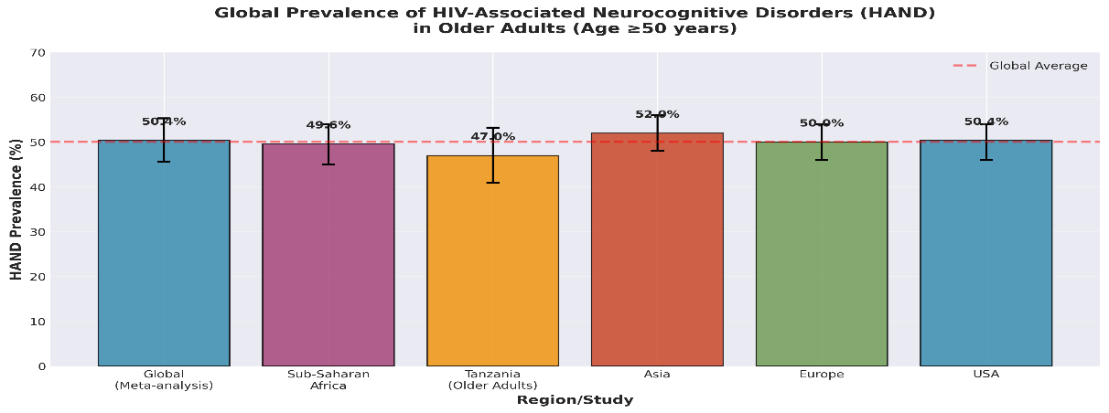
Figure 1: Global prevalence of HIV-associated neurocognitive disorders across different regions and study populations, demonstrating the consistent burden of cognitive impairment in older adults with HIV regardless of geographic location.

1.2 HAND Subtypes and Clinical Presentation in Older Adults
HIV-associated neurocognitive disorders encompass a spectrum of cognitive impairments classified according to Frascati criteria into three categories based on severity and functional impact. In a well-characterized longitudinal cohort of older adults (median age 57 years) in Tanzania, 47% met criteria for HAND despite well-controlled HIV disease (mean CD4 count 516 cells/μL, 95.5% on cART) (Flatt et al., 2021). Among those with HAND, the distribution revealed a predominance of milder forms: asymptomatic neurocognitive impairment (ANI) comprised 25.3%, mild neurocognitive disorder (MND) accounted for 18.2%, and HIV-associated dementia (HAD) represented only 3.6% (Flatt et al., 2021).
This distribution pattern reflects the changing face of HAND in the modern treatment era. While severe dementia has become rare due to effective viral suppression, subtler forms of cognitive impairment persist and can significantly impact daily functioning and quality of life. Longitudinal follow-up of this cohort over three years revealed that HAND status is not static: among fully assessed participants, HAND remained stable in 54%, improved in 15%, and declined in 31% (Spooner et al., 2021). This variability underscores the dynamic nature of cognitive function in aging PLWH and suggests opportunities for intervention to prevent progression.
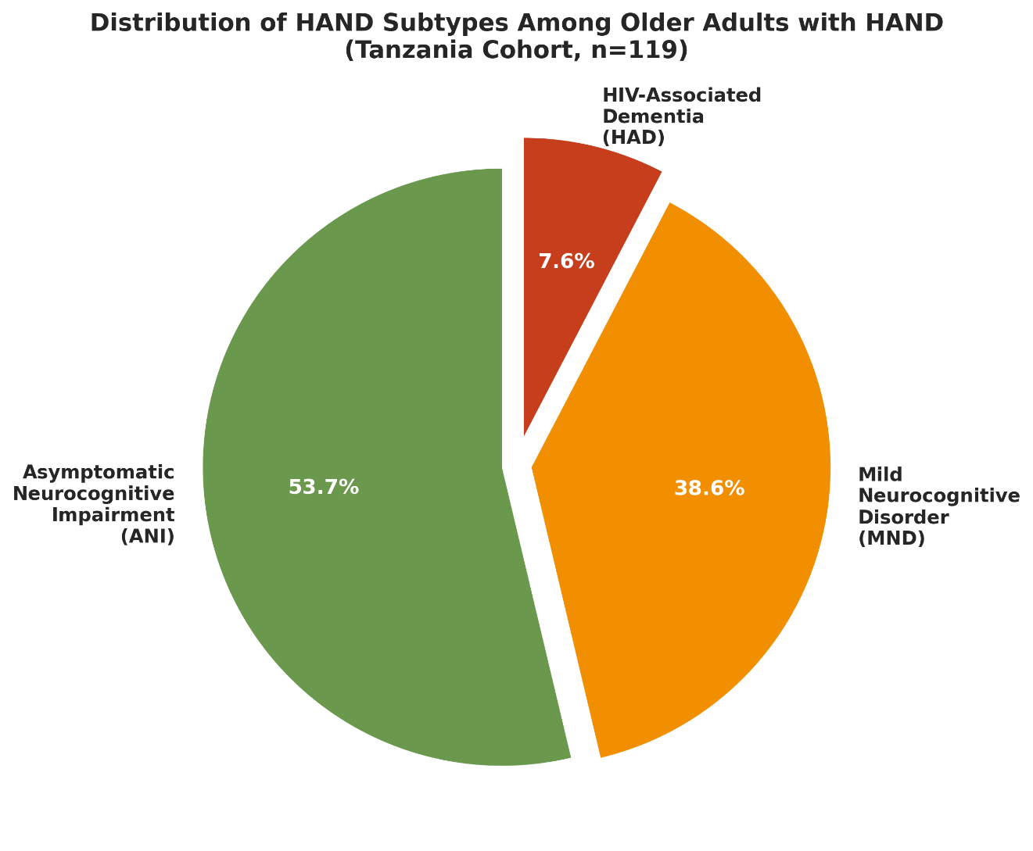
Figure 2: Distribution of HAND subtypes among older adults with HIV-associated neurocognitive disorders, showing the predominance of milder forms (ANI and MND) over severe dementia (HAD) in the modern antiretroviral treatment era.

1.3 One-Year Incidence and Reversibility
Beyond prevalence, incidence data provide crucial insights into the dynamic nature of cognitive function in older PLWH. The one-year incidence of HAND among older adults in Tanzania was remarkably high at 37.2% (95% CI: 25.9-51.8), indicating that a substantial proportion of individuals with initially normal cognition developed impairment over a 12-month period (Flatt et al., 2021). This high incidence rate raises concerns about the progressive nature of cognitive decline in this population and highlights the urgent need for regular cognitive screening and preventive interventions.
Importantly, HAND demonstrated some degree of reversibility, with 17.6% (95% CI: 10.0-28.6) of individuals showing improvement in cognitive status over one year (Flatt et al., 2021). This finding challenges the traditional view of HAND as an irreversibly progressive condition and suggests that modifiable factors contribute to cognitive fluctuations. Potential contributors to improvement may include optimization of antiretroviral regimens, treatment of comorbid conditions such as depression, enhancement of social support, and cognitive rehabilitation interventions. The reversibility observed in this cohort provides hope and justification for comprehensive interventions targeting multiple pathways to cognitive health.

1.4 Risk Factors for HAND Development and Progression
Identification of risk factors for HAND is essential for targeting preventive interventions and understanding pathogenic mechanisms. Multiple studies converge on several consistent risk factors across diverse populations. Sociodemographic factors play a substantial role: older age consistently predicts HAND, with individuals aged 65 years or older showing nearly four times the odds of cognitive impairment compared to younger adults (OR: 3.98, 95% CI: 3.56-4.44) (Boonyagars et al., 2022). Educational attainment demonstrates a particularly strong protective effect, with individuals lacking formal education showing dramatically elevated risk compared to those with secondary education (OR: 16.46, 95% CI: 11.31-23.97 for no education) (Nyundo, 2023). This education effect likely reflects cognitive reserve—the brain’s capacity to maintain function despite pathological changes (M et al., 2023).
HIV-specific clinical factors also contribute significantly to HAND risk. Low CD4 count (<500 cells/μL) increases odds of cognitive impairment (OR: 1.61, 95% CI: 1.45-1.79) (Zenebe et al., 2022), suggesting that immune compromise, even at levels considered acceptable for general health, may affect brain function. Advanced HIV disease stage and history of opportunistic infections further elevate risk (Nyundo, 2023). Importantly, in longitudinal analyses of older African adults, progression of HAND over three years was significantly predicted by older age and lower education, but not by HIV-specific factors such as CD4 count or viral load (Spooner et al., 2021). This finding suggests that in well-treated populations, cognitive reserve factors may be more important determinants of cognitive trajectories than HIV disease severity.
Psychiatric comorbidities, particularly depression, substantially increase HAND risk (OR: 1.32, 95% CI: 1.21-1.43) (Zenebe et al., 2022). The relationship between depression and cognitive function is complex and likely bidirectional, with depressive symptoms both resulting from and contributing to cognitive decline. Gender also appears to influence HAND risk, with females showing elevated odds (OR: 2.7, 95% CI: 1.6-4.5) compared to males in some studies (Nyundo, 2023), though this finding is not universal across all cohorts. These gender differences may reflect biological factors, psychosocial stressors, or differential access to healthcare resources.
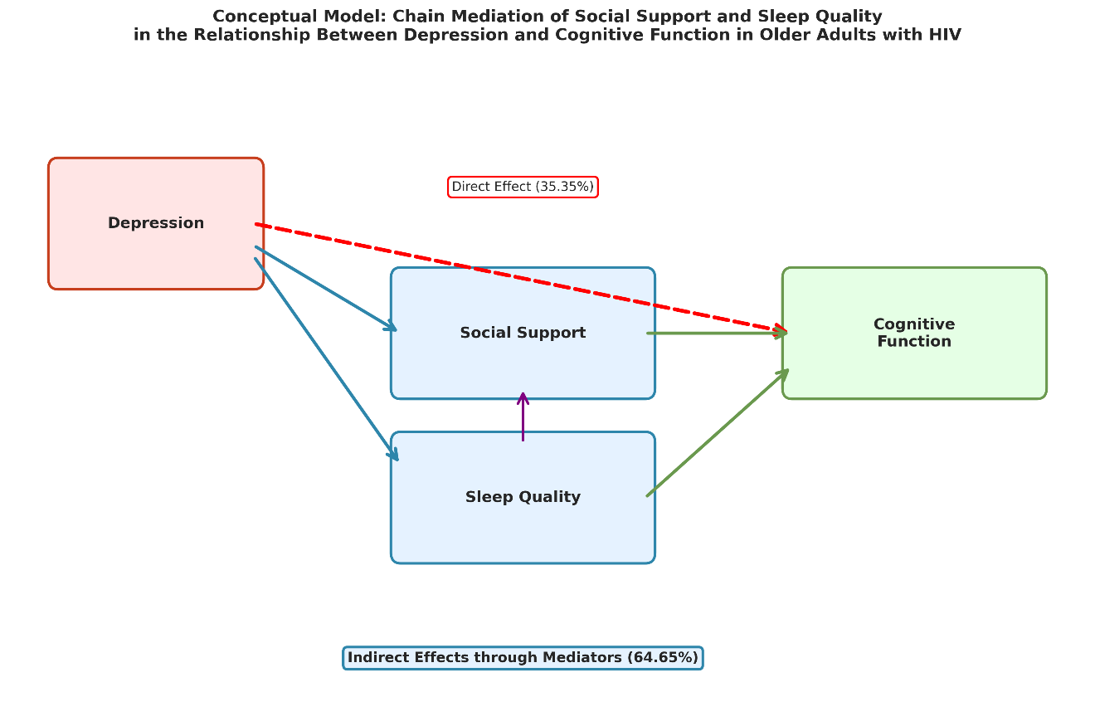
Figure 4: Major risk factors associated with HIV-associated neurocognitive disorders in older adults, showing adjusted odds ratios with 95% confidence intervals. Educational attainment and advanced age emerge as particularly strong predictors.

2. The Critical Role of Social Support in Cognitive Health

2.1 Social Support as a Protective Factor Against Cognitive Decline
Social support emerges as a crucial modifiable factor influencing cognitive outcomes in older adults living with HIV. A groundbreaking study from China examining 9,394 older adults in the Chinese Longitudinal Healthy Longevity Survey demonstrated that each one-point increase in social support score was associated with a 4.4% reduction in the hazard of incident cognitive impairment (HR: 0.956, 95% CI: 0.932-0.980) (Ma et al., 2024). This protective effect operates through multiple mechanisms, including facilitation of cognitive activity, reduction of psychological distress, and promotion of healthy behaviors. The study further revealed that cognitive activity itself serves as a mediator, accounting for 11.4-12.6% of the total association between social support and cognitive function (Ma et al., 2024).
The protective effects of social support are not uniform across all types and sources. A systematic review of 85 studies examining functional social support and cognitive function in middle- and older-aged adults found that emotional support showed particularly strong associations with preserved cognition (Mogic et al., 2023). Social engagement with neighbors and friends demonstrated protective effects against cognitive decline in Japanese older adults, with a one-year prospective study showing that support exchanges with neighbors and friends, but not family members, were associated with better Montreal Cognitive Assessment scores at follow-up (Noguchi et al., 2019). This finding suggests that diverse social networks extending beyond immediate family may be particularly valuable for cognitive health.
In the specific context of HIV, a Chinese cross-sectional study revealed complex chain mediation effects linking social support to cognitive function (Li et al., 2025). The study found that social support and sleep quality together mediated 64.65% of the relationship between depression and cognitive function in older adults with HIV. Social support exerted its beneficial effects both directly on cognition and indirectly through improvement of sleep quality and reduction of depressive symptoms. These findings highlight the multidimensional pathways through which social connections influence brain health and suggest that interventions enhancing social support networks may yield cognitive benefits through multiple mechanisms.

2.2 Mechanisms Linking Social Support to Cognitive Outcomes
The mechanisms through which social support influences cognitive function in older adults with HIV are multifaceted and operate at biological, psychological, and behavioral levels. At the biological level, robust social support has been associated with reduced systemic inflammation and improved immune function (Ahmad et al., 2020), both of which may protect against HIV-related neurological damage. Social isolation, conversely, triggers inflammatory responses and hypothalamic-pituitary-adrenal axis activation that can accelerate cognitive decline (Courtin & Knapp, 2015).
Psychologically, social support buffers against the adverse effects of stress and depression on cognitive function. Depression accounts for a substantial portion (47.7%) of variance in cognitive function among older adults with HIV (Li et al., 2025). When social support and sleep quality variables are incorporated into models, this increases to 65.7%, demonstrating the substantial explanatory power of these psychosocial factors (Li et al., 2025). Social support reduces psychological distress through providing emotional validation, practical assistance, and sense of belonging, all of which mitigate the cognitive effects of depressive symptoms.
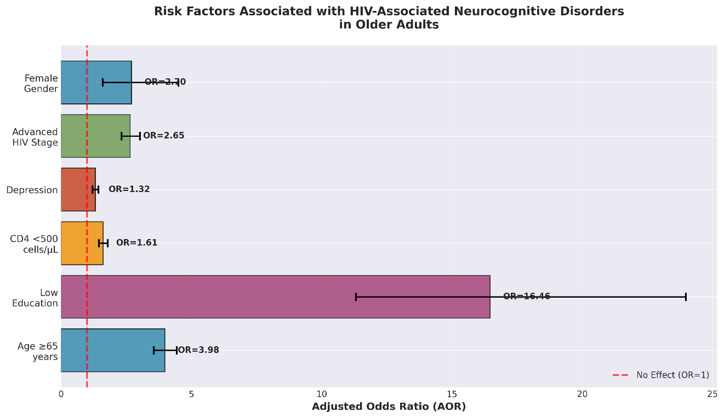
Figure 3: Conceptual model illustrating the chain mediation effect of social support and sleep quality in the relationship between depression and cognitive function among older adults living with HIV. The model demonstrates both direct effects (35.35%) and substantial indirect effects through mediators (64.65%).
Behaviorally, social support promotes engagement in cognitively stimulating activities, which builds cognitive reserve. Individuals with higher social support demonstrate increased participation in cognitive activities such as reading, social games, and intellectual discussions (Ma et al., 2024). These activities strengthen neural networks and enhance the brain’s capacity to maintain function despite pathological challenges. Furthermore, social support facilitates better health behaviors, including medication adherence, regular medical follow-up, and healthier lifestyle choices, all of which contribute to better cognitive outcomes (Ahmad et al., 2020).

2.3 Types and Sources of Social Support
Not all social support is equivalent in its cognitive benefits, and understanding the specific types and sources most beneficial for older adults with HIV can inform targeted interventions. Social support can be categorized into structural aspects (network size, frequency of contact) and functional aspects (emotional support, instrumental support, informational support). A comprehensive systematic review found that functional social support, particularly emotional and overall support, showed stronger associations with cognitive function than structural network measures alone (Mogic et al., 2023).
Among older Chinese adults, different sources of social support showed varying relationships with cognitive outcomes. Intergenerational financial transfers from children, perceived availability of future support, and pension income were all associated with higher baseline cognitive function, while living with others and pension income predicted slower rates of cognitive decline (Peng et al., 2022). Interestingly, children’s visits showed the most consistent protective effect against incident cognitive impairment, with regular visits from adult children reducing risk by approximately 20% (SHR: 0.808, 95% CI: 0.669-0.975) (Yin et al., 2020).
In the context of HIV specifically, informal social support from family and community appears crucial. Older adults with HIV face unique challenges related to stigma and disclosure concerns that may limit their ability to access support from broader social networks. Those who perceive high availability of social support despite HIV status demonstrate better cognitive outcomes and lower rates of progression to cognitive impairment (Zhang et al., 2024). This suggests that addressing HIV-related stigma and fostering supportive environments where PLWH feel comfortable disclosing their status may enhance cognitive protection.

2.4 Social Isolation Versus Loneliness: Differential Effects
Important distinctions exist between objective social isolation (lack of social contacts and interactions) and subjective loneliness (perceived disconnection from others). A large Chinese study (N=7,761) with longitudinal follow-up found that social isolation, but not loneliness, independently predicted cognitive decline after controlling for chronic diseases, health behaviors, and depressive symptoms (Yu et al., 2020, 2021). Social isolation was associated with decreases in both episodic memory (β = -0.05, p < 0.001) and mental status (β = -0.03, p < 0.01) at follow-up, even after controlling for loneliness and all confounding variables.
These findings suggest that the objective presence of social connections and activities may be more important for cognitive health than subjective feelings of connectedness. The mechanisms likely involve the cognitive stimulation inherent in social interactions, the structured activities that social engagement requires, and the information exchange that occurs through social networks. Interventions should therefore focus not only on addressing feelings of loneliness but also on actively increasing social contacts, community participation, and meaningful social roles for older adults with HIV.

3. Medication Adherence: A Bidirectional Challenge

3.1 Impact of Cognitive Impairment on Antiretroviral Adherence
Medication adherence represents a critical challenge at the intersection of cognitive function and HIV disease management. Optimal adherence to antiretroviral therapy (≥95% of prescribed doses) is essential for achieving and maintaining viral suppression, preventing drug resistance, and optimizing long-term health outcomes. However, cognitive impairment significantly undermines this adherence, creating a vicious cycle where poor cognition leads to suboptimal treatment, which in turn may worsen both HIV-related and cognitive outcomes.
A prospective study of adults aged 65 years and older with HIV found that both the Executive Clock-Drawing Task (CLOX-1) and the Grooved Pegboard Test were significantly related to medication adherence measured objectively using electronic monitoring caps (Caballero et al., 2018). The Grooved Pegboard, which assesses psychomotor speed and fine motor control, showed a particularly strong association with adherence (R = 0.514), demonstrating that both executive function and motor abilities contribute to the capacity to manage complex medication regimens. This relationship remained significant even after controlling for age, education, depression, and substance use (Hinkin et al., 2004).
Importantly, older age itself is generally associated with better medication adherence in HIV populations; however, when cognitive impairment is present, this protective effect of age is reversed (Hinkin et al., 2004). Cognitively impaired older adults show disproportionate difficulty adequately adhering to their medication regimens compared to their cognitively intact age-matched peers. This finding highlights that chronological age alone does not determine adherence capacity; rather, cognitive and functional status are the critical determinants. Vision loss, physical limitations, and polypharmacy—all common in older adults—further compound adherence challenges, particularly when cognitive impairment is present (Burgess et al., 2015).

3.2 Specific Cognitive Domains Affecting Medication Management
Different cognitive domains contribute uniquely to the complex task of medication self-management. Prospective memory—the ability to remember to perform intended actions at the appropriate time—is particularly critical for medication adherence. Older adults with HAND demonstrate moderate deficits in time-based prospective memory tasks, which directly parallel the requirement to remember to take medications at scheduled times (Matchanova et al., 2020). Individuals with HAND who spontaneously employed compensatory mnemonic strategies during laboratory testing of prospective memory showed better performance, and importantly, their strategy use in the laboratory was associated with more frequent use of general mnemonic strategies in daily life and specifically with internal prospective memory strategies for medication adherence (Matchanova et al., 2020).
Executive functions, including planning, organization, problem-solving, and cognitive flexibility, are essential for managing complex antiretroviral regimens, especially those requiring multiple medications with varying dosing schedules and food requirements. A cross-sectional study of older adults with heart failure found that cognitive impairment was associated with increased prevalence of inability to read pill bottle labels (prevalence ratio: 5.8, 95% CI: 3.2-10.5), inability to open safety caps (prevalence ratio: 3.3, 95% CI: 1.3-8.4), and more pill allocation errors (Howell et al., 2017). Among those with cognitive impairment, knowledge-based mistakes (reflecting misunderstanding of medication instructions) were significantly more common (75% vs 40%, p = 0.03), indicating that cognitive deficits impair not just memory but also comprehension and application of medication information.
Working memory and attention are required to track which medications have been taken, manage interruptions during medication administration, and coordinate medication-taking with other daily activities. Processing speed affects the time required to complete medication-related tasks and may influence whether individuals can efficiently manage their regimens within the context of busy daily schedules. The multifactorial nature of medication adherence explains why global cognitive impairment, rather than deficits in a single domain, most strongly predicts adherence difficulties.

3.3 Barriers and Facilitators for Adherence in Cognitively Impaired Older Adults
Beyond cognitive factors, multiple barriers complicate medication adherence in older adults with HIV and cognitive impairment. Physical barriers include arthritis limiting ability to open containers, visual impairment affecting reading of labels, and swallowing difficulties with large pills. Practical barriers encompass cost of medications, transportation difficulties accessing pharmacy refills, and medication storage requirements. Psychosocial barriers include depressive symptoms reducing motivation for self-care, stigma preventing disclosure and social support, and lack of trust in healthcare providers (Burgess et al., 2015).
Older adults with HIV and cognitive impairment may have lower expectations of their overall health status, contributing to therapeutic nihilism where they believe treatment is unlikely to help (Burgess et al., 2015). Depression and financial concerns, particularly among those on fixed incomes, further undermine adherence motivation. Polypharmacy for multiple comorbid conditions creates complexity and confusion, increasing cognitive demands for medication management. Drug-drug interactions between antiretrovirals and medications for age-related comorbidities must be carefully managed to avoid both therapeutic failure and adverse effects.
Facilitators of adherence include use of pill organizers and electronic reminder systems, though these tools require intact cognitive function to use effectively (Patel et al., 2022). Simplified once-daily regimens reduce cognitive burden compared to multiple daily doses. Social support from family members or caregivers who can provide reminders, assist with pill organization, and monitor adherence significantly improves medication-taking (Knight et al., 2018). Healthcare system factors including accessible pharmacy services, integrated care models, and regular monitoring also facilitate adherence. Some studies have explored technology-based interventions such as smartphone applications and electronic pill boxes with reminder alarms, which show promise but require adequate technological literacy (Weakley et al., 2021).

3.4 Interventions to Enhance Adherence in This Population
Given the documented challenges, targeted interventions to enhance medication adherence in older adults with HIV and cognitive impairment are urgently needed. Behavioral interventions incorporating multiple components appear most effective. Psychoeducation programs that provide information about medications using clear language, visual aids, and repetition can improve knowledge and adherence even in those with mild cognitive impairment (Domingues et al., 2018). Teaching compensatory mnemonic strategies—such as visualization, association techniques, and environmental cues—may help individuals with HAND support their prospective memory for medication-taking (Matchanova et al., 2020).
Involving caregivers or family members in adherence support shows promise, though evidence specifically targeting older adults with HIV and cognitive impairment remains limited (Knight et al., 2018). Caregivers can assist with medication organization, provide reminders, and identify early signs of confusion or non-adherence. However, such approaches must be balanced against patient autonomy and the potential for caregiver burden, particularly when caregivers are themselves older adults (Corra et al., 2023).
Technology-based interventions offer potential for scalable adherence support. Electronic reminder systems, video-directly observed therapy, and smartphone applications can provide timely prompts and track adherence patterns (NahumShani et al., 2016). However, digital literacy varies widely among older adults, and cognitive impairment may limit ability to learn and use new technologies. Simplified interfaces, hands-on training, and ongoing technical support are necessary for successful implementation in this population. Adaptive interventions that adjust reminder intensity and content based on individual adherence patterns may optimize effectiveness while minimizing burden.
Pharmacological strategies to simplify regimens can reduce cognitive demands. Single-tablet regimens combining multiple antiretrovirals into one daily pill significantly improve adherence compared to multi-pill regimens (Burgess et al., 2015). Long-acting injectable antiretrovirals, which require administration only monthly or every two months, eliminate daily adherence requirements entirely and show promise for individuals with cognitive impairment, though real-world data in older adults remain limited. Selection of antiretroviral regimens should consider cognitive effects of individual drugs; efavirenz, for example, is associated with neuropsychiatric adverse effects and may exacerbate cognitive symptoms (Treisman & Kaplin, 2002).
Table 1: Evidence-Based Strategies to Enhance Medication Adherence in Older Adults with HIV and Cognitive Impairment

Strategy Category | Specific Interventions | Evidence Level | Key Considerations
Regimen Simplification | Single-tablet regimensOnce-daily dosingLong-acting injectables | High | First-line strategy; reduces cognitive burdenConsider drug interactions with comorbid medications
Cognitive Aids | Pill organizersElectronic reminder systemsSmartphone applications | Moderate | Effectiveness depends on severity of impairmentMay require caregiver assistance to set up
Caregiver Support | Family/friend medication monitoringHome health nursing visitsPeer support programs | Moderate | Balance support with autonomyMonitor for caregiver burden
Behavioral Interventions | PsychoeducationMnemonic strategy trainingMotivational interviewing | Moderate | Adapt content for cognitive levelUse repetition and visual aids
Healthcare System | Integrated care modelsPharmacy synchronizationAutomated refill programs | Moderate | Reduce logistical barriersCoordinate with primary care
Environmental Modification | Medication storage optimizationRoutine linkage to daily activitiesVisual cue placement | Low | Individualize to patient’s living situationInvolve occupational therapy
Evidence levels based on systematic reviews and randomized controlled trials available in the literature (Kardas et al., 2013; Langebeek et al., 2014).

4. Independent Living and Functional Capacity

4.1 Impact of HAND on Activities of Daily Living
The ultimate consequence of cognitive impairment is its effect on an individual’s capacity to function independently in daily life. Activities of daily living (ADL) encompass basic self-care tasks such as bathing, dressing, eating, and toileting, while instrumental activities of daily living (IADL) include more complex tasks requiring higher cognitive function such as managing finances, shopping, meal preparation, medication management, and using transportation. HAND significantly impairs both domains, with particularly pronounced effects on IADL (Malaspina et al., 2010).
A cross-sectional study in Tanzania utilizing the Lawton Instrumental Activity of Daily Living scale found that individuals with HAND demonstrated significantly poorer IADL performance compared to those without cognitive impairment (Nyundo, 2023). The hierarchical nature of functional decline means that IADL impairments typically precede basic ADL deficits, serving as early markers of functional compromise. Specific IADL domains affected in HAND include telephone use, financial management, medication administration, and transportation navigation—all tasks requiring executive function, memory, and processing speed that are commonly impaired in HAND.
Among older adults who successfully aged with HIV (defined as absence of neurocognitive deficits and functional complaints), only 32% of a cohort of middle-aged individuals (mean age 51 years) with longstanding HIV met these criteria (Malaspina et al., 2010). Those with successful cognitive aging demonstrated superior abilities related to medication management and dealing with healthcare providers, highlighting the real-world functional significance of preserved cognition. Conversely, even mild cognitive impairment without functional impairment (asymptomatic neurocognitive impairment) has been associated with increased risk of future functional decline, underscoring the importance of early detection and intervention (Morgan et al., 2012).

4.2 Employment, Social Participation, and Quality of Life
Beyond basic functional capacity, HAND affects domains critical for quality of life including employment, social participation, and independent living arrangements. Older adults with HIV already face employment discrimination related to age and HIV status; when cognitive impairment is added, competitive employment becomes increasingly difficult. Neurocognitive impairment predicts unemployment even when accounting for other health factors, and among employed individuals, HAND is associated with poorer work performance and increased risk of job loss (Woods et al., 2009).
Social participation—engagement in community activities, maintenance of friendships, participation in leisure and recreational activities—is essential for psychological well-being and quality of life. Cognitive impairment creates a barrier to social engagement through multiple pathways: difficulty remembering social commitments, challenges navigating transportation to social venues, reduced conversational abilities due to language and executive deficits, and secondary social withdrawal due to embarrassment or awareness of cognitive difficulties (Mayo et al., 2021). This social isolation further accelerates cognitive decline, creating a self-perpetuating cycle.
Quality of life is significantly reduced in older adults with HIV and cognitive impairment (Ahmad et al., 2020). Health-related quality of life encompasses physical health, mental health, social functioning, and role functioning domains. HAND affects all these dimensions: physical health through difficulty managing medical care, mental health through depression and anxiety, social functioning through reduced social participation, and role functioning through employment and relationship difficulties. Interventions addressing cognitive function must therefore consider these broader quality of life impacts and aim for holistic improvement rather than isolated cognitive gains.

4.3 Driving and Mobility
Driving represents a particularly complex IADL with significant safety implications, requiring integration of visual-perceptual abilities, motor coordination, attention, processing speed, and executive function. Older adults with HIV and cognitive impairment demonstrate impairments in driving-relevant cognitive abilities including psychomotor speed and executive function (Vance et al., 2023). While speed of processing training has shown benefits for driving performance in healthy older adults, similar training in those with HAND showed limited transfer to broader cognitive domains or functional outcomes (Vance et al., 2023).
Driving cessation has profound consequences for older adults, including increased social isolation, depression, and reduced access to healthcare services. For older PLWH who rely on personal transportation to access HIV care, loss of driving privileges can threaten continuity of care and viral suppression. Conversely, continued driving despite significant cognitive impairment poses safety risks to the individual and community. Comprehensive geriatric assessment including cognitive screening, physical evaluation, and consideration of driving history should guide individualized recommendations about driving safety (Sangarlangkarn & Appelbaum, 2020).
Alternative transportation options become essential when driving cessation is necessary. Public transportation may be challenging for individuals with cognitive impairment who must navigate routes, transfers, and schedules. Ride-sharing services require smartphone use and may be cognitively demanding. Community transportation programs for seniors and disabled individuals offer promise but have limited availability in many regions. Addressing mobility needs is essential to prevent the social isolation and healthcare access barriers that follow driving cessation.

4.4 Living Arrangements and Care Needs
As functional impairment progresses, the feasibility of independent living diminishes, and more supportive living arrangements may become necessary. The majority of older adults with HIV live in community settings rather than institutional care, and most prefer to age in place in their own homes (Mayo et al., 2021). However, HAND can compromise safety of independent living through risks such as forgetting to turn off stoves, mismanaging medications, difficulty responding to emergencies, and vulnerability to financial exploitation.
Assessment of capacity for independent living requires comprehensive evaluation of cognitive function, physical abilities, social support, and environmental safety. Occupational therapy evaluation can identify hazards in the home environment and recommend modifications to enhance safety and function. Home care services including medication management assistance, meal delivery, and personal care support can enable continued community living for those with mild to moderate impairment. For individuals with more severe impairment, assisted living facilities offering structured support and supervision may be necessary, though stigma related to HIV may limit acceptance in some facilities.
Planning for future care needs through advance care planning is particularly important for older PLWH, who may lack traditional family support structures (Ahmad et al., 2020). Legal documents including durable power of attorney for healthcare and financial decisions, living wills specifying preferences for life-sustaining treatment, and documentation of a designated healthcare proxy can ensure that individual preferences guide care even if decision-making capacity is lost. Healthcare providers should initiate these conversations early, before cognitive impairment precludes meaningful participation in advance care planning.

5. Caregiver Burden and Support Needs

5.1 Magnitude and Dimensions of Caregiver Burden
Informal caregivers—typically family members or friends who provide unpaid assistance—play an indispensable role in supporting older adults with HIV and cognitive impairment. However, this caregiving exacts substantial personal costs, creating multidimensional burden encompassing physical strain, emotional distress, financial hardship, social isolation, and role conflict. A study of informal caregivers for older adults with cognitive impairment found that caregivers for those with signs of cognitive impairment reported significantly higher burden (measured by Zarit Burden Interview) and perceived stress compared to caregivers for cognitively intact older adults (Corra et al., 2023).
The specific challenges of caregiving for individuals with HAND include managing medication regimens, coordinating medical appointments, monitoring for complications, providing assistance with IADL and potentially ADL, and coping with neuropsychiatric symptoms such as apathy, irritability, and disinhibition (Nemcikova et al., 2023). When HIV-related stigma is present, caregivers may face additional stressors related to confidentiality concerns, limited ability to seek support from broader social networks, and potential discrimination (Ahmad et al., 2020). Caregiver burden in the context of HIV and cognitive impairment is not uniform; rather, it varies based on multiple factors including severity of impairment, caregiver characteristics, quality of the caregiver-care recipient relationship, and availability of external support.
Research examining caregiver burden across different care needs profiles found that caregivers for older adults with unmet social and memory needs reported the highest levels of strain (Sung & Chan, 2022). This suggests that the inability to adequately address care recipients’ needs, rather than simply the presence of needs, drives caregiver burden. Conversely, when needs are being met—even if numerous—caregiver burden may be more manageable. This finding has important implications for intervention design: providing resources that enable caregivers to effectively meet care recipients’ needs may be more effective than simply reducing the number of tasks required.

5.2 Predictors of Caregiver Burden
Multiple factors influence the magnitude of burden experienced by caregivers of older adults with HIV and cognitive impairment. Care recipient characteristics including severity of cognitive impairment, presence of behavioral disturbances, and degree of functional dependence consistently predict higher caregiver burden (Sung et al., 2023). Caregivers for individuals with severe health impairments (defined by multiple comorbidities, greater functional limitations, and poorer overall health status) are significantly more likely to report high levels of burden compared to those caring for less impaired individuals (Sung et al., 2023).
Caregiver characteristics also matter substantially. Caregivers who are themselves older adults face compounded challenges, as they may have their own health limitations that reduce caregiving capacity (Corra et al., 2023). The study found that aged caregivers of older adults with cognitive impairment were older, had lower schooling levels, and provided more hours of daily care compared to caregivers of those without cognitive impairment—all factors associated with higher caregiver burden (Corra et al., 2023). Caregiver gender influences burden, with female caregivers comprising 81.7% of informal caregivers and often experiencing higher burden than male caregivers (Nemcikova et al., 2023).
The relationship between caregiver and care recipient affects burden and caregiving outcomes. Spousal caregivers often experience high burden due to the totality of care responsibility and the emotional impact of watching a partner decline, yet they may demonstrate strong commitment to caregiving rooted in relationship history (Nemcikova et al., 2023). Adult child caregivers may experience role conflict between caregiving, employment, and raising their own families, leading to stress from competing demands. Non-family caregivers such as friends may have more flexibility to withdraw from caregiving if burden becomes excessive, potentially leading to care discontinuity.

5.3 Protective Factors: Social Support and Positive Aspects of Caregiving
Despite significant challenges, many caregivers identify positive aspects of the caregiving experience and demonstrate resilience in the face of adversity. Perceived social support emerges as a critical protective factor against caregiver burden. A study of caregivers for older adults with dementia found that higher perceived social support was significantly associated with lower caregiving burden (β = -0.33, p < 0.01) (Nemcikova et al., 2023). This protective effect operates through multiple mechanisms: social support provides practical assistance that reduces task load, offers emotional validation that buffers psychological distress, and creates opportunities for respite and self-care.
Positive aspects of caregiving—including feelings of personal growth, strengthened relationships with care recipients, sense of purpose and meaning, and satisfaction from helping a loved one—also buffer against burden. Caregivers who report higher scores on the Positive Aspects of Caregiving scale experience lower burden (β = -0.33, p < 0.01) even when controlling for care recipient characteristics and caregiving intensity (Nemcikova et al., 2023). Fostering recognition and cultivation of positive caregiving experiences through caregiver support programs may enhance resilience and reduce burden.
Interestingly, while social support for caregivers themselves is crucial, the social support received by care recipients also affects caregiver well-being. When older adults with cognitive impairment have good perceived social support, their caregivers demonstrate significantly higher competence and self-efficacy at three months post-assessment, with effects sustained over 12 months (Tseng et al., 2025). This finding suggests that interventions enhancing care recipients’ social support networks may yield dual benefits: direct benefits for care recipients’ health and indirect benefits for caregivers through reduced demands and enhanced mastery.

5.4 Interventions to Reduce Caregiver Burden
Given the substantial burden faced by caregivers of older adults with HIV and cognitive impairment, development and implementation of evidence-based interventions to support caregivers is a clinical and public health imperative. A systematic review examining nonpharmacological interventions to reduce burden and psychological symptoms in caregivers of individuals with mild cognitive impairment identified several promising approaches (Domingues et al., 2018). Cognitive interventions for care recipients, such as calendar training and note-taking skills, significantly decreased caregivers’ depressive symptoms and prevented worsening of subjective burden six months post-treatment (Domingues et al., 2018). This demonstrates that interventions targeting care recipients’ function can have spillover benefits for caregivers.
Educational interventions providing caregivers with information about HIV, cognitive disorders, disease progression, and caregiving strategies reduce burden through enhancing caregivers’ understanding, setting realistic expectations, and building competence (Domingues et al., 2018). A combination of educational material with problem-solving therapy reduced caregiver depressive symptoms at three months post-treatment (Domingues et al., 2018). Problem-solving therapy equips caregivers with skills to identify challenges, generate potential solutions, implement action plans, and evaluate outcomes—capabilities that enhance self-efficacy and reduce feelings of helplessness.
Psychosocial interventions including caregiver support groups, respite care, and counseling services address the emotional and social toll of caregiving. Support groups provide opportunities to share experiences, receive validation, learn coping strategies from peers, and reduce feelings of isolation (Nemcikova et al., 2023). Respite care—temporary relief from caregiving responsibilities through adult day programs, in-home respite services, or short-term residential care—allows caregivers time for rest, self-care, and attention to their own health needs. Access to respite care has been associated with lower caregiver burden and reduced risk of institutionalization of care recipients.
Technology-based interventions offer potential for scalable caregiver support. Telehealth consultations with healthcare providers reduce transportation burden and enable remote monitoring and guidance (Weakley et al., 2021). Web-based caregiver platforms provide educational resources, skills training, and peer support accessible at any time. Virtual reality-based interventions for care recipients may engage individuals with cognitive impairment while providing caregivers with respite time (Park & Hung, 2022). However, technology-based approaches must account for digital literacy limitations in both caregivers and care recipients and ensure that technology enhances rather than complicates care.
Table 2: Evidence-Based Interventions to Reduce Caregiver Burden in HIV and Cognitive Impairment

Intervention Type | Specific Components | Target Outcomes | Evidence Quality | Implementation Considerations
Educational Programs | Disease educationCaregiving skills trainingResource navigation | ↓ Burden↑ Knowledge↑ Competence | Moderate | Adapt content for literacy levelOffer multiple formats (group, individual, online)
Psychotherapeutic | Problem-solving therapyCognitive-behavioral therapyCounseling | ↓ Depression↓ Anxiety↑ Coping skills | Moderate-High | Require trained facilitatorsCultural adaptation needed
Support Groups | Peer supportShared experiencesEmotional validation | ↓ Isolation↑ Social support↓ Distress | Moderate | Can be in-person or virtualConsider HIV stigma in group formation
Respite Care | Adult day programsIn-home respiteShort-term residential | ↓ Caregiver stress↑ Self-care time↓ Burnout | Moderate | Cost and availability limitationsMay require subsidy programs
Care Recipient Interventions | Cognitive trainingFunctional skills trainingBehavioral management | ↓ Care needs↓ Behavioral symptoms↑ Function | Moderate | Indirect caregiver benefitsRequires ongoing engagement
Technology-Based | Telehealth consultationsWeb-based resourcesVirtual support groups | ↑ Access to support↓ Travel burdenFlexible timing | Low-Moderate | Digital literacy requirementsPrivacy and security considerations
Multicomponent Programs | Combination of aboveIndividualized care plansCase management | ↓ Burden↑ Multiple outcomes↑ Caregiver well-being | High | Resource intensiveBest evidence for effectiveness
Evidence quality based on systematic reviews and meta-analyses. ↓ indicates decrease, ↑ indicates increase (Domingues et al., 2018; Nemcikova et al., 2023; Pino Casado et al., 2018).

6. Hong Kong Context and Implications

6.1 HIV Epidemiology and Healthcare System in Hong Kong
Hong Kong presents a unique context for understanding and addressing HAND in older adults due to its specific demographic profile, healthcare system structure, and sociocultural characteristics. As a high-income region with a well-developed public healthcare infrastructure, Hong Kong offers universal access to antiretroviral therapy through government-subsidized programs. The Hong Kong Special Administrative Region’s healthcare system provides HIV treatment and monitoring at specialized clinics, ensuring that the majority of diagnosed individuals have access to effective cART and regular clinical follow-up.
The demographics of people living with HIV in Hong Kong are shifting toward an older population, consistent with global trends. While specific prevalence data for HAND among older adults in Hong Kong are limited in the published literature, regional Asian data suggest prevalence rates of approximately 52%, slightly above the global average (Zenebe et al., 2022). A South Asian study in Singapore found HAND prevalence of 22.7% using comprehensive assessment, with 70% of those with HAND having asymptomatic neurocognitive impairment (Chan et al., 2012). These regional data suggest that HAND represents a significant concern for Hong Kong’s aging HIV population, warranting systematic screening and intervention programs.

6.2 Sociocultural Factors Influencing HAND Management
Hong Kong’s sociocultural context presents both challenges and opportunities for managing HAND in older adults. Traditional Chinese cultural values emphasizing family responsibility and filial p ty create strong expectations for family caregiving of older adults with health problems. This cultural framework can provide robust informal support networks for older PLWH with cognitive impairment, as adult children often assume caregiving responsibilities (Yin et al., 2020). However, these same cultural values may intensify caregiver burden, particularly when caregivers feel obligated to provide care despite personal cost, and may limit willingness to utilize formal care services due to perceptions of family duty.
HIV-related stigma remains a significant barrier in Hong Kong and other Chinese communities, potentially limiting disclosure of HIV status even to family members and restricting access to social support (Li et al., 2025). Older adults who acquired HIV through routes perceived as socially unacceptable may face particular challenges accessing support. This stigma can exacerbate social isolation and depression, both of which are risk factors for cognitive decline. Culturally adapted interventions that address stigma while respecting privacy concerns are essential for engaging older Chinese adults with HIV in cognitive health programs.
Language and literacy considerations are particularly relevant in Hong Kong’s diverse population. Many older adults have limited formal education and may be more comfortable with Cantonese than written Chinese or English. Cognitive assessment tools and educational materials must be adapted and validated for Chinese-speaking populations with varying literacy levels (Fotheringham et al., 2024). Community-based programs delivered in accessible venues such as community centers or integrated within existing HIV care clinics may enhance reach and engagement compared to hospital-based programs requiring separate appointments.

6.3 Healthcare Service Gaps and Opportunities
Despite Hong Kong’s advanced healthcare infrastructure, several gaps exist in addressing the complex needs of older adults with HIV and cognitive impairment. Current HIV clinical care focuses primarily on virological and immunological monitoring, with limited systematic cognitive screening or integration of geriatric care principles (Sangarlangkarn & Appelbaum, 2020). Neuropsychological testing requires specialized expertise and time that may not be available in routine HIV clinics. Brief screening tools such as the Montreal Cognitive Assessment or International HIV Dementia Scale could be incorporated into standard care, though validation in Hong Kong populations is needed (Paddick, 2023).
Multidisciplinary care models integrating HIV medicine, geriatrics, psychiatry, neurology, social work, and nursing show promise for comprehensive management of older PLWH with cognitive concerns (Alford et al., 2024). Such integrated clinics can address the multiple comorbidities common in aging PLWH while coordinating care across specialties. However, implementation requires resources, training, and reorganization of care delivery that may be challenging in resource-constrained settings. Pilot programs demonstrating feasibility and effectiveness in the Hong Kong context could inform broader implementation.
Community-based services including case management, home care support, and caregiver respite programs require expansion to meet growing needs of older PLWH with cognitive impairment and their caregivers (Song et al., 2022). Current services may not be adequately tailored to the specific needs of this population, including considerations of HIV-related stigma, medication management complexity, and cognitive impairment. Development of specialized programs within existing elder services or HIV community organizations could fill these gaps. Leveraging technology including telehealth, remote monitoring, and web-based support platforms may enhance service accessibility while respecting privacy concerns.

7. Conclusions and Recommendations

7.1 Summary of Key Findings
This comprehensive report has synthesized substantial evidence demonstrating that HIV-associated neurocognitive disorders represent a major and persistent complication affecting approximately half of older adults living with HIV globally, including populations in Asia with relevance to Hong Kong (Zenebe et al., 2022). Despite effective antiretroviral therapy and viral suppression, cognitive impairment across multiple domains—including memory, executive function, processing speed, and motor skills—remains prevalent and impacts functional capacity, medication adherence, and quality of life (Woods et al., 2009). The burden extends beyond individual patients to encompass their informal caregivers, who experience significant physical, emotional, and social strain (Corra et al., 2023; Nemcikova et al., 2023).
Social support emerges as a critical modifiable factor with protective effects against cognitive decline, operating through direct pathways and indirect mediation involving sleep quality and reduction of depression (Li et al., 2025). The relationship between cognitive function and medication adherence is bidirectional: cognitive impairment undermines adherence capacity, while poor adherence may worsen both HIV-related and cognitive outcomes (Caballero et al., 2018). Comprehensive approaches addressing cognitive health, social support, medication management, and caregiver well-being are essential for optimizing outcomes in this vulnerable population.

7.2 Clinical and Public Health Recommendations
Based on the synthesized evidence, several recommendations emerge for clinical practice and public health programming:
Routine Cognitive Screening: Implement systematic cognitive screening for all adults aged 50 years and older attending HIV care using validated brief instruments such as the Montreal Cognitive Assessment (Nyundo, 2023). Screening should occur at baseline and annually, with additional assessment if concerns arise. Positive screens should trigger comprehensive neuropsychological evaluation to characterize specific cognitive deficits and guide interventions.
Integrated Care Models: Develop multidisciplinary clinics integrating HIV medicine with geriatrics, psychiatry, neurology, and social services to address the complex needs of older PLWH with cognitive impairment (Alford et al., 2024). These clinics should provide comprehensive assessment, coordinated treatment planning, and longitudinal monitoring of cognitive, functional, and psychosocial outcomes.
Social Support Enhancement: Implement programs to enhance social support networks for older PLWH, including peer support groups, community engagement activities, and interventions addressing HIV-related stigma to facilitate disclosure and support-seeking (Li et al., 2025; Mogic et al., 2023). Recognize that social support operates through multiple pathways—cognitive stimulation, emotional buffering, behavioral reinforcement—and design interventions that activate these mechanisms.
Caregiver Support Services: Establish comprehensive caregiver support programs including education, skills training, respite care, support groups, and counseling services (Domingues et al., 2018; Nemcikova et al., 2023). Services should address both burden reduction and enhancement of positive caregiving experiences. Culturally appropriate programs that respect family dynamics while providing practical assistance are essential.

7.3 Future Research Priorities
Substantial gaps in knowledge require targeted research efforts. Longitudinal studies with larger, more diverse samples are needed to characterize trajectories of cognitive change in aging PLWH and identify modifiable factors predicting stability versus decline (Paddick & Mukaetova-Ladinska, 2023). Research should examine whether interventions targeting social support, depression, sleep quality, and other modifiable factors can prevent or slow HAND progression. Intervention trials testing cognitive training, aerobic exercise, and other non-pharmacological approaches specifically in older PLWH with HAND are needed, as evidence from general older adult populations may not directly translate to this unique clinical context (Nweke et al., 2022; Vance et al., 2023).
Studies investigating optimal screening instruments and diagnostic approaches for HAND in diverse cultural and linguistic contexts, including Chinese-speaking populations, would enhance early detection (Fotheringham et al., 2024; Paddick, 2023). Research on caregiver interventions specifically designed for families affected by HIV and cognitive impairment is lacking, with most existing evidence derived from dementia caregiving literature (Domingues et al., 2018). Understanding the unique challenges and needs of this caregiver population can inform development of tailored, effective support programs.
In conclusion, HIV-associated neurocognitive disorders in older adults represent a complex challenge requiring integrated responses spanning clinical care, community support, and public health policy. The evidence reviewed demonstrates that through comprehensive assessment, evidence-based interventions, and person-centered care addressing both individuals with HAND and their caregivers, meaningful improvements in cognitive function, medication adherence, independent living, and caregiver well-being are achievable. As populations with HIV continue to age globally and in Hong Kong, prioritizing cognitive health as a core component of HIV care will be essential for ensuring that increased longevity translates into quality of life and functional independence.

References
Ahmad, A., Neelamegam, M., & Rajasuriar, R. (2020). Ageing with HIV: Health implications and evolving care needs. International AIDS Society.
Alford, K., OBrien, C., Banerjee, S., Fitzpatrick, C., & Vera, J. H. (2024). Managing cognitive impairment in people with HIV. Current Opinion in Infectious Diseases.
Boonyagars, L., Kiatsoongsong, N., & Winitprichagul, S. (2022). HIV-associated dementia: Associated factors and characteristics of cognitive domain abnormalities in elderly people living with HIV treated with highly active antiretroviral therapy. American Society of Tropical Medicine and Hygiene.
Burgess, M., Zeuli, J., & Kasten, M. J. (2015). Management of HIV/AIDS in older patientsdrug/drug interactions and adherence to antiretroviral therapy. HIV/AIDS.
Caballero, J., Ownby, R., Jacobs, R., Thomas, J., & Schweizer, M. (2018). Association between cognitive tests and antiretroviral medication adherence in older adults with HIV. The Annals of Pharmacotherapy.
Chan, L. G., Kandiah, N., & Chua, A. (2012). HIV-associated neurocognitive disorders (HAND) in a south asian population - contextual application of the 2007 criteria. BMJ Open.
Corra, L., Ottaviani, A. C., Bregola, A., Oliveira, N. A. de, Bento, S. R., & Pavarini, S. (2023). Cognitive performance, burden and stress in aged caregivers of older adults with and without cognitive impairment. Dementia & Neuropsychologia.
Courtin, milie, & Knapp, M. (2015). Social isolation, loneliness and health in old age: A scoping review. Wiley.
Domingues, N., Verreault, P., & Hudon, C. (2018). Reducing burden for caregivers of older adults with mild cognitive impairment: A systematic review. American Journal of Alzheimers Disease & Other Dementias.
Flatt, A., Gentry, T., Kellett-Wright, J., Eaton, P., Joseph, M., Urasa, S., Howlett, W., Dekker, M., Kisoli, A., Rogathe, J., Henderson, L., Lewis, T., Thornton, J., Mccartney, J., Yarwood, V., Irwin, C., Mukaetova-Ladinska, E., Akinyemi, R., Gray, W., … Paddick, S. (2021). Prevalence and 1-year incidence of HIV-associated neurocognitive disorder (HAND) in adults aged 50 years attending standard HIV clinical care in kilimanjaro, tanzania. International Psychogeriatrics.
Fotheringham, L., Lawson, R. A., Urasa, S., Boshe, J., Mukaetova-Ladinska, E., Rogathi, J., Howlett, W., Dekker, M., Gray, W. K., Evans, J., Walker, R. W., Makupa, P. C., & Paddick, S. (2024). Neuropsychological tests associated with symptomatic HIV-associated neurocognitive disorder (HAND) in a cohort of older adults in tanzania. Journal of the International Neuropsychological Society.
Hinkin, C. H., Hardy, D., Mason, K., Castellon, S. A., Durvasula, R., Lam, M., & Stefaniak, M. (2004). Medication adherence in HIV-infected adults. Lippincott Williams & Wilkins.
Howell, E. H., Senapati, A., Hsich, E., & Gorodeski, E. Z. (2017). Medication self-management skills and cognitive impairment in older adults hospitalized for heart failure: A cross-sectional study. SAGE Open Medicine.
Kardas, P., Lewek, P., & Matyjaszczyk, M. (2013). Determinants of patient adherence: A review of systematic reviews. Frontiers Media.
Knight, L., Mukumbang, F. C., & Schatz, E. (2018). Behavioral and cognitive interventions to improve treatment adherence and access to HIV care among older adults in sub-saharan africa: An updated systematic review. Systematic Reviews.
Langebeek, N., Gisolf, E. H., Reiss, P., Vervoort, S. C. J. M., Hafsteinsdttir, T. B., Richter, C., Sprangers, M. A. G., & Nieuwkerk, P. T. (2014). Predictors and correlates of adherence to combination antiretroviral therapy (ART) for chronic HIV infection: A meta-analysis. BioMed Central.
Li, M., Xu, Y., Liu, Q., Bao, Z., Zhang, Y., Zhang, X., Su, C., Zhu, Q., Wang, H., & Yang, P. (2025). The mediating roles of social support and sleep quality in the relationship between depression and cognitive function among older adults living with HIV in china. Scientific Reports.
M, S., E, K., N, T.-R., E, C., K, S., Kaminyoge, M. S., B, M., R, W., G, L., K, G. W., S-M, P., & B, M. (2023). The role of cognitive reserve in mediating HIVassociated neurocognitive disorders in older adults living withtreated HIV in mbeya, tanzania: A crosssectional observational study. International Journal of Geriatric Psychiatry.
Ma, T., Liao, J., Ye, Y., & Li, J. (2024). Social support and cognitive activity and their associations with incident cognitive impairment in cognitively normal older adults. BMC Geriatrics.
Malaspina, L., Woods, S. P., Moore, D. J., Depp, C. A., Letendre, S., Jeste, D. V., & Grant, I. (2010). Successful cognitive aging in persons living with HIV infection. Springer Science+Business Media.
Matchanova, A., Babicz, M. A., Johnson, B., Loft, S., Morgan, E., & Woods, S. (2020). Prospective memory and spontaneous compensatory mnemonic strategy use in the laboratory and daily life in HIV-associated neurocognitive disorders. Journal of Clinical and Experimental Neuropsychology.
Mayo, C. D., Kenny, R. A., Scarapicchia, V., Ohlhauser, L., Syme, R., & Gawryluk, J. R. (2021). Aging in place: Challenges of older adults with self-reported cognitive decline. Canadian Geriatrics Journal.
Mogic, L., Rutter, E. C., Tyas, S., Maxwell, C., O”connell, M., & Oremus, M. (2023). Functional social support and cognitive function in middle- and older-aged adults: A systematic review of cross-sectional and cohort studies. Systematic Reviews.
Morgan, E. E., Woods, S. P., & Grant, I. (2012). Intra-individual neurocognitive variability confers risk of dependence in activities of daily living among HIV-seropositive individuals without HIV-associated neurocognitive disorders. Oxford University Press.
NahumShani, I., Smith, S. N., Spring, B., Collins, L. M., Witkiewitz, K., Tewari, A., & Murphy, S. A. (2016). Just-in-time adaptive interventions (JITAIs) in mobile health: Key components and design principles for ongoing health behavior support. Oxford University Press.
Nemcikova, M., Katreniakov, Z., & Nagyova, I. (2023). Social support, positive caregiving experience, and caregiver burden in informal caregivers of older adults with dementia. Frontiers in Public Health.
Noguchi, T., Nojima, I., Inoue-Hirakawa, T., & Sugiura, H. (2019). The association between social support sources and cognitive function among community-dwelling older adults: A one-year prospective study. International Journal of Environmental Research and Public Health.
Nweke, M., Nombeko, M., Govender, N., Akinpelu, A., Ukwuoma, M., & Ogunniyi, A. (2022). Aerobic exercise for HIV-associated neurocognitive disorders in individuals on antiretroviral therapy: A randomised controlled trial. Clinical Rehabilitation.
Nyundo, A. (2023). Correlates of the HIV-associated neurocognitive disorders among adults living with HIV in dodoma region, central tanzania: A cross-sectional study. PLoS ONE.
Olajide, T., Ogungbemi, E., Olajide, G., Ogundijo, D., Osakuade, O., & Moshood, F. (2024). HIV-associated neurocognitive disorders in africa: Challenges, peculiarities, and future directions. AIDS Research and Therapy.
Paddick, S. (2023). Challenges in identification of HIVAssociated neurocognitive disorders, a focus on low and middle income countries. Alzheimer”s &Amp; Dementia.
Paddick, S., & Mukaetova-Ladinska, E. (2023). Recent advances in HIV-associated neurocognitive disorders: A focus on older adults and sub-saharan africa. Current Opinion in Psychiatry.
Park, J., & Hung, L. (2022). TECHNOLOGY-BASED INTERVENTIONS AND ASSESSMENT FOR OLDER ADULTS WITH COGNITIVE IMPAIRMENT. Innovation in Aging.
Patel, T., Ivo, J., McDougall, A., Lee, C., Chang, F., Bauer, J., & Pritchard, S. (2022). Development of a clinician guide for electronic medication adherence products in older adults. Canadian Pharmacists Journal / Revue Des Pharmaciens Du Canada.
Peng, C., Burr, J., & Han, S. (2022). Cognitive function and cognitive decline among older rural chinese adults: The roles of social support, pension benefits, and medical insurance. Aging & Mental Health.
Pino Casado, R. del, Osuna, A. F., Palomino Moral, P. ngel, RuzafaMartnez, M., & RamosMorcillo, A. J. (2018). Social support and subjective burden in caregivers of adults and older adults: A meta-analysis. Public Library of Science.
Sangarlangkarn, A., & Appelbaum, J. (2020). Comprehensive geriatric assessment in older persons with HIV. Oxford University Press.
Song, Y., Wang, H., Yin, Y., Nie, A., Yang, H., Liu, Y., Tao, L., Zhong, H., Zhang, L., & Chen, H. (2022). Caregiver burden among informal caregivers of persons living with HIV/AIDS in liangshan prefecture, china. Patient Preference and Adherence.
Spooner, R., Ranasinghe, S., Urasa, S., Yoseph, M., Koipapi, S., Mukaetova-Ladinska, E., Lewis, T., Howlett, W., Dekker, M., Kisoli, A., Gray, W., Walker, R., Dotchin, C., Kalaria, R., Lwezuala, B., Makupa, P. C., Akinyemi, R., & Paddick, S. (2021). HIV-associated neurocognitive disorders: The first longitudinal follow-up of a cART-treated cohort of older people in sub-saharan africa. Journal of Acquired Immune Deficiency Syndromes.
Sung, P., & Chan, A. (2022). Care needs profiles and their association with caregiver strain among community-dwelling older adults with cognitive impairment. Dementia and Geriatric Cognitive Disorders.
Sung, P., Lim-Soh, J. W., & Chan, A. (2023). Health profiles among community-dwelling older adults with cognitive impairment and their implications for caregiving experience. Dementia and Geriatric Cognitive Disorders.
Treisman, G. J., & Kaplin, A. (2002). Neurologic and psychiatric complications of antiretroviral agents. Lippincott Williams & Wilkins.
Tseng, M., Liang, J., Chen, Y.-J., Wu, C.-C., & Shyu, Y. (2025). Influences of social support following hip-fracture surgery for older adults with cognitive impairment and their family caregivers. BMC Geriatrics.
Vance, D., Fazeli, P., Azuero, A., Frank, J., Wadley, V., Raper, J., Pope, C. N., & Ball, K. (2023). A 2-year longitudinal randomized controlled trial examining the transfer of speed of processing training to secondary cognitive domains in middle-aged and older adults with HIV-associated neurocognitive disorder: Results of the think fast study. Clinical Neuropsychologist.
Weakley, A., Liu, X., Duvvur, S., Kaushal, H., Mussi, N., Namboodiri, S., Choi, Y., & Farias, S. (2021). Interactive care: A webbased platform for remote caregiving and functional independence in older adults with cognitive impairment. Alzheimer”s & Dementia.
Woods, S. P., Moore, D. J., Weber, E., & Grant, I. (2009). Cognitive neuropsychology of HIV-associated neurocognitive disorders. Springer Science+Business Media.
Yin, S., Yang, Q., Xiong, J., Li, T., & Zhu, X. (2020). Social support and the incidence of cognitive impairment among older adults in china: Findings from the chinese longitudinal healthy longevity survey study. Frontiers in Psychiatry.
Yu, B., Steptoe, A., Chen, Y., & Jia, X. (2020). Social isolation, rather than loneliness, is associated with cognitive decline in older adults: The china health and retirement longitudinal study. Psychological Medicine.
Yu, B., Steptoe, A., Chen, Y., & Jia, X. (2021). Social isolation, rather than loneliness, is associated with cognitive decline in older adults: The china health and retirement longitudinal study. Psychological Medicine.
Zenebe, Y., Necho, M., Yimam, W., & Akele, B. (2022). Worldwide occurrence of HIV-associated neurocognitive disorders and its associated factors: A systematic review and meta-analysis. Frontiers in Psychiatry.
Zhang, D., Zheng, W., & Li, K. (2024). The relationship between marital status and cognitive impairment in chinese older adults: The multiple mediating effects of social support and depression. BMC Geriatrics.

