Leveraging “Undetectable = Untransmittable” for Serodiscordant Couples: A Family-Centred Counselling Intervention in a Chinese Context

The Hong Kong Aids Prevention Society (HKAPS)

© 2024 The Hong Kong Aids Prevention Society (HKAPS). All rights reserved. No part of this publication may be reproduced, distributed, or transmitted in any form or by any means, including photocopying, recording, or other electronic or mechanical methods, without the prior written permission of the HKAPS. For permission requests, please contact info@hkaps.org.hk

EXECUTIVE SUMMARY
This comprehensive report presents an evidence-based framework for developing and implementing a culturally sensitive, family-centered counselling intervention for HIV serodiscordant couples in Hong Kong and the broader Chinese context. The intervention leverages the transformative “Undetectable = Untransmittable” (U=U) principle—the scientifically established fact that people living with HIV who maintain an undetectable viral load through antiretroviral therapy (ART) cannot sexually transmit HIV to their partners.
Despite robust scientific evidence supporting U=U, awareness and acceptance remain limited among serodiscordant couples in Chinese communities, with significant implications for relationship dynamics, mental health, and reproductive decision-making. This report synthesizes global and regional evidence, identifies key cultural considerations specific to Chinese contexts, and proposes a manualized intervention combining individual education, couples-based counseling, and family engagement strategies. The primary outcomes target reductions in internalized stigma and anxiety, improvements in relationship quality and sexual well-being, and enhanced support for reproductive choices including natural conception.
Key findings indicate that serodiscordant couples face unique psychosocial challenges shaped by cultural factors including stigma, face-saving concerns, filial piety obligations, and family involvement in healthcare decisions. The proposed intervention addresses these through culturally adapted materials, joint couple counseling sessions, provider training modules, and family education components. Implementation considerations for Hong Kong’s healthcare system are detailed, including integration with existing HIV care services, training requirements for healthcare providers, and evaluation frameworks measuring relationship quality, anxiety levels, sexual function, and reproductive health outcomes.

1. INTRODUCTION AND BACKGROUND

1.1 The HIV Landscape in Hong Kong and China
Hong Kong and mainland China have experienced evolving HIV epidemics characterized by shifting transmission patterns and changing demographics of people living with HIV. While injection drug use dominated early transmission patterns, sexual transmission now accounts for the majority of new infections, with heterosexual transmission and men who have sex with men (MSM) representing key affected populations (Han et al., 2024). Serodiscordant relationships—where one partner is HIV-positive and the other is HIV-negative—constitute a significant proportion of partnerships among people living with HIV, yet they remain underserved by targeted interventions (Wang et al., 2013). In China specifically, HIV transmission among serodiscordant couples has been identified as a persistent public health issue, with seroconversion rates historically ranging from 0.82 to 2.45 per 100 person-years in cohorts without comprehensive prevention strategies (Wang et al., 2013).
The advent of highly effective antiretroviral therapy has transformed HIV from a fatal illness to a manageable chronic condition (Eisinger et al., 2019). However, this biomedical progress has not been matched by commensurate psychosocial support for serodiscordant couples navigating complex decisions about intimacy, reproduction, and family planning. Studies from Chinese populations demonstrate that serodiscordant couples face multifaceted challenges including disclosure anxiety, relationship strain, reproductive desires complicated by transmission fears, and pervasive HIV-related stigma (Huang et al., 2018). These challenges are compounded by cultural factors unique to Chinese contexts, such as strong family involvement in healthcare decisions, emphasis on lineage continuation through childbearing, and concerns about “face” (mianzi) and social reputation (Guo, Chongsuvivatwong, et al., 2023).

1.2 The Undetectable = Untransmittable (U=U) Paradigm
The U=U principle represents one of the most significant advances in HIV prevention and represents a paradigm shift in understanding HIV transmission risk. Launched in 2016 by the Prevention Access Campaign, U=U communicates that people living with HIV who achieve and maintain an undetectable viral load through consistent ART use cannot sexually transmit HIV to their partners (Eisinger et al., 2019). This principle is supported by compelling evidence from multiple large-scale studies, including the landmark HPTN 052 randomized controlled trial, which demonstrated a 96% reduction in linked HIV transmissions when the HIV-positive partner initiated early ART (Eisinger et al., 2019). Subsequent observational studies including PARTNER 1, PARTNER 2, and Opposites Attract found zero phylogenetically linked transmissions across tens of thousands of condomless sex acts when the HIV-positive partner maintained viral suppression (Eisinger et al., 2019).

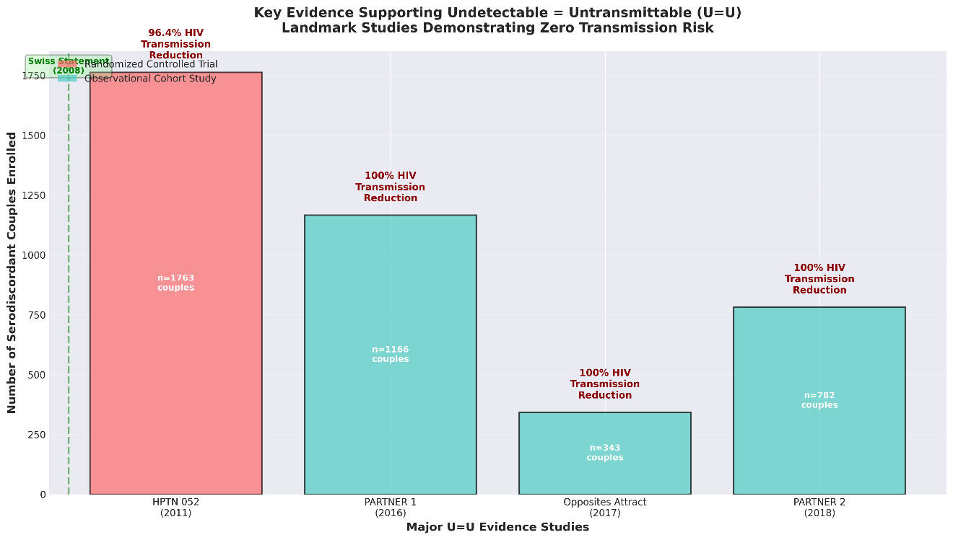
Figure 1: Key evidence supporting the Undetectable = Untransmittable principle from landmark studies demonstrating zero transmission risk when the HIV-positive partner maintains viral suppression.

The clinical threshold for “undetectable” is generally defined as a viral load below 200 copies/mL, though many jurisdictions use the more sensitive threshold of <50 copies/mL (Eisinger et al., 2019). The implications of U=U extend beyond prevention science to encompass profound psychological, social, and legal dimensions. For people living with HIV, U=U knowledge can reduce internalized stigma, improve self-esteem, enhance relationship quality, and support informed reproductive decision-making (Senkoro et al., 2025). For serodiscordant couples specifically, U=U offers the possibility of condomless sex within the relationship, natural conception without assisted reproductive technologies, and reduced anxiety about transmission risk (Xi et al., 2025).

1.3 Rationale for a Family-Centered Approach in Chinese Contexts
Traditional HIV interventions have predominantly focused on individual-level behavior change, often neglecting the dyadic and familial contexts in which HIV prevention and care decisions are made (Mashaphu et al., 2018). This individual-centric approach is particularly incongruent with Chinese cultural values that emphasize collectivism, family interconnectedness, and relational decision-making. Research with Chinese serodiscordant couples has demonstrated the critical importance of dyadic coping—wherein both partners collaboratively manage HIV-related stressors—and “we-ness” identity, conceptualizing the couple as a unified entity rather than two separate individuals (Fu et al., 2024).
Studies specifically examining Chinese serodiscordant male couples have shown that we-ness mediates the relationship between dyadic coping and HIV-specific support, with both actor effects (one’s own we-ness affecting one’s own support provision) and partner effects (one’s we-ness affecting their partner’s received support) (Fu et al., 2024). Furthermore, common dyadic coping—where both partners work together as a team—significantly mediates associations between shared disease appraisal and both relationship satisfaction and quality of life outcomes (Hou et al., 2023). These findings underscore the necessity of interventions that explicitly target the couple as the unit of intervention rather than isolated individuals.
Beyond the couple dyad, Chinese families typically play substantial roles in healthcare decisions, emotional support provision, and caregiving for members with chronic illnesses (Chen et al., 2018). Fertility decisions, in particular, are often influenced by extended family expectations related to lineage continuation, a core value in Chinese culture shaped by Confucian traditions emphasizing filial piety and ancestral veneration (Guo, Chongsuvivatwong, et al., 2023). For serodiscordant couples considering childbearing, family pressures to produce offspring may conflict with fears about HIV transmission to partners or vertical transmission to children. A family-centered intervention that educates and engages family members can address these tensions, mobilize family support, and align family expectations with evidence-based reproductive health strategies.

2. LITERATURE REVIEW

2.1 Global Evidence on U=U Awareness and Implementation
Despite robust scientific consensus supporting U=U, awareness and acceptance vary substantially across populations and geographic contexts. Studies from high-income Western countries have documented relatively high awareness among people living with HIV—ranging from 72% to 89%—but considerably lower rates among HIV-negative individuals and healthcare providers (MacGibbon et al., 2023). A 25-country survey found that 66.5% of people living with HIV had discussed U=U with their main healthcare provider, though this varied from 38% in South Korea to 87% in Switzerland (Okoli et al., 2020). Notably, heterosexual men and individuals in Asia demonstrated the lowest awareness, highlighting important gaps that require targeted educational efforts (Okoli et al., 2020).
Qualitative research has revealed that U=U knowledge and acceptance evolve over time, often progressing from initial skepticism to gradual trust as HIV-negative partners remain uninfected despite condomless sex (Senkoro et al., 2025). However, barriers persist including fear of transmission, skepticism about the science, concerns about ART adherence, and residual stigma. Among serodiscordant couples in East Africa, while all participants demonstrated basic U=U knowledge, initial doubts gave way to trust as couples gained experience with the principle (Senkoro et al., 2025). Importantly, use of additional prevention methods such as pre-exposure prophylaxis (PrEP) and condoms alongside U=U helped address residual concerns about adherence lapses and relationship fidelity, suggesting that combination prevention approaches may be most acceptable to couples (Senkoro et al., 2025).
Healthcare provider perspectives reveal additional implementation challenges (Grace et al., 2022). Providers report discomfort with “zero risk” messaging, preferring to maintain a margin of uncertainty; prioritization of other clinical issues over U=U education; and concerns about patients’ readiness to receive the information (Grace et al., 2022). Provider skepticism, shaped by the legacy of HIV as a highly stigmatized and infectious disease, can undermine confidence in delivering U=U messages. Furthermore, limited availability of culturally appropriate U=U resources for diverse populations—including non-English speakers, gender minorities, and specific ethnic communities—creates additional barriers (Grace et al., 2022).

2.2 Serodiscordant Couples: Relationship Dynamics and Psychosocial Challenges
Serodiscordant couples face distinctive relationship dynamics and psychosocial stressors that differentiate their experiences from both seroconcordant HIV-positive couples and HIV-negative couples (Mendelsohn et al., 2015). Research has identified multiple domains of challenges including sexual risk negotiation, relationship quality concerns, disclosure decisions, reproductive planning, and management of HIV-related stigma. A comprehensive scoping review of high-income settings found that most research clustered around risk behaviors and risk management, with relatively less attention to relationship quality, social support, and the lived experiences of couples navigating serodiscordance (Mendelsohn et al., 2015).
Studies of Chinese serodiscordant couples have documented that couple identity—conceptualized as a sense of “we-ness”—serves as a protective factor predicting better psychological well-being and physical health (Huang et al., 2018). Longitudinal research demonstrated that couple identity predicted fewer depressive symptoms at both within-couple and between-couple levels, as well as better self-rated physical health at the between-couple level one year later (Huang et al., 2018). Critically, these protective effects were diminished when HIV stigma was high, highlighting stigma as a key contextual factor that can undermine relationship resilience (Huang et al., 2018). This finding emphasizes the necessity of addressing stigma not only at individual levels but also through community-level interventions that shift social norms and reduce discrimination.
Daily diary studies using dyadic analysis methods have provided granular insights into how serodiscordant couples manage HIV as a shared stressor. Research using the common fate model found that we-disease appraisal—viewing HIV as “our” illness rather than solely the HIV-positive partner’s burden—was associated with both partners’ quality of life at the between-person level (Hou et al., 2025). Common dyadic coping mediated associations between we-disease appraisal and relationship satisfaction at the within-person level, indicating that day-to-day collaborative coping processes are critical mechanisms linking shared illness perceptions to relationship outcomes (Hou et al., 2025). These findings suggest that interventions should foster shared disease appraisals and train couples in common dyadic coping strategies applicable to their daily lives.

2.3 Reproductive Health Needs and Safer Conception Strategies
Reproductive desires are common among serodiscordant couples, yet they face unique complexities in achieving pregnancy safely (Saleem et al., 2017). In Chinese contexts, studies have documented that fertility desire among people living with HIV is influenced by motivating factors similar to HIV-negative individuals—including social norms, cultural values, and government policies—as well as HIV-specific factors such as availability of prevention of mother-to-child transmission (PMTCT) services, health concerns, and HIV-related stigma (Guo, Chongsuvivatwong, et al., 2023). Male partners more frequently reported fertility desire while female partners expressed greater concerns, reflecting gender differences in risk perception and reproductive decision-making (Guo, Chongsuvivatwong, et al., 2023).
Research examining fertility intention among heterosexual serodiscordant couples in Kunming, China, revealed that both stigma and HIV status were associated with fertility intention, mediated through fertility desire (Guo et al., 2022). Husbands’ perceived provider stigma was associated with both their own and their wives’ fertility intention via the mediating effect of fertility desire (Guo et al., 2022). High intra-couple correlation in fertility intentions suggested that counseling should be conducted with both spouses present, allowing extensive discussion of HIV-related stigma, potential discrepancies between partners’ desires and intentions, and the influence of one partner on the other (Guo et al., 2022).
Safer conception strategies for serodiscordant couples have evolved significantly with the advent of U=U (Wagner et al., 2021). When the male partner is HIV-positive and virally suppressed, timed condomless intercourse during the female partner’s fertile window, combined with continued viral suppression monitoring and optional PrEP use by the HIV-negative partner, represents a safe approach (Wagner et al., 2021). When the female partner is HIV-positive and virally suppressed, natural conception can proceed with minimal risk. However, many serodiscordant couples remain unaware of these options or lack access to comprehensive safer conception counseling integrated with HIV care services (Wagner et al., 2021). A randomized controlled trial in Uganda demonstrated that couples who received intensive safer conception counseling reported significantly higher use of appropriate reproductive methods compared to usual care, with a cost of $631 per person to achieve accurate use of safer conception methods (Wagner et al., 2021).

2.4 Stigma and Mental Health in Serodiscordant Relationships
HIV-related stigma operates at multiple levels—internalized self-stigma, anticipated stigma from others, and enacted discrimination—all of which profoundly impact serodiscordant couples’ mental health and relationship functioning (Rueda et al., 2016). A meta-analysis of 64 studies found significant associations between HIV-related stigma and higher rates of depression, lower social support, reduced ART adherence, and decreased access to health services among people living with HIV (Rueda et al., 2016). Relationship-specific stigma, stemming from societal disapproval of serodiscordant partnerships, adds an additional layer of stress that can reduce relationship satisfaction and increase mental health burden (Gamarel et al., 2022).
In Chinese populations specifically, stigma is shaped by cultural associations between HIV and “social evils” such as drug use and sex work, leading to intense stigmatization (Brickley et al., 2008). Qualitative research with pregnant and postpartum women living with HIV in China revealed that fear of discrimination led to selective disclosure, with women carefully managing who learned about their HIV status (Brickley et al., 2008). When disclosed, women experienced both support and discrimination from family and community members, highlighting the double-edged nature of disclosure (Brickley et al., 2008). This cultural context necessitates interventions that directly address stigma through community education and normalization of living with HIV as a manageable chronic condition.
Research has also documented that serodiscordant couples experience unique forms of anxiety related to transmission risk, relationship stability, and reproductive decision-making. Studies from Tanzania found that Relationship distrust, poor communication about HIV risk, and the need for control over transmission risk were highly influential in couples’ decisions regarding prevention strategies (Jani et al., 2021). Anticipated stigma of being perceived as HIV-positive as a result of using prevention methods such as PrEP served as a significant deterrent (Jani et al., 2021). These findings emphasize the necessity of couples counseling that enhances communication, builds trust, and addresses both HIV-related and relationship-specific anxieties.

2.5 Current Counselling Approaches for Serodiscordant Couples
Existing counseling interventions for serodiscordant couples vary in intensity, theoretical foundation, and delivery modality (Mashaphu et al., 2018). Couples-based HIV testing and counseling (CVCT) has been widely implemented in Sub-Saharan Africa and shown effectiveness in promoting disclosure, increasing condom use, and reducing HIV transmission risk (Mashaphu et al., 2018). However, most interventions have focused primarily on risk reduction and prevention rather than holistically addressing relationship quality, mental health, and reproductive goals.
Recent intervention research has incorporated U=U messaging, though approaches and outcomes vary. In South Africa, intervention mapping was used to develop culturally acceptable U=U communication tools featuring personal testimonials of people living with HIV and their partners, organized as a mobile application for use in primary healthcare settings (Sineke et al., 2024). This approach emphasized the importance of simple, standardized U=U presentations that provide encouragement and model success stories while maintaining clear guidance toward ART adherence (Sineke et al., 2024). The needs assessment revealed low U=U awareness in Africa and skepticism about its effectiveness, underscoring the necessity of evidence-based messaging that directly addresses doubts and misconceptions.
In Chinese contexts specifically, counseling interventions for serodiscordant couples have demonstrated effectiveness in enhancing ART adherence and reducing HIV transmission risk (Han et al., 2024). A randomized controlled trial in Yunnan Province found that increased follow-up, counseling, and awareness of HIV risk enhanced ART compliance, thereby maximizing treatment efficacy (Han et al., 2024). However, current Chinese health guidelines do not widely recommend combining counseling with ART to specifically support serodiscordant couples, representing a gap in clinical practice (Han et al., 2024).

3. CULTURAL CONTEXT: CHINESE VALUES AND HIV

3.1 Face (Mianzi), Stigma, and Family Honor
The concept of “face” (mianzi) is central to Chinese social interactions and profoundly influences how individuals and families respond to HIV (Huang et al., 2018). Face refers to one’s social standing, dignity, and reputation in the eyes of others, functioning as a form of social capital that can be gained, lost, maintained, or enhanced through interactions. An HIV diagnosis threatens not only the individual’s face but also the family’s collective face, potentially bringing shame to the extended family and ancestors.
This cultural dynamic creates powerful incentives for concealment and selective disclosure of HIV status (Guo, Chongsuvivatwong, et al., 2023). Serodiscordant couples may avoid discussing their situation with extended family members to preserve family face, even when family support could benefit their mental health and relationship stability. Fear of gossip, social ostracism, and marriage disruption can lead to isolation and reduced access to social support networks (Lelaka & Mavhandu-Mudzusi, 2024). Interventions must therefore incorporate strategies that help couples navigate disclosure decisions sensitively, provide education to reduce family-level stigma, and create safe spaces for family conversations about HIV.

3.2 Collectivism, Family Involvement, and Shared Decision-Making
Chinese culture emphasizes collectivism over individualism, with family units prioritized over individual autonomy in decision-making (Fu et al., 2024). Healthcare decisions, including those related to HIV treatment and reproductive planning, are often made collectively involving the patient, their partner, and extended family members such as parents and in-laws. This contrasts sharply with Western biomedical models emphasizing individual autonomy and confidentiality.
For serodiscordant couples, family involvement can be both beneficial and challenging. Supportive families can provide emotional encouragement, practical assistance with medication adherence, financial help, and childcare (Lelaka et al., 2022). However, family members who lack accurate HIV knowledge may perpetuate stigma, pressure couples to avoid pregnancy entirely, or create relationship strain through blame and judgment (Lelaka & Mavhandu-Mudzusi, 2024). Research has shown that family members of serodiscordant couples experience distress themselves and may show reluctance to secondary disclosure (sharing information with other family members) due to concerns about gossip and lack of support (Lelaka & Mavhandu-Mudzusi, 2024).
Family-centered interventions should therefore aim to educate family members about HIV transmission, U=U principles, modern treatment effectiveness, and reproductive safety. Engaging family members as allies in supporting ART adherence and relationship well-being can harness the positive potential of collective decision-making while mitigating family-based stigma.

3.3 Filial Piety and Reproductive Expectations
Filial piety—respect for and obligation to one’s parents and ancestors—is a foundational value in Chinese culture rooted in Confucian philosophy (Guo, Chongsuvivatwong, et al., 2023). A key component of filial piety is the continuation of the family lineage through childbearing, traditionally expressed in the saying “of the three unfilial acts, having no descendants is the worst.” This cultural imperative creates strong pressures on couples to have children, pressures that can conflict with HIV-related concerns about transmission risk.
Studies of fertility desire among Chinese people living with HIV have found that traditional family values and the desire to fulfill filial obligations motivate childbearing even in the context of HIV (Guo, Chongsuvivatwong, et al., 2023). Government policies also shape reproductive decisions; China’s shift from a one-child policy to a two-child policy has prompted many couples to consider having children or additional children (Guo, Chongsuvivatwong, et al., 2023). For serodiscordant couples, these sociocultural and policy contexts create tensions between reproductive desires and HIV-related fears.
U=U messaging that emphasizes safe conception opportunities may help serodiscordant couples feel empowered to fulfill cultural expectations while protecting both partner and infant health. Counseling should validate couples’ reproductive desires, provide evidence-based information about conception safety, and support informed decision-making that aligns personal preferences with family obligations.

3.4 Gender Roles and Power Dynamics
Traditional Chinese gender norms assign men authority in family decision-making while expecting women to prioritize family harmony and caregiving (Guo et al., 2022). These dynamics influence HIV-related decisions in serodiscordant relationships. Research has found that male partners often dominate fertility decisions, with wives’ fertility desires and intentions influenced more strongly by their husbands’ preferences than vice versa (Guo, Liu, et al., 2023). Similarly, disclosure decisions and prevention strategy choices may be influenced by gendered power imbalances.
Couple-based interventions must therefore address gender equity, enhance women’s voice in shared decision-making, and promote egalitarian communication patterns (Ojikutu et al., 2016). Evidence suggests that interventions emphasizing partnership, mutual support, and shared responsibility are more effective than those that inadvertently reinforce patriarchal power structures.

4. PROPOSED INTERVENTION FRAMEWORK

4.1 Conceptual Model
The proposed family-centered U=U counseling intervention operates across three interconnected levels: individual, couple/dyadic, and family/cultural. This multi-level approach recognizes that serodiscordant couples’ experiences and outcomes are shaped by factors operating simultaneously at different ecological levels.
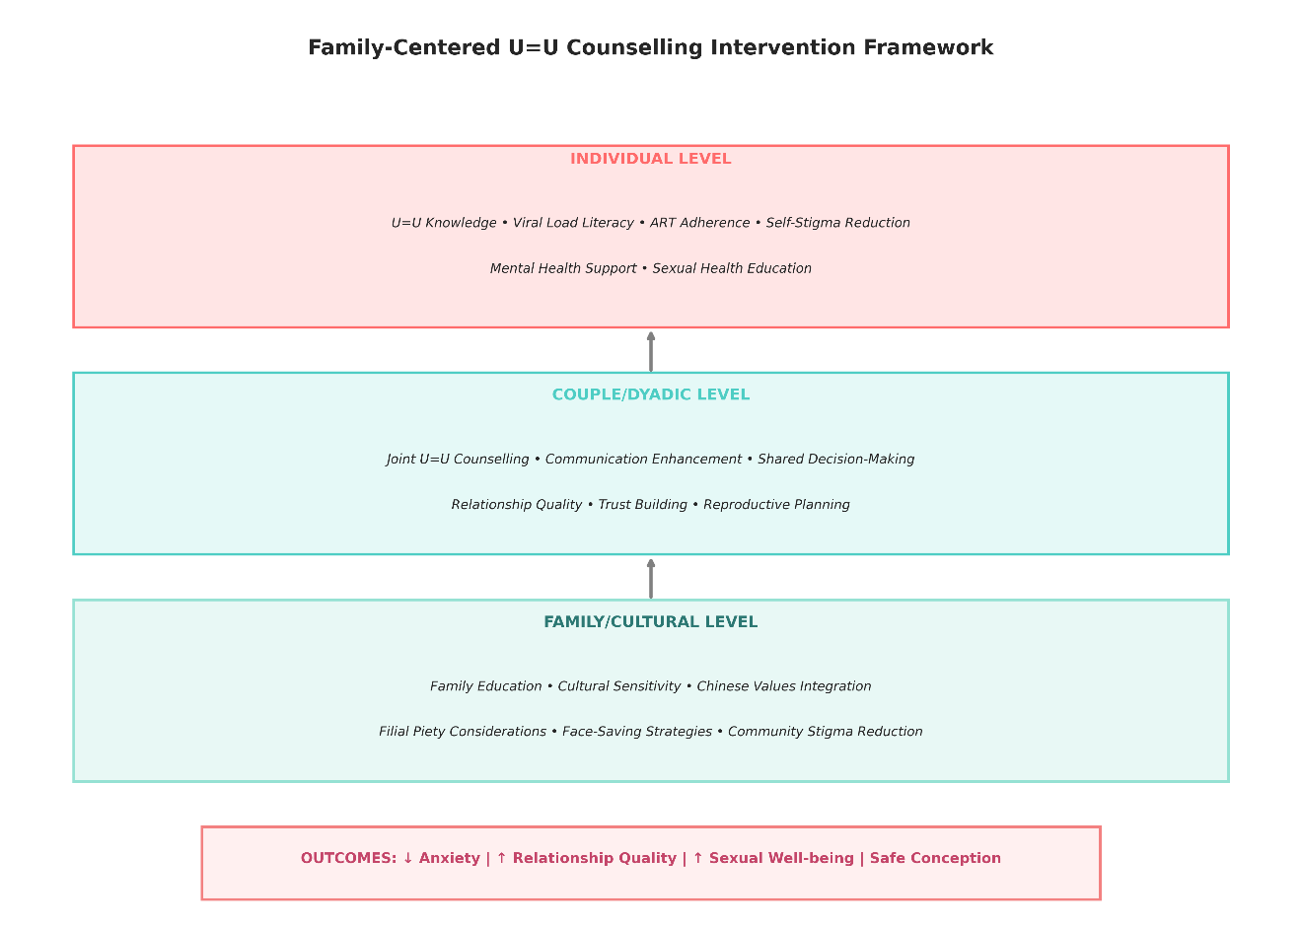
Figure 2: Conceptual framework for the family-centered U=U counseling intervention, illustrating the multi-level approach targeting individual knowledge and mental health, couple communication and relationship quality, and family/cultural factors.
Individual Level: At the individual level, the intervention focuses on enhancing U=U knowledge, viral load literacy, ART adherence, and self-stigma reduction (Senkoro et al., 2025). Both HIV-positive and HIV-negative partners receive evidence-based education about U=U science, the importance of viral suppression, and strategies for maintaining treatment adherence. Mental health support addresses anxiety, depression, and HIV-related distress. Sexual health education covers safer sex practices, STI prevention, and strategies for maintaining sexual well-being.
Couple/Dyadic Level: The dyadic level emphasizes joint U=U counseling sessions where both partners participate together (Hou et al., 2025). These sessions foster shared understanding of U=U principles, enhance communication about HIV and sexual health, build trust, and support shared decision-making regarding prevention strategies and reproductive planning (Fu et al., 2024). Relationship quality enhancement activities help couples strengthen their bond, navigate HIV-related challenges collaboratively, and cultivate “we-ness” identity that conceptualizes HIV as a shared concern rather than solely the HIV-positive partner’s burden.
Family/Cultural Level: The family/cultural level involves educating key family members about HIV, U=U, and modern treatment while addressing cultural values and concerns (Lelaka & Mavhandu-Mudzusi, 2024). This includes discussions about face-saving strategies, filial piety considerations, and culturally appropriate approaches to disclosure and family support mobilization. Community-level education aims to reduce HIV stigma and normalize living with HIV as a manageable chronic condition.

4.2 Core Components and Session Structure
The intervention consists of six sessions delivered over 12 weeks, combining individual education, joint couple counseling, and optional family sessions. Each session lasts 60-90 minutes and is delivered by trained healthcare providers (nurses, counselors, or physicians) with expertise in HIV care and couples counseling.
Session | Focus | Content | Participants
Session 1 | U=U Education & Viral Load Literacy | • Introduction to U=U science and evidence• Understanding viral load and suppression• ART adherence importance• Addressing myths and misconceptions | Individual (both partners separately)
Session 2 | Couple Communication & Shared Understanding | • Joint review of U=U principles• Communication enhancement exercises• Disclosure and trust-building• Addressing partners’ questions and concerns | Couple (joint session)
Session 3 | Stigma Reduction & Mental Health | • Understanding internalized and anticipated stigma• Cognitive-behavioral strategies for stigma management• Mental health screening and support• Building self-esteem and resilience | Individual (both partners separately)
Session 4 | Relationship Quality & Intimacy | • Sexual health and well-being• Enhancing intimacy and pleasure• Negotiating condom use decisions• Addressing sexual concerns | Couple (joint session)
Session 5 | Reproductive Health & Safer Conception | • Fertility desires and family planning• Safer conception strategies• PMTCT and reproductive safety• Family pressures and cultural considerations | Couple (joint session)
Session 6 | Family Engagement & Sustainability | • Optional family education session• Disclosure planning with family• Mobilizing family support• Long-term maintenance and follow-up planning | Couple + selected family members (optional)
Each session incorporates culturally adapted materials, including visual aids translated into Chinese, testimonials from Chinese people living with HIV, and discussion guides addressing culturally specific concerns. Providers receive a detailed manual with session-by-session protocols, sample scripts, and guidance for addressing common questions and concerns.

4.3 Theoretical Foundations
The intervention integrates multiple evidence-based theoretical frameworks:
Systemic-Transactional Model (STM): This model conceptualizes stress and coping as dyadic processes occurring within the couple system (Hou et al., 2023). HIV is understood not as an individual stressor but as a shared challenge requiring coordinated responses from both partners. Common dyadic coping—where both partners engage collaboratively in stress management—is emphasized as a key mechanism linking shared disease appraisal to positive outcomes.
Information-Motivation-Behavioral Skills (IMB) Model: This health behavior theory posits that health-protective behaviors result from accurate information, motivation to engage in the behavior, and behavioral skills to enact it effectively. The intervention provides comprehensive U=U information, enhances motivation through addressing stigma and building self-efficacy, and develops skills for ART adherence, communication, and safer conception.
Social Ecological Model: Recognizing that health behaviors and outcomes are influenced by factors at multiple levels—individual, interpersonal, organizational, community, and policy—the intervention targets individual knowledge and attitudes, couple dynamics, family support, and community-level stigma (Saleem et al., 2017).
Minority Stress Theory: Adapted to the HIV context, this framework acknowledges that serodiscordant couples experience unique stressors related to HIV stigma and serodiscordance that can undermine health and well-being (Gamarel et al., 2022). The intervention aims to buffer these minority stressors through education, social support, and stigma reduction strategies.

5. IMPLEMENTATION IN HONG KONG CONTEXT

5.1 Healthcare System Integration
Hong Kong’s public healthcare system, managed by the Hospital Authority, provides comprehensive HIV care including free ART to all residents living with HIV. Specialist HIV clinics operate across Hong Kong’s seven hospital clusters, staffed by infectious disease physicians, nurses, pharmacists, and medical social workers. Integration of the proposed U=U counseling intervention would leverage existing infrastructure while requiring several adaptations:
Service Delivery Settings: The intervention can be delivered within existing HIV specialist clinics, taking advantage of established patient relationships and trust. Alternatively, dedicated serodiscordant couple clinics could be piloted in high-volume centers to provide focused services. Community-based organizations serving people living with HIV could partner with hospital services to offer intervention sessions in more accessible community locations, reducing barriers related to stigma and convenience.
Staffing and Training: Existing nursing staff and medical social workers represent ideal candidates for intervention delivery, given their training in counseling and patient education. A comprehensive 2-day training program would cover U=U evidence and messaging, couples counseling techniques, cultural competency in Chinese contexts, reproductive health counseling, stigma reduction strategies, and intervention protocols. Ongoing supervision and case discussion forums would support providers in addressing complex cases and maintaining intervention fidelity.
Referral Pathways: Serodiscordant couples can be identified through routine partner notification, couples HIV testing services, and self-referral following awareness campaigns. Infectious disease physicians would refer interested couples to trained intervention providers, with warm handoffs ensuring continuity of care. Linkages to reproductive health services, mental health services, and peer support programs would address needs beyond the intervention scope.

5.2 Barriers and Facilitators Analysis
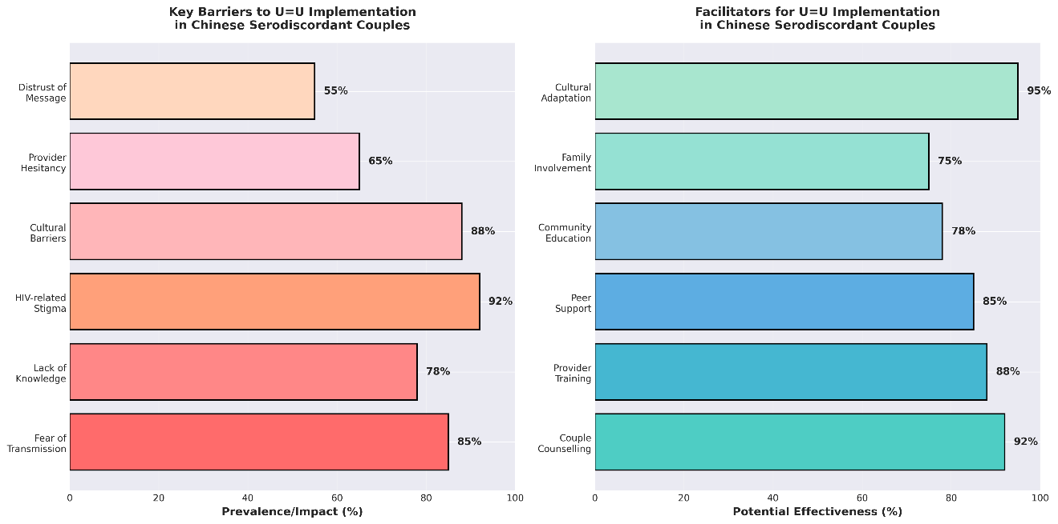
Figure 3: Key barriers and facilitators for implementing U=U counseling interventions among serodiscordant couples in Chinese contexts.

Anticipated Barriers:
Knowledge and Awareness Gaps: Both healthcare providers and patients may have limited awareness of U=U, with surveys suggesting low awareness in Asian populations (Okoli et al., 2020). Misconceptions about U=U effectiveness and concerns about risk may lead to hesitancy in accepting the message.
HIV-Related Stigma: Persistent stigma in Chinese communities creates fears of disclosure and social ostracism (Huang et al., 2018). Couples may be reluctant to participate in services that require disclosure of their serodiscordant status or to bring family members into counseling.
Cultural Barriers: Concerns about face loss, family honor, and community reputation can inhibit help-seeking and disclosure (Lelaka & Mavhandu-Mudzusi, 2024). Traditional gender norms may limit women’s participation in shared decision-making.
Provider Hesitancy: Healthcare providers may feel uncomfortable delivering U=U messages due to concerns about liability, fear of being blamed if transmission occurs, or discomfort with discussing sexuality (Grace et al., 2022).
Resource Constraints: Limited time during clinical visits, competing clinical priorities, and insufficient staffing may constrain intervention delivery. Language barriers for non-Cantonese speakers may limit accessibility.
Key Facilitators:
Couple-Centered Approach: Evidence consistently demonstrates that couple-based interventions are more effective than individual approaches for serodiscordant couples (Mashaphu et al., 2018). Joint sessions enhance communication, build shared understanding, and support coordinated action.
Provider Training and Support: Comprehensive training equipping providers with knowledge, skills, and confidence to deliver U=U counseling effectively can overcome provider-level barriers (Sineke et al., 2024). Ongoing supervision and peer support sustain quality implementation.
Peer Support and Role Models: Incorporating testimonials and facilitating connections with peer mentors who are successfully managing serodiscordant relationships can normalize experiences and provide social support.
Cultural Adaptation: Tailoring materials and approaches to align with Chinese values, using Chinese language materials, and incorporating culturally relevant examples enhance acceptability and engagement (Sineke et al., 2024).
Family Involvement: Strategic engagement of supportive family members leverages the cultural strength of collectivism and family orientation, mobilizing family resources for couple support (Lelaka et al., 2022).
Policy Support: Endorsement by Hong Kong Department of Health and Hospital Authority, inclusion in clinical practice guidelines, and allocation of resources signal commitment and legitimize the intervention.

5.3 Cultural Adaptation Strategies
Successful implementation requires careful cultural adaptation addressing language, values, family dynamics, and stigma:
Language and Literacy: All materials are translated into Traditional Chinese (used in Hong Kong) with attention to health literacy levels. Visual aids, infographics, and videos supplement written materials. Bilingual staff or interpreters support non-Cantonese speakers including Mandarin speakers and ethnic minorities.
Face-Saving Communication: Counseling approaches emphasize privacy, confidentiality, and dignity. Providers use indirect communication styles when appropriate, allowing clients to “save face” when discussing sensitive topics. Emphasis is placed on HIV as a manageable health condition rather than a moral failing.
Family-Oriented Framing: The intervention frames U=U and safer conception in terms of family well-being, lineage continuation, and fulfilling family responsibilities. This alignment with cultural values enhances motivation and reduces dissonance between HIV management and family obligations.
Gender-Sensitive Approaches: Counselors actively create space for both partners to voice opinions and preferences, particularly supporting women’s participation in decision-making. Gender equity is emphasized as beneficial for relationship quality and health outcomes.
Stigma Reduction Education: Factual information about HIV transmission, modern treatment effectiveness, and U=U principles is provided to family members and community members when appropriate, reducing stigma rooted in misinformation and fear.

6. EVALUATION FRAMEWORK

6.1 Research Design
A hybrid effectiveness-implementation trial using a cluster-randomized controlled design would rigorously evaluate the intervention. Six to eight HIV clinics in Hong Kong would be randomized to either: (1) Intervention arm receiving the family-centered U=U counseling intervention, or (2) Control arm receiving standard HIV care including routine counseling on transmission prevention. Cluster randomization at the clinic level prevents contamination between arms while allowing implementation within real-world service delivery contexts.
Sample Size: A target enrollment of 150-200 serodiscordant couples (300-400 individuals) would provide adequate power to detect moderate effect sizes (Cohen’s d = 0.4-0.5) for primary outcomes. Assuming 20% attrition over 12 months, initial enrollment of 180-240 couples would yield sufficient final sample size for analysis.
Inclusion Criteria: - Both partners age 18 or older - Confirmed HIV serodiscordant status (one HIV-positive, one HIV-negative) - Relationship duration of at least 6 months - HIV-positive partner on ART with most recent viral load <200 copies/mL OR willing to initiate ART - Sexually active or planning sexual activity within the relationship - Both partners willing to participate and provide informed consent - Cantonese, Mandarin, or English fluency
Exclusion Criteria: - Cognitive impairment preventing informed consent or participation - Active severe mental illness requiring immediate psychiatric intervention - Presence of intimate partner violence (couples screened privately and referred to appropriate services)

6.2 Primary and Secondary Outcomes
Primary Outcomes:
Outcome Domain | Measure | Assessment Timepoints | Relationship Quality | Couples Satisfaction Index (CSI-32);Dyadic Adjustment Scale (DAS)
Baseline, 3 months, 6 months, 12 months | HIV-Related Anxiety | Brief HIV Anxiety Scale;State-Trait Anxiety Inventory (STAI) | Baseline, 3 months, 6 months, 12 months | Sexual Well-being
Female Sexual Function Index (FSFI);International Index of Erectile Function (IIEF);Sexual Quality of Life Questionnaire | Baseline, 3 months, 6 months, 12 months | U=U Knowledge & Acceptance | Custom U=U Knowledge Scale;U=U Acceptance Scale | Baseline, 3 months, 6 months, 12 months
Secondary Outcomes:
- HIV-Related Stigma: Internalized AIDS-Related Stigma Scale, Anticipated Stigma Scale
- ART Adherence: Self-reported adherence (visual analog scale), viral load suppression rates
- Reproductive Health: Safer conception knowledge, contraception use, pregnancy intentions and outcomes
- Mental Health: Depression (PHQ-9), Quality of Life (WHO-QOL-HIV)
- Couple Communication: Communication Patterns Questionnaire
- HIV Transmission Events: Seroconversion in HIV-negative partners (assessed through HIV testing every 6 months)
Process Evaluation: Implementation fidelity, intervention dose received, participant engagement, provider experiences, barriers and facilitators to implementation. Qualitative interviews with subset of participants (n=40 couples) and all intervention providers to capture experiences, perceived benefits, challenges, and recommendations.

6.3 Analysis Plan
Quantitative Analysis: Primary analyses will use intention-to-treat principles including all randomized participants. Mixed-effects linear regression models will estimate intervention effects on continuous outcomes, accounting for clustering at the clinic level and repeated measures within individuals. Actor-Partner Interdependence Models (APIM) will be employed for dyadic outcomes, estimating actor effects (one’s own intervention exposure predicting one’s own outcomes) and partner effects (one’s intervention exposure predicting partner’s outcomes) (Guo et al., 2022). Baseline values of outcome variables will be included as covariates. Sensitivity analyses will explore differential intervention effects by gender, relationship duration, HIV-positive partner gender, and baseline stigma levels.
Qualitative Analysis: Semi-structured interview transcripts will be analyzed using thematic analysis following the framework method (Senkoro et al., 2025). Two independent coders will conduct line-by-line coding, develop a coding framework, and identify themes related to intervention experiences, perceived mechanisms of change, cultural acceptability, and sustainability. Triangulation of quantitative and qualitative findings will provide comprehensive understanding of intervention effects and processes.

7. RECOMMENDATIONS AND FUTURE DIRECTIONS

7.1 Policy Recommendations
Clinical Practice Guidelines: Hong Kong Department of Health and Hospital Authority should develop and disseminate clinical practice guidelines recommending routine discussion of U=U with all people living with HIV who achieve viral suppression, with special emphasis on serodiscordant couples. Guidelines should specify evidence-based thresholds for undetectable status, reassessment intervals for viral load monitoring, and protocols for addressing treatment interruptions or virologic failure.
Healthcare Provider Training: Mandatory continuing education modules on U=U for all healthcare providers working in HIV care would ensure consistent, accurate messaging. Training curricula should address U=U science, couple-based counseling skills, reproductive health counseling, cultural competency, and stigma reduction strategies. Provider certification or credentialing for U=U counseling could incentivize skill development.
Integration with Existing Services: U=U counseling should be integrated into multiple service touchpoints including HIV diagnosis counseling, ART initiation consultations, routine HIV care visits, sexual health clinics, antenatal care for pregnant women living with HIV, and fertility/family planning services. Systematic integration ensures that serodiscordant couples encounter U=U messaging consistently across care continuum.
Public Health Messaging: Community-level awareness campaigns targeting both people living with HIV and the general public would normalize U=U, reduce stigma, and promote testing (Smith et al., 2021). Campaigns should feature diverse role models including serodiscordant couples successfully managing HIV, use culturally appropriate messaging, and disseminate information through multiple channels including social media, television, print media, and community forums.

7.2 Research Priorities
Long-Term Follow-Up Studies: Extended follow-up beyond 12 months is needed to assess durability of intervention effects and long-term outcomes including sustained relationship quality, cumulative pregnancy outcomes, and prevention of HIV transmission. Cohort studies tracking serodiscordant couples over 3-5 years would provide valuable data on natural relationship trajectories and factors predicting relationship dissolution, seroconversion, or successful management.
Diverse Populations: Research should expand to include diverse populations within Hong Kong including ethnic minorities, migrant communities, men who have sex with men, older adults, and couples with HIV-positive female partners. Comparative effectiveness research could identify whether intervention adaptations are needed for specific subgroups.
Implementation Science: Research examining scalability, sustainability, and cost-effectiveness of the intervention across different settings (hospital clinics, community organizations, online delivery) would guide large-scale implementation. Mixed-methods implementation research could identify optimal delivery models, staffing configurations, and strategies for maintaining quality over time.
Mechanisms of Change: Mediation analyses exploring pathways through which the intervention affects outcomes would elucidate mechanisms of change. Candidate mediators include U=U knowledge, self-efficacy, dyadic coping, we-ness identity, reduced stigma, and improved communication. Understanding mechanisms guides intervention refinement and optimization.
Family Dynamics: In-depth research on family involvement in HIV care and reproductive decision-making among Chinese serodiscordant couples would inform family engagement strategies. Studies comparing outcomes when family members participate in counseling versus couple-only approaches would determine added value of family components.

7.3 Clinical Practice Recommendations
Routine Assessment: All people living with HIV should be routinely asked about relationship status, partner HIV status, sexual activity, and reproductive intentions during clinical visits. Serodiscordant couples should be proactively identified and offered targeted services.
Individualized Counseling: Counseling should be individualized based on couples’ specific circumstances including gender of HIV-positive partner, relationship characteristics, reproductive goals, cultural background, and psychosocial factors. Flexible intervention delivery accommodates diverse needs and preferences.
Multidisciplinary Teams: Optimal care for serodiscordant couples requires collaboration among infectious disease specialists, nurses, counselors, social workers, reproductive health specialists, and mental health professionals. Multidisciplinary team meetings facilitate care coordination and comprehensive support.
Peer Support Programs: Connecting serodiscordant couples with peer mentors—other couples successfully managing serodiscordance—provides social support, reduces isolation, and models effective coping strategies. Peer support groups create community and facilitate information exchange.
Addressing Intimate Partner Violence: Providers must screen for intimate partner violence, recognize that serodiscordance may create or exacerbate relationship conflict, and ensure access to safety planning and domestic violence services when needed.

8. CONCLUSION
The U=U principle represents a transformative advance in HIV prevention science with profound implications for serodiscordant couples’ sexual health, relationship quality, reproductive autonomy, and psychological well-being. However, realizing U=U’s potential requires more than disseminating scientific evidence; it demands culturally sensitive, relationship-centered interventions that address the complex psychosocial realities of couples navigating HIV in pecific cultural contexts.
This report has presented a comprehensive framework for developing and implementing a family-centered U=U counseling intervention tailored to serodiscordant couples in Hong Kong and the broader Chinese context. Drawing on robust international evidence demonstrating zero transmission risk when viral suppression is maintained, the proposed intervention addresses critical gaps in current HIV care by explicitly targeting the couple as the unit of intervention rather than isolated individuals (Senkoro et al., 2025). This dyadic approach aligns with Chinese cultural values emphasizing collectivism, family interconnectedness, and relational decision-making, while simultaneously addressing unique challenges including pervasive HIV-related stigma, concerns about face and family honor, and pressures related to filial piety and reproductive expectations (Huang et al., 2018).
The multi-level intervention framework operates simultaneously at individual, couple/dyadic, and family/cultural levels, recognizing that serodiscordant couples’ experiences are shaped by factors across multiple ecological domains (Saleem et al., 2017). By combining evidence-based U=U education with couples communication enhancement, mental health support, reproductive health counseling, and strategic family engagement, the intervention addresses the multifaceted needs of Chinese serodiscordant couples in a holistic, culturally congruent manner. The proposed six-session structure provides sufficient intensity to achieve meaningful outcomes while remaining feasible for implementation within existing Hong Kong healthcare infrastructure.
Critical to the intervention’s success will be comprehensive training of healthcare providers, who must develop not only knowledge about U=U science but also skills in couples counseling, cultural competency, and sensitive communication about sexuality and reproductive health (Grace et al., 2022). Provider hesitancy and discomfort with U=U messaging represent significant implementation barriers that can be overcome through evidence-based training curricula, ongoing supervision, and institutional support signaling the legitimacy and importance of U=U counseling.
The rigorous evaluation framework proposed—employing a cluster-randomized controlled trial design with validated outcome measures spanning relationship quality, anxiety, sexual well-being, and reproductive health—will generate robust evidence regarding intervention effectiveness. Importantly, incorporation of dyadic analysis methods such as the Actor-Partner Interdependence Model will illuminate how intervention effects operate within the couple system, revealing both actor effects (intervention impact on one’s own outcomes) and partner effects (intervention impact on one’s partner’s outcomes) (Hou et al., 2025). Qualitative process evaluation will provide rich insights into intervention mechanisms, cultural acceptability, and implementation challenges that can inform refinement and scale-up.
Looking forward, successful implementation of this intervention in Hong Kong could serve as a model for other Chinese-majority settings including mainland China, Taiwan, Singapore, and Chinese diaspora communities globally. The principles of cultural adaptation, family engagement, and multi-level intervention design are transferable to diverse cultural contexts beyond Chinese populations. As global efforts to end the HIV epidemic intensify, evidence-based interventions addressing the specific needs of serodiscordant couples—a population accounting for substantial HIV transmission risk—become increasingly critical (Han et al., 2024).
Ultimately, this intervention represents an investment in both HIV prevention and the well-being of couples and families affected by HIV. By empowering serodiscordant couples with accurate U=U knowledge, reducing internalized and anticipated stigma, enhancing relationship quality and communication, and supporting informed reproductive decision-making, we can transform the lived experience of serodiscordance from one characterized by fear and constraint to one of hope, agency, and possibility. The convergence of biomedical advances in HIV treatment with psychosocial interventions addressing relationship and cultural dimensions offers unprecedented opportunities to improve health outcomes and quality of life for serodiscordant couples in Hong Kong and beyond.

References

Brickley, D. B., Hanh, D. L. D., Nguyet, L. T., Mandel, J. S., Le, G. T., & Sohn, A. H. (2008). Community, family, and partner-related stigma experienced by pregnant and postpartum women with HIV in ho chi minh city, vietnam. Springer Science+Business Media.
Chen, W.-T., Shiu, C., Yang, J. P., Wang, K., Zhang, L., Zhang, J., Reynolds, N., Kennedy, H., Khoshnood, K., Chen, L.-C., Bao, M., Zhao, H., & Lu, H. (2018). Quality of life in HIV-infected chinese women and their family caregivers:an intervention study. AIDS Care.
Eisinger, R., Dieffenbach, C., & Fauci, A. (2019). HIV viral load and transmissibility of HIV infection: Undetectable equals untransmittable. Journal of the American Medical Association (JAMA).
Fu, R., Hou, J., Chen, C., Gu, Y., & Yu, N. X. (2024). The role of we-ness in chinese serodiscordant male couples coping with HIV: A mixed-methods study. Culture, Health and Sexuality.
Gamarel, K., farrales, willi, Venegas, L., Dilworth, S., Coffin, L. S., Neilands, T., Johnson, M. O., & Koester, K. A. (2022). A mixed-methods study of relationship stigma and well-being among sexual and gender minority couples. Journal of Social Issues.
Grace, D., Stewart, M., Blaque, E., Ryu, H., Anand, P., Gaspar, M., Worthington, C., & Gilbert, M. (2022). Challenges to communicating the undetectable equals untransmittable (u=u) HIV prevention message: Healthcare provider perspectives. Public Library of Science.
Guo, Y., Chongsuvivatwong, V., Songwathana, P., Liu, J., & Wichaidit, W. (2023). Fertility desire among HIV-positive individuals in the chinese sociocultural context: A qualitative study. Journal of Education and Health Promotion.
Guo, Y., Liu, J., Du, Y., & Chongsuvivatwong, V. (2023). Effects of (in)congruency in fertility motivation on fertility desire and intention among couples living with HIV: A dyadic approach. International Journal of General Medicine.
Guo, Y., Wichaidit, W., Du, Y., Liu, J., & Chongsuvivatwong, V. (2022). Mediation of the association between stigma and HIV status and fertility intention by fertility desire among heterosexual couples living with HIV in kunming, china. PLoS ONE.
Han, J., Li, J., Shi, Y., Zang, C., Yang, Z., Han, Y., Ma, Y., Duan, Q., Hu, Y., Bai, Z., Yang, C., Bulloch, G., Mao, Y., Tang, H., Wu, Z., & Liu, Y. (2024). Effectiveness of frequent viral load testing plus additional interventions to prevent HIV transmission in heterosexual, serodiscordant couples yunnan province, china, 20192021. China CDC Weekly.

Hou, J., Fu, R., Jiang, T., & Yu, N. X. (2023). Common dyadic coping mediates the associations between we-disease appraisal and relationship satisfaction and quality of life in HIV serodiscordant couples: The common fate mediation model. Annals of Behavioral Medicine.
Hou, J., Fu, R., Jiang, T., & Yu, N. X. (2025). Delineating the dyadic coping process in HIV serodiscordant male couples: A dyadic daily diary study using the common fate model. Quality of Life Research.
Huang, J., Zhang, J., & Yu, N. X. (2018). Couple identity and well-being in chinese HIV serodiscordant couples: Resilience under the risk of stigma. AIDS Care.
Jani, N., Mathur, S., Kahabuka, C., Makyao, N., & Pilgrim, N. (2021). Relationship dynamics and anticipated stigma: Key considerations for PrEP use among tanzanian adolescent girls and young women and male partners. Public Library of Science.
Lelaka, C. M., & Mavhandu-Mudzusi, A. (2024). Drawbacks associated with secondary disclosure among family members of the discordant couples: Findings from a qualitative study at a regional hospital in johannesburg, south africa. The Social Science.
Lelaka, C. M., Moyo, I., Tshivhase, L., & Mavhandu-Mudzusi, A. (2022). Psychosocial support for HIV serodiscordant couples. Health Psychology and Behavioral Medicine.
MacGibbon, J., Bavinton, B., Broady, T., Ellard, J., Murphy, D., Calabrese, S., Kalwicz, D. A., Heath-Paynter, D., Molyneux, A., Power, C., Heslop, A., Wit, J. D. de, & Holt, M. (2023). Familiarity with, perceived accuracy of, and willingness to rely on undetectable=untransmittable (u=u) among gay and bisexual men in australia: Results of a national cross-sectional survey. Sexual Health.
Mashaphu, S., Burns, J., Wyatt, G., & Vawda, N. (2018). Psychosocial and behavioural interventions towards HIV risk reduction for serodiscordant couples in africa: A systematic review. South African Journal of Psychiatry.
Mendelsohn, J., Calzavara, L., Daftary, A., Mitra, S., Pidutti, J., Allman, D., Bourne, A., Loutfy, M., & Myers, T. (2015). A scoping review and thematic analysis of social and behavioural research among HIV-serodiscordant couples in high-income settings. BMC Public Health.
Ojikutu, B. O., Pathak, S., Srithanaviboonchai, K., Limbada, M., Friedman, R. K., Li, S., Mimiaga, M. J., Mayer, K. H., Safren, S. A., & Team, H. P. T. N. 063. (2016). Community cultural norms, stigma and disclosure to sexual partners among women living with HIV in thailand, brazil and zambia (HPTN 063). Public Library of Science.
Okoli, C., Velde, N. V. de, Richman, B. W., Allan, B., Castellanos, E., Young, B., Brough, G., Eremin, A., Corbelli, G. M., Britton, M. M., Hardy, W. D., & Rios, P. (2020). Undetectable equals untransmittable (u = u): Awareness and associations with health outcomes among people living with HIV in 25 countries. BMJ.
Rueda, S., Mitra, S., Chen, S., Gogolishvili, D., Globerman, J., Chambers, L. A., Wilson, M., Logie, C., Shi, Q., Morassaei, S., & Rourke, S. (2016). Examining the associations between HIV-related stigma and health outcomes in people living with HIV/AIDS: A series of meta-analyses. BMJ Open.
Saleem, H. T., Narasimhan, M., Denison, J., & Kennedy, C. (2017). Achieving pregnancy safely for HIV-serodiscordant couples: A social ecological approach. Journal of the International AIDS Society.
Senkoro, E., Muwonge, T. R., Samson, L., Kasiita, V., Nalumansi, A., Kamusiime, B., Mollel, G. J., Weisser, M., & Mujugira, A. (2025). Experiences of undetectable=untransmittable among couples with different HIV serostatus: A qualitative study in tanzania and uganda. BMC Public Health.
Sineke, T., Bor, J., King, R., Mokhele, I., Dukashe, M., Bokaba, D., Inglis, R., Kgowedi, S., Richman, B., Kinker, C., Blandford, J., Ruiter, R. A., & Onoya, D. (2024). Integrating undetectable equals untransmittable into HIV counselling in south africa: The development of locally acceptable communication tools using intervention mapping. BMC Public Health.
Smith, P., Davey, D. J. J., Schmucker, L., Bruns, C., Bekker, L., Medina-Marino, A., Thirumurthy, H., & Buttenheim, A. (2021). Participatory prototyping of a tailored undetectable equals untransmittable message to increase HIV testing among men in western cape, south africa. AIDS Patients Care and STDs.
Wagner, G., Wanyenze, R., Beyeza-Kashesya, J., Gwokyalya, V., Hurley, E. A., Mindry, D., Finocchario-Kessler, S., Nanfuka, M., Tebeka, M., Saya, U., Booth, M., Ghosh-Dastidar, B., Linnemayr, S., Staggs, V., & Goggin, K. (2021). Our choice improves use of safer conception methods among HIV serodiscordant couples in uganda: A cluster randomized controlled trial evaluating two implementation approaches. Implementation Science.
Wang, L., Wang, L., Smith, K. M., Li, L., Ming, S., L, J., Cao, W., He, W., Zhou, J., & Wang, N. (2013). Heterosexual transmission of HIV and related risk factors among serodiscordant couples in henan province, china. Chinese Medical Journal.
Xi, M., Bullock, S., Mendelsohn, J. B., Moravan, V., Burchell, A. N., Tan, D. H. S., Lebouch, B., Routy, J., Daftary, A., Thompson, T., & Calzavara, L. (2025). The impact of undetectable=untransmittable and viral suppression on condomless sex among mixed HIV-status couples in canada. PLoS ONE.

