The Impact of School-Based Sexual Health Education in Hong Kong: A Comprehensive Analytical Report

The Hong Kong Aids Prevention Society (HKAPS)

© 2025 The Hong Kong Aids Prevention Society (HKAPS). All rights reserved. No part of this publication may be reproduced, distributed, or transmitted in any form or by any means, including photocopying, recording, or other electronic or mechanical methods, without the prior written permission of the HKAPS. For permission requests, please contact info@hkaps.org.hk

Executive Summary
This report provides a systematic analysis of the current state of school-based sexual health education (SHE) in Hong Kong, examining the pedagogical approaches employed, their benefits and limitations, and the complex ecosystem of stakeholders involved in shaping sexual health education policy and practice. Hong Kong lacks comprehensive, standardized sexuality education despite growing public health concerns related to sexually transmitted infections (STIs), unintended pregnancies, and sexual abuse among adolescents (Andres et al., 2021). The analysis reveals significant gaps in knowledge delivery, inconsistent implementation across school types, and substantial barriers rooted in cultural conservatism, insufficient teacher preparation, and fragmented stakeholder engagement. However, opportunities exist to modernize curriculum content by incorporating evidence-based concepts such as Pre-Exposure Prophylaxis (PrEP) and the U=U (Undetectable=Untransmittable) principle, while adopting comprehensive sexuality education frameworks proven effective in similar cultural contexts.

I. Current State of Sexual Health Education in Hong Kong

1.1 Landscape Across Secondary Education Settings
The sexual health education landscape in Hong Kong is characterized by significant heterogeneity across different school types. Hong Kong’s secondary education system comprises local government-subsidized schools, direct subsidy scheme schools, international schools, and private institutions, each operating with varying degrees of autonomy in curriculum design and implementation. Recent public health concerns have highlighted the inadequacies of sex education provision across this diverse educational ecosystem (Andres et al., 2021). Unlike many developed nations with mandated comprehensive sexuality education standards, Hong Kong lacks a unified, evidence-based framework, resulting in inconsistent content delivery and quality across institutions.
A comprehensive review of sexuality education across Chinese-speaking contexts including Hong Kong, Mainland China, and Taiwan reveals that existing programs and interventions may be inadequate or ineffective in addressing contemporary adolescent sexual health needs (Leung et al., 2019). The World Health Organization reports that approximately one-third of all new HIV infections worldwide occur among youth aged 15-25, with teen pregnancy rates rising in many regions. These worrying trends underscore the urgency of developing contextually-relevant, comprehensive sexuality education in Hong Kong. Local public schools typically deliver minimal sexual health content within Personal, Social, and Health Education (PSHE) curricula, often emphasizing abstinence and biological reproduction while neglecting critical topics such as consent, healthy relationships, LGBTQ+ inclusivity, and modern prevention technologies.
International schools in Hong Kong often implement more progressive, comprehensive sexuality education frameworks aligned with their home country standards, creating educational disparities based on socioeconomic status and school type. Research on adolescent sexual health knowledge in Hong Kong demonstrates deficiencies in understanding contraception, safe sex practices, and STI prevention. A study examining sex knowledge, attitudes, and high-risk sexual behaviors among unmarried youth in Hong Kong found that while participants demonstrated adequate general sex knowledge, contraceptive knowledge was notably deficient (Yip et al., 2013). Approximately 41.5% of unmarried youth reported engaging in premarital sex, yet fewer than 10% engaged in proactive safer sex behaviors, highlighting the disconnect between knowledge acquisition and behavioral application (see Figure 1).
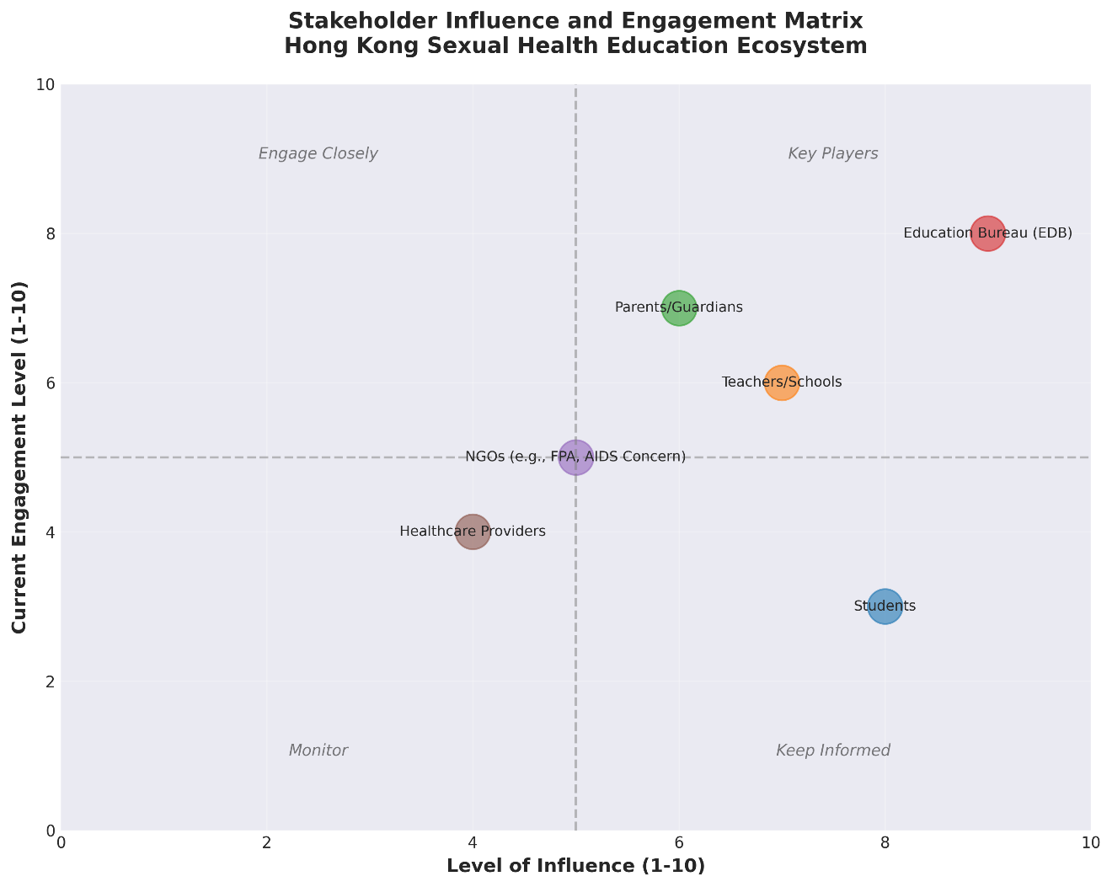
Figure 1: Relationship Between Sexual Health Knowledge and High-Risk Behavior Engagement Among Hong Kong Youth

1.2 Current Pedagogical Approaches and Content Coverage
The predominant pedagogical approach in Hong Kong schools emphasizes a biomedical, risk-focused model that prioritizes abstinence messaging and disease prevention over comprehensive sexual health literacy. Teachers typically deliver sexual health content through didactic lectures focusing on anatomy, puberty, and STI transmission, with limited interactive or skills-based components. This approach fails to address the broader determinants of sexual health, including communication skills, power dynamics in relationships, gender equality, and positive sexuality concepts. Research across Chinese-speaking contexts indicates that only 55.6% of Chinese college students self-reported having received any form of school-based sexuality education (Li et al., 2017). Among those who did receive education, the content was often fragmented and failed to provide comprehensive coverage of critical topics.
The lack of teacher training and confidence represents a fundamental barrier to effective delivery. A systematic review of teachers’ perspectives on sexual and reproductive health education found that adequacy was directly linked to three factors: teachers’ confidence to provide such education, supportive school policies and environment, and the priority accorded to SRH education within the institution (Walker et al., 2020). Many Hong Kong teachers report discomfort discussing sensitive sexual health topics, particularly those related to sexual pleasure, diverse sexual orientations, and gender identities. This discomfort is compounded by limited pre-service and in-service training opportunities specifically focused on comprehensive sexuality education pedagogy.
Digital and media literacy approaches to sexual health education remain underutilized in Hong Kong despite evidence of effectiveness in similar contexts. Web-based media literacy programs have demonstrated significant improvements in students’ critical thinking about media messages related to sex, reduced perceived realism of risky sexual norms, and increased intentions to use contraception and communicate about sexual health (Scull et al., 2021). Such innovative pedagogical approaches could help Hong Kong educators overcome cultural barriers to discussing sexuality by creating distance through technology-mediated learning while still delivering evidence-based content.

II. Benefits and Limitations of Existing Frameworks

2.1 Documented Benefits of School-Based Sexual Health Education
Despite implementation challenges, school-based sexual health education in Hong Kong and similar contexts demonstrates measurable benefits when delivered effectively. Research evidence indicates that students who receive school-based sexuality education score significantly higher on sexual and reproductive health knowledge assessments compared to those without such education (Li et al., 2017). In a large-scale study of 18,000 Chinese college students, those with higher sexual health knowledge demonstrated delayed sexual debut, reduced likelihood of unprotected sex, and lower rates of unintended pregnancy and abortion among sexually active students (see Figure 2). These protective effects were stronger among male students, suggesting the need for gender-sensitive educational strategies.
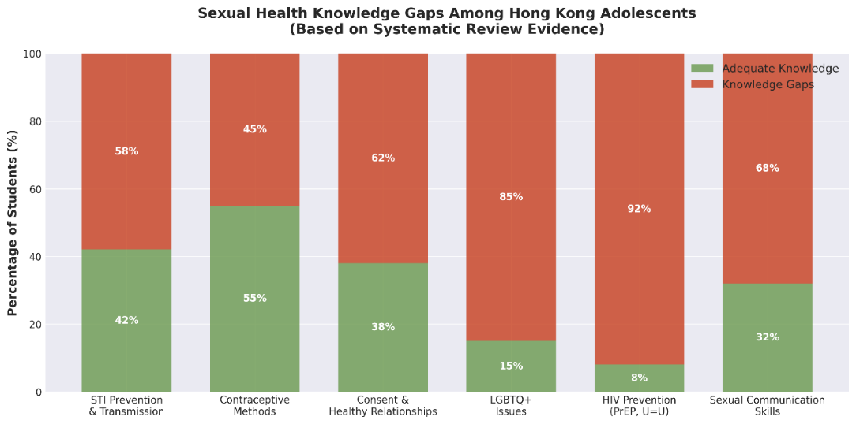
Figure 2: Comparative Sexual Health Outcomes for Students With vs. Without Comprehensive Sexuality Education
School-based sexuality education provides an inclusive platform to reach all adolescents regardless of family background or socioeconomic status. Schools represent the primary setting where young people spend significant time under the supervision of trained professionals, creating natural opportunities for health promotion (Szucs et al., 2021). The U.S. Centers for Disease Control and Prevention’s Division of Adolescent and School Health has advanced school-based approaches to STI/HIV and pregnancy prevention through decades of systematic research, demonstrating that school health education plays a crucial role in shaping adolescents’ protective health behaviors and outcomes. Effective programs can improve knowledge, modify attitudes toward risky behaviors, enhance self-efficacy for safer sex practices, and create supportive peer norms that reinforce healthy decision-making.
Comprehensive sexuality education creates opportunities to address co-occurring health and social concerns affecting adolescents. Research demonstrates linkages between sexual health education and improvements in mental health literacy, reduced gender-based violence, enhanced body image, and stronger communication skills applicable across life domains (Frberg & Fredriksson, 2025). When implemented through whole-school approaches that engage multiple stakeholders including students, teachers, parents, and community partners, sexual health education can contribute to creating safer, more inclusive school environments that respect diversity and promote equity.

2.2 Limitations and Challenges of Current Approaches
The current sexual health education framework in Hong Kong suffers from fundamental structural limitations that undermine its potential effectiveness. The absence of mandatory, evidence-based standards allows for wide variations in content, quality, and delivery across schools (Andres et al., 2021). This inconsistency means that adolescents’ access to critical sexual health information depends largely on which school they attend, perpetuating health inequities. Conservative content limitations often result in “abstinence-plus” approaches that emphasize delaying sexual activity while providing minimal information about contraception, safe sex practices, or pleasure-positive sexuality concepts.
Teacher discomfort and inadequate preparation represent persistent barriers to quality implementation. Studies examining teacher perspectives consistently identify insufficient training as a primary constraint on delivering comprehensive sexuality education (Walker et al., 2020). Teachers expressed that time limitations, low prioritization relative to academic subjects, and lack of ongoing professional development prevented them from delivering sexuality education effectively. Teachers express particular difficulty addressing topics related to sexual pleasure, masturbation, pornography, and LGBTQ+ sexualities, often avoiding these subjects despite their relevance to adolescent experiences.
Cultural and parental resistance creates additional implementation challenges in Hong Kong’s socially conservative context. The politics of sexual morality in Hong Kong, influenced by evangelical activism and traditional Chinese values, has shaped public discourse around sexuality education. Pro-family campaign movements have mobilized opposition to comprehensive sexuality education under the premise that it promotes promiscuity or undermines family values, despite research evidence to the contrary. These ideological tensions create barriers for teachers who fear backlash from parents or administrators if they address topics deemed controversial, such as sexual diversity, abortion, or non-heterosexual relationships.
The current frameworks also fail to address the specific needs of marginalized student populations including LGBTQ+ youth, students with disabilities, and those from diverse cultural backgrounds. Research indicates that sexuality education programs often operate from heteronormative assumptions, providing limited or no information relevant to sexual and gender minority students (Frberg & Fredriksson, 2025). This exclusion contributes to health disparities, as these populations face elevated risks for sexual health problems, mental health challenges, and violence yet receive inadequate support from school-based education programs.

III. Stakeholder Ecosystem and Roles

3.1 Students: Primary Consumers and Beneficiaries
Students represent the central stakeholders in sexual health education, yet their voices are often marginalized in curriculum design and policy development. Hong Kong adolescents demonstrate mixed receptiveness to sexuality education, with engagement levels varying based on content relevance, delivery methods, and perceived teacher competence. Research indicates that young people express desire for more comprehensive, practical information about sexual health but report feeling embarrassed or uncomfortable during teacher-delivered sessions. Students identified multiple barriers to their engagement including blurred boundaries when regular teachers deliver sensitive content, fear of harassment or judgment from peers, and curriculum content that feels out of touch with their lived experiences.
Adolescents in Hong Kong obtain sexual health information through diverse informal channels when formal education proves inadequate. Peer networks, online media, and pornography often fill knowledge gaps left by insufficient school-based education, potentially exposing young people to inaccurate or harmful information. A study of Hong Kong unmarried youth found that liberal attitudes toward premarital sex and sexual activity were common, yet contraceptive knowledge remained deficient (Yip et al., 2013). Students from divorced families, those out of school, and those with more liberal attitudes toward risky sexual behaviors were more likely to engage in premarital sex and high-risk sexual behaviors, highlighting the importance of targeted educational interventions.
The needs of Hong Kong students are highly diverse, requiring differentiated approaches to sexuality education. Sexual and gender minority students face particular challenges accessing relevant information and support. Research demonstrates that LGBTQ+ adolescents experience elevated rates of mental health problems, bullying, and sexual health risks yet rarely see themselves represented in sexuality education curricula (Frberg & Fredriksson, 2025). Similarly, students with varying cultural backgrounds, linguistic abilities, and developmental needs require adaptations to ensure accessibility and relevance of sexual health education content.

3.2 Educators and Schools: Delivery Agents with Variable Capacity
Teachers and school administrators serve as frontline delivery agents for sexual health education, yet their capacity varies dramatically across Hong Kong’s educational landscape. The adequacy of sexual and reproductive health education is directly linked to teachers’ confidence, training, and institutional support (Walker et al., 2020). Facilitators positively impacting school-based SRH education include intensive pre-service and in-service training, supportive school environments, and promotion of understanding regarding the importance of sexuality education within schools and broader community contexts.
Significant differences exist in teacher agency and autonomy across school types. International schools often provide greater flexibility for teachers to implement comprehensive, evidence-based sexuality education aligned with international standards. In contrast, teachers in local government-subsidized schools face more constraints related to conservative parental expectations, limited curriculum time allocated to personal and social education, and insufficient administrative support. Teachers reported that limited curriculum time, health education being perceived as lower priority than academic subjects, and lack of dedicated funding represented main barriers to health promotion training.
Teacher training levels remain inadequate to support comprehensive sexuality education delivery. Research examining teachers’ experiences indicates that many feel unprepared to address sensitive topics, manage classroom dynamics during sexuality education lessons, or respond appropriately to student disclosures of sexual violence or abuse (Walker et al., 2020). Professional development opportunities specifically focused on sexuality education pedagogy are limited in Hong Kong, and many teachers rely on outdated textbooks or personal beliefs rather than evidence-based curricula. Studies suggest that effective teacher training should include practical skills development, opportunities for experiential learning, and ongoing mentorship rather than one-time workshops.
Institutional policies and school culture significantly influence sexuality education quality. Schools with supportive senior management, clear policies affirming the importance of comprehensive sexuality education, and whole-school approaches that engage multiple staff members demonstrate better implementation outcomes. However, research on implementation fidelity reveals that even well-designed sexuality education programs often fail to be delivered as intended due to competing curriculum demands, staff turnover, and insufficient resources allocated to program maintenance.

3.3 Curriculum Policymakers: Regulators Setting Guidelines
The Education Bureau (EDB) in Hong Kong functions as the primary regulatory body establishing guidelines and constraints for sexuality education, yet it has not mandated comprehensive, evidence-based standards. Unlike jurisdictions with detailed, age-appropriate sexuality education curricula specified in national guidelines, Hong Kong’s approach remains largely discretionary, allowing individual schools significant autonomy in determining content coverage and instructional approaches. This regulatory gap contributes to the inconsistent quality and availability of sexuality education across the territory.
Policy-level barriers include the absence of political will to implement comprehensive sexuality education amid conservative opposition. The politics surrounding sexuality education in Hong Kong reflect broader tensions between progressive public health imperatives and traditional cultural values. Evangelical Christian organizations and pro-family advocacy groups have mobilized substantial opposition to comprehensive sexuality education policies, arguing that such programs undermine parental authority and promote premature sexual activity. These political dynamics create challenges for policymakers seeking to strengthen sexuality education standards while managing diverse stakeholder concerns.
International policy frameworks provide models that Hong Kong policymakers could adapt. The International Conference on Population and Development (ICPD) Programme of Action highlighted the roles of governments in offering comprehensive sex education to promote teenage reproductive health (Leung et al., 2019). Similarly, the Society for Adolescent Health and Medicine positions comprehensive sexual and reproductive health information as fundamental human rights for all adolescents, recommending universal access, clinician competency, and investment in education, services, research, and advocacy (Frberg & Fredriksson, 2025). Such frameworks emphasize evidence-based approaches, inclusivity, and alignment with human rights principles that could inform Hong Kong policy development.
Effective policy implementation requires coordination across government sectors including education, health, and social welfare. Research on comprehensive sexuality education programs demonstrates that success depends on multi-sectoral approaches involving partnerships between schools, healthcare systems, community organizations, and families (Andres et al., 2021). Hong Kong policymakers could strengthen outcomes by establishing clearer intersectoral coordination mechanisms, dedicated funding streams for sexuality education, and accountability systems to monitor implementation quality and health outcomes.

3.4 Parents and Guardians: Influential Stakeholders
Parents and guardians wield substantial influence over sexuality education policy and practice in Hong Kong, yet their engagement varies considerably. Research indicates that parents generally hold conservative attitudes toward comprehensive sexuality education, preferring abstinence-focused messaging over instruction about contraception or sexual diversity (Yip et al., 2013). Many parents believe that sexuality education is the school’s responsibility yet resist comprehensive content that conflicts with their values, creating tensions for educators attempting to implement evidence-based programs. Cultural norms in Chinese communities often discourage open parent-child communication about sexuality, leaving adolescents without adequate support from either home or school environments.
Parental consent requirements and opt-out provisions in some Hong Kong schools create additional barriers to universal access to sexuality education. When parents can remove their children from sexuality education classes, those students most in need of information and support may be denied access. Research examining parental perspectives found that while many parents acknowledge their children need sexual health information, they lack confidence in their own ability to provide accurate, comprehensive education. This suggests the need for parent education initiatives that enhance parental capacity while complementing school-based programs.
Strategies to enhance parental engagement include targeted information campaigns, parent education workshops, and opportunities for parents to preview curriculum materials. A study of comprehensive sexuality education implementation found that providing informational workshops for parents alongside student education improved parental self-efficacy to engage in sexual health discussions with children and increased awareness of community sexual health resources (Andres et al., 2021). Such approaches can help alleviate parental concerns by demonstrating that comprehensive sexuality education supports rather than undermines family values and parental authority.

3.5 NGOs and Public Health Advocates: External Partners
Non-governmental organizations (NGOs) including the Family Planning Association of Hong Kong (FPAHK), AIDS Concern, and other sexual health advocacy groups serve as critical external partners providing education, services, and policy advocacy. The FPAHK has provided public information about family planning and introduced sexuality education programs in Hong Kong since the 1960s, evolving to comprehensive reproductive health promotion. These organizations fill gaps left by insufficient school-based education through community outreach, youth-friendly sexual health services, and development of educational resources.
NGOs contribute specialized expertise that complements school-based efforts. Many have developed innovative, evidence-based sexuality education curricula, trained peer educators, and created digital platforms to reach young people through channels they prefer. AIDS Concern, for example, provides targeted HIV prevention education, testing services, and advocacy for populations at elevated risk including men who have sex with men and transgender individuals. Such organizations can address topics that schools may avoid due to political sensitivities while providing safe spaces for marginalized youth to access information and support.
The relationship between NGOs and the formal education system remains underdeveloped in Hong Kong. While some schools partner with NGOs to deliver guest sessions or special programs, systematic integration of NGO expertise into regular curriculum delivery is limited. Research on school-based sexual health interventions suggests that partnerships with community-based organizations can enhance program effectiveness by bringing additional resources, specialized knowledge, and connections to clinical services (Aventin et al., 2020). Strengthening these collaborations could improve sexuality education quality while building sustainable support systems for adolescent sexual health.

3.6 Healthcare Providers: Clinical Information and Services
Healthcare providers including physicians, nurses, and allied health professionals represent important stakeholders who can reinforce and extend sexuality education through clinical encounters. Adolescent-friendly health services that provide confidential sexual health counseling, contraception, STI testing, and treatment create essential links between education and care. However, research indicates that healthcare provider knowledge about comprehensive sexuality education and awareness of school-based programs remains limited, reducing opportunities for coordinated messaging and referrals.
An interactive web-based sexual health literacy program for female Chinese university students demonstrated that interventions combining education with healthcare access can improve outcomes (Wong et al., 2021). The study found that while the program did not significantly increase consistency of condom use compared to basic information, it did improve knowledge, attitudes, norms, and self-efficacy regarding safer sex. These findings suggest that healthcare provider engagement in sexuality education, whether through school partnerships or clinical counseling, can contribute to comprehensive approaches addressing multiple determinants of sexual health.
Barriers to healthcare provider involvement include time constraints, discomfort discussing sexuality with adolescents, concerns about parental consent, and lack of training in adolescent-friendly communication approaches. Creating formal linkages between schools and healthcare providers through referral pathways, co-location of services, and shared educational resources could strengthen the overall ecosystem supporting adolescent sexual health.

IV. Barriers and Challenges to Comprehensive Implementation

4.1 Cultural and Religious Conservatism
Cultural conservatism represents a fundamental barrier to comprehensive sexuality education in Hong Kong. Traditional Chinese values emphasizing chastity, family honor, and avoidance of explicit sexual discourse create resistance to open discussion of sexuality in educational settings. The influence of conservative religious groups, particularly evangelical Christian organizations, has shaped public debates about sexuality education content and scope. Pro-family movements have mobilized opposition to comprehensive programs, arguing that sexuality education should emphasize abstinence and heterosexual marriage while avoiding topics related to contraception, abortion, or LGBTQ+ identities.
Research examining the politics of sexual morality in Hong Kong reveals how conservative activism has influenced educational policy and practice. Signature campaigns, lobbying efforts, and public statements by religious organizations have created political pressure against comprehensive sexuality education reforms. These movements frame comprehensive approaches as Western impositions that conflict with Chinese cultural values, despite evidence that adolescents across cultures benefit from evidence-based sexual health information. The resulting climate discourages educators and policymakers from adopting progressive approaches, perpetuating gaps in adolescent sexual health knowledge and services.
Cultural attitudes toward discussing sexuality also affect parent-child communication and parental support for school-based programs. Studies of Hong Kong families indicate that parents rarely engage in substantive conversations about sexual health with their adolescent children, preferring to delegate this responsibility to schools yet resisting comprehensive content when schools attempt to provide it (Yip et al., 2013). This creates a vacuum wherein adolescents receive inadequate information from both home and school, increasing reliance on peer networks and media sources that may provide inaccurate or harmful information.

4.2 Insufficient Teacher Preparation and Support
The lack of adequate teacher training represents a persistent structural barrier undermining sexuality education quality. Research examining teachers’ perspectives consistently identifies insufficient preparation as a primary constraint on delivering comprehensive content (Walker et al., 2020). Many teachers report never receiving formal training in sexuality education pedagogy during pre-service education, and in-service professional development opportunities remain limited. Teachers reported that fewer than two-thirds of programs covered sex and relationships education, and coverage rates were even lower for specific topics.
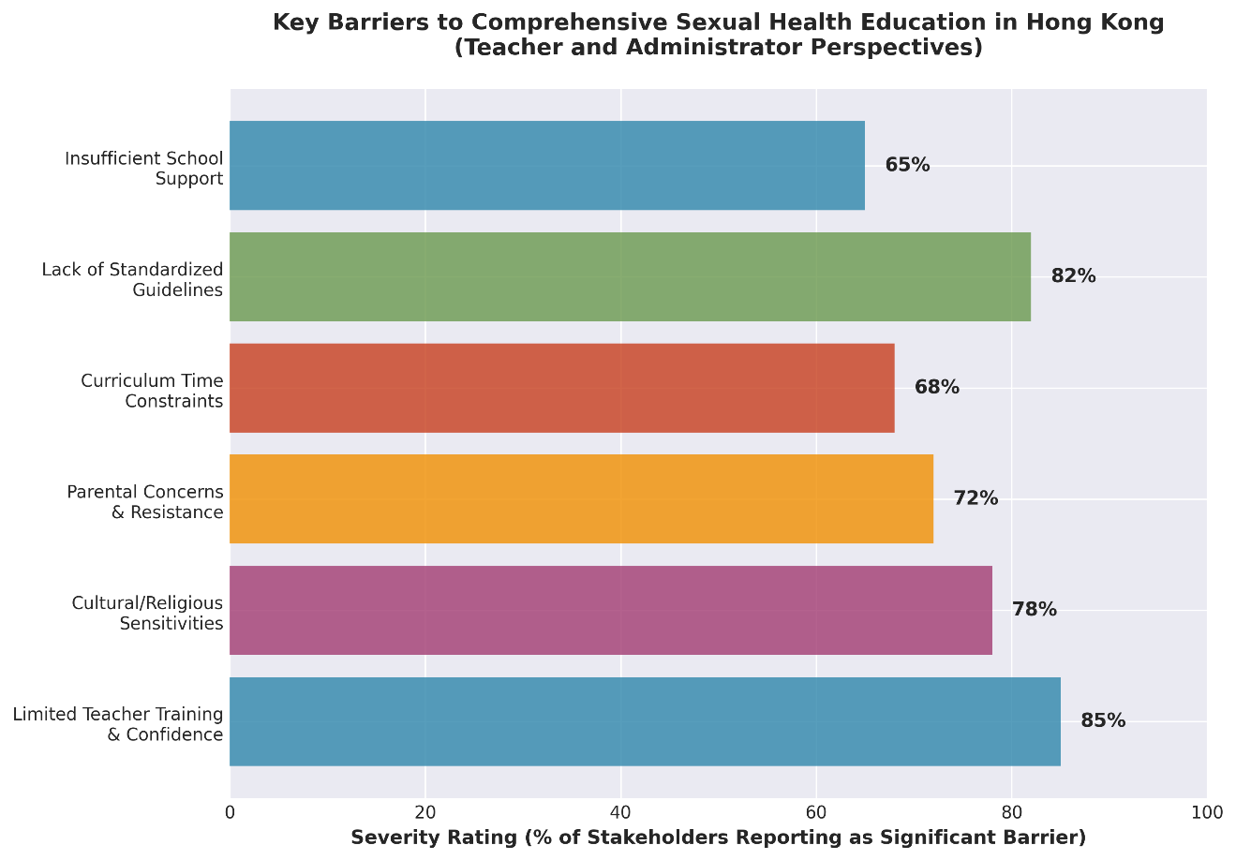
Figure 3: Reported Barriers to Sexuality Education Delivery Among Hong Kong Secondary School Teachers

Teacher discomfort and embarrassment when addressing sensitive sexual health topics further compromises delivery quality. Qualitative research with students and teachers reveals that both groups experience vulnerability and embarrassment during sexuality education lessons, with teachers’ discomfort often transmitted to students, creating barriers to open discussion. Teachers express particular difficulty addressing topics related to sexual pleasure, masturbation, pornography, and LGBTQ+ sexualities, often avoiding these subjects despite their relevance to adolescent experiences (see Figure 3).
The absence of ongoing support structures leaves teachers isolated in managing complex classroom dynamics and responding appropriately to student needs. Effective sexuality education requires skills in facilitating sensitive discussions, managing diverse student reactions, responding to disclosures of abuse or violence, and addressing misinformation while respecting diverse values. Without adequate preparation and support, teachers may rely on outdated materials, personal beliefs, or avoid controversial topics altogether, resulting in incomplete or biased information delivery.

4.3 Curriculum Constraints and Competing Priorities
Limited curriculum time represents a significant practical barrier to comprehensive sexuality education implementation. Schools in Hong Kong face intense pressure to prioritize academic subjects relevant to high-stakes examinations, leaving minimal time for personal, social, and health education. Research on implementation fidelity indicates that even when sexuality education programs are adopted, competing curriculum demands often result in reduced lesson time, rushed delivery, or elimination of components deemed less essential. This compression undermines program effectiveness, as comprehensive sexuality education requires sufficient time for skills development, discussion, and reflection beyond basic information transmission.
The low prioritization of sexuality education relative to academic subjects affects resource allocation and administrative support. Teachers report that school leadership often views health education as secondary to examination-focused subjects, resulting in inadequate funding for materials, professional development, and program evaluation. When budget constraints emerge, sexuality education resources are often among the first to be reduced or eliminated, reflecting systemic undervaluation of this domain despite its critical importance for adolescent health and wellbeing.
Assessment and accountability mechanisms for sexuality education remain underdeveloped in Hong Kong. Unlike academic subjects with standardized examinations and performance metrics, sexuality education outcomes are rarely systematically evaluated. This absence of accountability allows schools to provide minimal or ineffective programs without consequences, while also making it difficult to demonstrate the value of high-quality implementation to skeptical stakeholders (Andres et al., 2021). Developing appropriate assessment approaches that measure knowledge, attitudes, skills, and behavioral intentions could strengthen accountability while providing data to guide continuous improvement.

4.4 Lack of Standardized, Evidence-Based Frameworks
The absence of mandatory, comprehensive sexuality education standards in Hong Kong creates a fragmented landscape with wide variations in quality and content across schools. Unlike jurisdictions with detailed national curricula specifying learning objectives, age-appropriate content, and pedagogical approaches, Hong Kong leaves sexuality education largely to school discretion (Andres et al., 2021). This decentralized approach results in significant inequities, with students’ access to comprehensive sexual health information depending primarily on which school they attend rather than being guaranteed as a universal entitlement.
Without clear evidence-based guidelines, schools and teachers must independently determine appropriate content, creating risks of omission or misinformation. Research indicates that when educators lack guidance, they tend to focus on biological aspects of reproduction and STI transmission while avoiding more complex topics related to relationships, consent, power dynamics, and sexual diversity (Walker et al., 2020). This narrow approach fails to address the multidimensional nature of sexual health and wellbeing, leaving students unprepared to navigate real-world challenges they will encounter.
The lack of standardization also impedes quality improvement and program evaluation efforts. When every school implements different approaches with varying content and intensity, it becomes impossible to conduct meaningful assessments of sexuality education effectiveness or to identify best practices that could be scaled (Andres et al., 2021). Developing comprehensive standards based on international evidence and adapted to Hong Kong’s cultural context could provide the foundation for more consistent, high-quality implementation while maintaining appropriate flexibility for local adaptation.

V. Opportunities for Reform: Modern Concepts and Evidence-Based Approaches

5.1 Incorporating Contemporary HIV Prevention Technologies
Hong Kong’s sexuality education curriculum presents significant opportunities to integrate modern HIV prevention concepts including Pre-Exposure Prophylaxis (PrEP) and the U=U (Undetectable=Untransmittable) principle. PrEP, the use of antiretroviral medication by HIV-negative individuals to prevent infection, represents a major advancement in HIV prevention yet remains largely unknown among adolescents and young adults globally. These low awareness levels highlight the critical need for educational interventions introducing young people to biomedical prevention options before they encounter elevated risk situations.
Incorporating PrEP education into Hong Kong’s sexuality curriculum could empower adolescents with comprehensive prevention knowledge complementing traditional approaches emphasizing abstinence and condom use. Curriculum content should present PrEP within comprehensive prevention frameworks emphasizing combination approaches rather than positioning it as a replacement for other methods.
The U=U principle—that people living with HIV who maintain undetectable viral loads through antiretroviral treatment cannot transmit the virus sexually—represents another critical concept absent from current sexuality education in Hong Kong. Understanding U=U can reduce HIV-related stigma, support treatment adherence among people living with HIV, and provide reassurance to serodiscordant couples. Comprehensive sexuality education programs should integrate accurate, age-appropriate information about HIV treatment as prevention alongside traditional prevention messaging, helping to normalize HIV as a manageable chronic condition rather than a death sentence.

5.2 Adopting Comprehensive Sexuality Education Frameworks
International evidence demonstrates that comprehensive sexuality education (CSE) frameworks produce superior outcomes compared to abstinence-only or narrow biomedical approaches. CSE addresses sexuality holistically, incorporating biological, psychological, social, and cultural dimensions while emphasizing positive sexuality concepts including pleasure, intimacy, and healthy relationships. Research across diverse cultural contexts indicates that CSE programs can delay sexual debut, reduce unprotected sex and STI rates, increase contraceptive use, and improve communication skills without increasing sexual activity rates (Frberg & Fredriksson, 2025). These findings directly counter conservative arguments that comprehensive approaches promote promiscuity, instead demonstrating protective effects.
Hong Kong could adapt CSE frameworks successfully implemented in similar Asian contexts while respecting local cultural values. A comprehensive review examining sexuality education across Chinese-speaking contexts identified key components of effective programs including: age-appropriate content spanning elementary through secondary education; skills-based pedagogy emphasizing communication, decision-making, and critical thinking; inclusive approaches addressing diverse sexual orientations and gender identities; and engagement of multiple stakeholders including parents, teachers, and community partners (Leung et al., 2019). Implementing such frameworks requires systemic changes including policy reforms, teacher training, curriculum development, and community engagement.
Evidence-based CSE programs incorporate specific pedagogical approaches proven effective in diverse settings. Interactive methodologies including role-plays, case discussions, and peer education activities demonstrate greater effectiveness than didactic lectures in changing attitudes and behaviors (Haruna et al., 2018). Game-based learning and gamification approaches show particular promise for engaging adolescents while developing critical thinking skills about sexual health information. Digital platforms complementing face-to-face instruction can provide additional resources, support self-paced learning, and enable private access to sensitive information.

5.3 Strengthening Teacher Capacity Through Professional Development
Systematic investment in teacher preparation represents a critical lever for improving sexuality education quality in Hong Kong. Comprehensive professional development should address multiple dimensions including content knowledge, pedagogical skills, comfort with sensitive topics, and strategies for managing diverse classroom dynamics. Research examining effective teacher training approaches indicates that programs should include practical skills development through experiential learning, opportunities to practice facilitation techniques, and ongoing mentorship rather than one-time workshops. Training should help teachers develop competence in creating safe, respectful learning environments where students feel comfortable asking questions and engaging with complex topics.
Pre-service teacher education programs should incorporate sexuality education as a mandatory component, ensuring all teachers acquire foundational knowledge and skills regardless of their subject specialization. Currently, many Hong Kong teachers receive no formal preparation in sexuality education during initial training, leaving them dependent on personal knowledge and values when delivering content (Walker et al., 2020). Integrating CSE modules into teacher preparation programs can normalize sexuality education as a core educational competency while providing structured opportunities to develop expertise under supervised conditions before entering classrooms.
In-service professional development should provide ongoing support for practicing teachers through multiple mechanisms. Intensive workshops providing evidence-based curricula, demonstration lessons, and practice opportunities can enhance teacher confidence and competence. Establishing communities of practice where teachers share experiences, problem-solve challenges, and learn from peers creates sustainable support structures extending beyond formal training events. Online platforms offering resources, discussion forums, and expert consultation can supplement face-to-face professional development while providing just-in-time support when teachers encounter difficult situations.

5.4 Engaging Multiple Stakeholders Through Ecological Approaches
Comprehensive sexuality education achieves optimal outcomes when implemented through whole-school, multi-stakeholder approaches engaging students, teachers, parents, administrators, and community partners. An ecological model recognizing that adolescent sexual health is shaped by individual, interpersonal, organizational, community, and policy factors suggests that interventions addressing multiple levels simultaneously produce synergistic effects (Andres et al., 2021). Hong Kong programs could adopt such approaches by coordinating school-based education with parent workshops, teacher training, policy advocacy, and community awareness campaigns to create supportive ecosystems reinforcing healthy development.
Parental engagement strategies should move beyond passive consent toward active partnership in supporting adolescent sexual health. Research demonstrates that parent education workshops can enhance parental self-efficacy for discussing sexuality with children, increase knowledge of sexual health topics, and improve awareness of community resources (Andres et al., 2021). Providing parents with developmentally-appropriate conversation guides, addressing their concerns and questions, and demonstrating how sexuality education supports family values can reduce resistance while strengthening home-school partnerships. Digital platforms offering parent education modules and resources can extend reach beyond those able to attend in-person sessions.
Community partnerships with NGOs, healthcare providers, and youth-serving organizations can enhance program quality and sustainability. Formal partnerships establishing clear roles, resource-sharing agreements, and coordination mechanisms can create comprehensive support systems addressing diverse adolescent needs. School-community linkages facilitating referrals to sexual health services, counseling, and additional support ensure that students can access resources when education alone is insufficient to address their needs.

5.5 Leveraging Technology and Innovation
Digital technologies offer innovative opportunities to enhance sexuality education accessibility, engagement, and effectiveness in Hong Kong. Web-based platforms can deliver comprehensive content privately, reducing embarrassment barriers that constrain classroom participation. Interactive modules incorporating multimedia, self-paced learning, and immediate feedback can accommodate diverse learning styles and preferences (Wong et al., 2021). Mobile applications providing sexual health information, decision-support tools, and service locators empower young people to access resources independently while supporting continuous learning beyond discrete classroom sessions.
Social media and peer-to-peer digital platforms can extend sexuality education reach and reinforce messaging through channels adolescents already use extensively. Carefully designed social media campaigns normalizing safer sex practices, challenging stigma, and promoting help-seeking behaviors can shift peer norms and community attitudes. Peer education programs enhanced through digital technologies enable trained youth ambassadors to reach larger audiences with culturally-relevant messaging while creating opportunities for interactive engagement, questions, and support (Aventin et al., 2020). Such approaches recognize adolescents as active agents in health promotion rather than passive recipients of adult-delivered information.
Game-based learning and gamification approaches show particular promise for engaging adolescents in sexuality education while developing critical thinking skills. Research demonstrates that these methodologies increase student engagement, enjoyment, and participation while fostering critical thinking, improving confidence, and stimulating self-regulatory learning (Haruna et al., 2018). Digital games addressing sexual health topics can create safe spaces for exploring complex scenarios, practicing decision-making, and experiencing consequences of choices without real-world risks. Hong Kong educators could adopt or adapt evidence-based digital games while ensuring cultural appropriateness and alignment with learning objectives.

VI. Recommendations and Conclusions

6.1 Policy-Level Recommendations
Hong Kong’s Education Bureau should establish comprehensive, mandatory sexuality education standards specifying age-appropriate learning objectives, core content areas, and pedagogical approaches across primary and secondary education. Standards should be evidence-based, drawing on international best practices while being adapted to Hong Kong’s cultural context. Comprehensive guidelines should address biological, psychological, social, and ethical dimensions of sexuality while explicitly including topics often excluded such as consent, healthy relationships, LGBTQ+ inclusivity, modern prevention technologies (PrEP, U=U), and pleasure-positive approaches to sexual health.
Policy reforms should mandate pre-service and in-service teacher training in sexuality education for all educators regardless of subject specialization. The Education Bureau should collaborate with teacher education institutions to integrate comprehensive sexuality education modules into all teacher preparation programs, ensuring graduates possess foundational knowledge and pedagogical skills. Ongoing professional development requirements should include regular updates on sexuality education evidence, emerging issues affecting adolescents, and skills enhancement opportunities. Dedicated funding streams should support training initiatives, curriculum development, and program evaluation efforts.
Government should invest in multi-sectoral coordination mechanisms bringing together education, health, social welfare, and community sectors to support comprehensive approaches. Establishing an Adolescent Sexual Health Task Force with representation from key stakeholder groups could facilitate policy coordination, resource sharing, and accountability for outcomes. Clear referral pathways connecting schools with healthcare services, counseling, and social support should be developed and promoted to ensure students can access comprehensive services when needed.

6.2 Institutional and Programmatic Recommendations
Schools should adopt whole-school approaches to sexuality education that engage multiple constituencies rather than limiting content to discrete classroom lessons. School policies should explicitly affirm commitment to comprehensive, inclusive sexuality education while providing clear guidance to teachers regarding acceptable content and pedagogical approaches. Senior leadership support, adequate resource allocation, and integration across curriculum areas can signal organizational priority for sexual health promotion.
Curriculum development efforts should emphasize evidence-based, skills-building pedagogies over didactic information transmission. Sexuality education programs should incorporate interactive methodologies including role-plays, case discussions, media literacy activities, and peer education to enhance engagement and learning. Digital platforms complementing face-to-face instruction can provide additional resources, support self-paced learning, and enable private access to sensitive information. Programs should be evaluated regularly using appropriate measures of knowledge, attitudes, skills, and behavioral intentions to guide continuous improvement.
Schools should strengthen partnerships with NGOs and healthcare providers to enhance program quality and create comprehensive support systems. Formal agreements establishing clear roles, resource-sharing mechanisms, and coordination protocols can facilitate effective collaboration. Guest sessions by health professionals, parent education workshops, and linkages to youth-friendly sexual health services can extend schools’ capacity while connecting students with additional resources and support.

6.3 Research Priorities
Rigorous evaluation research examining sexuality education effectiveness in Hong Kong contexts is urgently needed to build the local evidence base. Studies should assess multiple outcomes including knowledge, attitudes, self-efficacy, behavioral intentions, and actual sexual health behaviors, using robust designs with adequate follow-up periods to detect sustained effects. Research should investigate differential impacts across student subgroups including gender, sexual orientation, socioeconomic status, and cultural background to identify equity implications and inform targeted approaches.
Implementation science research exploring barriers and facilitators to high-quality sexuality education delivery in Hong Kong schools can guide practical improvements. Studies should examine factors affecting teacher fidelity to evidence-based curricula, strategies for enhancing parental engagement, and approaches to navigating cultural sensitivities while maintaining program integrity. Research investigating cost-effectiveness of different implementation models can inform resource allocation decisions and support arguments for sustained investment.
Longitudinal research tracking adolescent sexual health outcomes over time can demonstrate the long-term impacts of comprehensive sexuality education while identifying critical periods for intervention. Cohort studies examining pathways from education exposure to sexual health literacy, behaviors, and outcomes can elucidate mechanisms of effect and inform theory development. Research should also investigate unintended consequences or potential harms to ensure that programs optimize benefits while minimizing risks.

6.4 Concluding Observations
School-based sexual health education in Hong Kong stands at a critical juncture. Growing public health concerns related to STIs, unintended pregnancies, and sexual violence among adolescents underscore the inadequacy of current approaches. Yet substantial barriers rooted in cultural conservatism, insufficient teacher preparation, and fragmented stakeholder engagement impede progress toward comprehensive, evidence-based sexuality education. The absence of mandatory standards creates inequities wherein students’ access to critical information depends on which school they attend rather than being guaranteed as a universal entitlement.
Opportunities for meaningful reform exist through multiple pathways. Incorporating modern HIV prevention concepts including PrEP and U=U can update curriculum content while empowering adolescents with comprehensive prevention knowledge. Adopting internationally-validated comprehensive sexuality education frameworks adapted to Hong Kong’s context can address the multidimensional nature of sexual health while respecting local values. Systematic investment in teacher preparation, whole-school approaches engaging multiple stakeholders, and leveraging of digital technologies can enhance quality and reach.
The stakeholder ecosystem influencing sexuality education in Hong Kong is complex, involving students, teachers, parents, policymakers, NGOs, and healthcare providers with diverse and sometimes conflicting interests. Progress requires deliberate efforts to engage all stakeholders authentically, addressing concerns while building shared understanding of evidence demonstrating that comprehensive approaches protect rather than harm young people. Policy leadership from the Education Bureau establishing clear standards and accountability mechanisms is essential to drive systemic change.
Ultimately, ensuring all Hong Kong adolescents receive comprehensive, high-quality sexuality education is both a public health imperative and a human rights issue. Research evidence overwhelmingly demonstrates that empowering young people with accurate information, critical thinking skills, and self-efficacy for healthy decision-making produces measurable improvements in sexual health outcomes. As Hong Kong charts its path forward, drawing on international evidence while respecting local context, the opportunity exists to create an educational system that truly supports adolescent development, wellbeing, and thriving into adulthood.

Key Findings Summary Table
Domain | Current State | Key Challenges | Opportunities
Policy Framework | No mandatory comprehensive sexuality education standards; discretionary school-level implementation | Political resistance from conservative groups; lack of evidence-based guidelines | Establish comprehensive CSE standards aligned with international best practices
Teacher Capacity | Limited pre-service/in-service training; low confidence with sensitive topics | Insufficient professional development; cultural discomfort; competing priorities | Systematic training programs; communities of practice; ongoing mentorship
Curriculum Content | Biomedical focus; abstinence emphasis; limited coverage of relationships, consent, LGBTQ+ topics | Conservative content restrictions; avoidance of “controversial” subjects | Integrate modern concepts (PrEP, U=U); adopt skills-based, inclusive CSE frameworks
Student Outcomes | Adequate basic knowledge but deficient contraceptive literacy; high-risk behaviors among subgroups | Knowledge-behavior gap; limited access to services; stigma barriers | Enhanced linkages to youth-friendly services; peer education; digital platforms
Parental Engagement | Low parent-child communication; resistance to comprehensive content | Cultural taboos; limited parental capacity; values conflicts | Parent education workshops; transparent curriculum sharing; demonstration of alignment with family values
NGO/Healthcare Partnerships | Ad hoc collaborations; underutilized expertise | Weak school-community linkages; unclear referral pathways | Formalized partnerships; integrated service delivery; leveraging NGO resources

References
Andres, E. B., Choi, E. P., Fung, A., Lau, K., Ng, N., Yeung, M., & Johnston, J. (2021). Comprehensive sexuality education in hong kong: Study protocol for process and outcome evaluation. BMC Public Health.
Aventin, ine, Gough, A., McShane, T., Gillespie, K. A., O”Hare, L., Young, H., Lewis, R., Warren, E., Buckley, K., & Lohan, M. (2020). Engaging parents in digital sexual and reproductive health education: Evidence from the JACK trial. Reproductive Health.
Frberg, J., & Fredriksson, L. (2025). Sexual and reproductive health and rights. Journal of Adolescent Health.
Haruna, H., Hu, X., & Chu, S. (2018). Adolescent school-based sexual health education and training: A literature review on teaching and learning strategies.
Leung, H., Shek, D. T. L., Leung, E., & Shek, E. Y. W. (2019). Development of contextually-relevant sexuality education: Lessons from a comprehensive review of adolescent sexuality education across cultures. Multidisciplinary Digital Publishing Institute.
Li, C., Cheng, Z., Wu, T., Liang, X., Gaoshan, J., Li, L., Hong, P., & Tang, K. (2017). The relationships of school-based sexuality education, sexual knowledge and sexual behaviorsa study of 18,000 chinese college students. Reproductive Health.
Scull, T., Malik, C. V., Morrison, A. M., & Keefe, E. M. (2021). Promoting sexual health in high school: A feasibility study of a web-based media literacy education program. Journal of Health Communication.
Szucs, L. E., Barrios, L., Young, E., Robin, L., Hunt, P., & Jayne, P. E. (2021). The CDC”s division of adolescent and school health approach to sexual health education in schools: 3 decades in review. Journal of School Health.
Walker, R., Drakeley, S., Welch, R., Leahy, D., & Boyle, J. (2020). Teachers perspectives of sexual and reproductive health education in primary and secondary schools: A systematic review of qualitative studies. Sex Education : Sexuality, Society and Learning.
Wong, J. Y., Zhang, W., Wu, Y., Choi, E. P., Lo, H., Wong, W., Chio, J., Tam, H., Ngai, F., Tarrant, M., Wang, M., Ngan, H., & Fong, D. (2021). An interactive web-based sexual health literacy program for safe sex practice for female chinese university students: Multicenter randomized controlled trial. Journal of Medical Internet Research.
Yip, P., Zhang, H., Lam, T., Lam, K., Lee, A., Chan, J., & Fan, S. (2013). Sex knowledge, attitudes, and high-risk sexual behaviors among unmarried youth in hong kong. BMC Public Health.

